Linking Coopetition and Corporate Entrepreneurship

Thomas Mohr, Research Associate

University of St. Gallen (HSG)

Institute of Technology Management

Dufourstrasse 40a, CH-9000 St. Gallen, Switzerland
Tel: +41 77 405 2522 Email: thomas.mohr@unisg.ch
www.item.unisg.ch

Dr. Anja Schulze, Project Manager

Swiss Federal Institute of Technology Zürich (ETH)

Chair of Technology and Innovation Management

Kreuzplatz 5, CH-8032 Zürich, Switzerland
Tel: +41 44 632 0632 Email: aschulze@ethz.ch
www.tim.ethz.ch

Abstract
Objectives: Which large organization would not pursue to make its employees think and act in an entrepreneurial manner? Consequently, many existing companies have reached the point of anchoring the term `corporate entrepreneurship' or `intrapreneurship' into their corporate visions and leadership principles. In this course, organizations have installed `profit centres' or `business units' considered as enterprises within the overall enterprise. These organizational entities have to interact with each other – more precisely they have to cooperate or even compete with each other. This research aims at clarifying, how structures of simultaneous cooperation and competition affect entrepreneurial behaviour. The main objective is to analyze and understand whether and how mechanisms of intra-organizational ‘coopetition’ influence Corporate Entrepreneurship.
Prior Work: The research rests upon the existent literature on corporate entrepreneurship. Within this framework, coopetition is defined as the situational state between competition and cooperation in a particular context - the context is understood as relationship between two or more entities of a social network.
Approach: The main objective of the research is the investigation of the behaviour within the enterprise. With this perception, behaviour represents the instance, which links organizational and individual factors that are able to foster entrepreneurial behaviour. Additionally, the research follows Brandenburger & Nalebuff (1996) who suggested viewing the "game of business'' from the PARTS perspective (players, added values, rules, tactics, and strategies). The players may be arranged in a value-net. Transferred to the intra-organizational context of our studied game, players are the studied subunits within the value-network of the corporate new product development.
Results: Coopetition is operationalized using a social network approach. First results from a pilot study show that this kind of social network data could serve as a base in explaining the nexus of coopetition on entrepreneurial behaviour. In addition, the results from the pilot illustrate that coopetition is inherently given in any social network and can be operationalized by our new approach.
Implications: The article argues that intra-organizational coopetition can combine the advantages of competition and collaboration. We believe that coopetition could, managed in a proper way, support and encourage corporate entrepreneurship within boundaries of organizations.
Value: Our research findings aim to contribute to the understanding, how internal entrepreneurial behaviour takes place. Additionally, we hypothesize how an intra-organizational coopetition strategy may impact on employee’s entrepreneurial behaviour. To sum up, we aim to spotlight, how established organizations can utilize the mechanisms of coopetition to support or even foster entrepreneurial behaviour within rigid intra-organizational networks.

Research motivation
To stay competitive in dynamic, and knowledge-dominated environments, today organizations have to be entrepreneurial i.e., to develop capabilities like adaptability, flexibility, speed, aggressiveness, and innovativeness (Morris and Kuratko 2002). In particular, being entrepreneurial aims at fostering innovativeness and organizational renewal by the development of new businesses (Kuratko, Ireland et al. 2001). The different effects of corporate entrepreneurship can be summarized by formulating the unifying objective of improving the competitive position and financial performance primarily by innovation (Chaney, Devinney et al. 1991; Lengnick-Hall 1992; Antoncic and Hisrich 2003). Drawing on these findings Zahra et al. elucidated that organizations, which successfully enrol entrepreneurial activities simply “achieve superior performance'' (1999, p.57).
Established companies in existing industries are confronted with the fact that newcomers are creating the largest portion of the new wealth (Hamel 1999). Although every firm began as a start-up, the entrepreneurial spirit of their founding pioneers often shifts to bureaucracy. Large firms have been recognizing that their size hampers entrepreneurial behaviour within the firm while at the same time they face dynamically changing markets. Consequently, many established companies have reached the point of anchoring the term 'corporate entrepreneurship' or 'intrapreneurship' into their corporate visions and leadership advices. In addition, several scholars conducted research on how to enhance entrepreneurial behaviour.
Scholars focus on the process of turning opportunities or individual ideas into successful innovation (Burgelman 1983; Stevenson and Jarillo 1990; Dess and Rasheed 1991; Hornsby, Naffziger et al. 1993; Chung and Gibbons 1997; Russell 1999; Antoncic 2001); on (flexible) resources needed to pursue this process (Stevenson and Jarillo 1990; Bartlett and Goshal 1996; Hamel 1999); or the organizational environment within the internal entrepreneurial process takes place (Burgelman and Sayles 1985; Morse 1986; Covin and Slevin 1988; Echols and Neck 1998; Damanpour and Schneider 2006). Further antecedents to encourage internal entrepreneurial behaviour comprise management support and coaching (Burgelman 1983; Kanter 1985; Bartlett and Goshal 1996). A large amount of research has been conducted on such entrepreneurial oriented organizations and about the dimensions of entrepreneurial orientation (Lumpkin and Dess 1996; Knight 1997; Kreiser, Marino et al. 2002; Dess, Lumpkin et al. 2005). Here, the entrepreneurial orientation of an organization could be expressed by autonomy, innovativeness, risk taking, proactiveness, and competitive aggressiveness (Lumpkin and Dess 1996).
However, these researchers discarded today's organizational structures. Along with the globalization, innovative developments of communication technology, and increasing decentralized task structures, we have been witnessing a disaggregation of centralized organizations. Results are miscellaneous forms of networks, which are characterized by modular organizational structures with (decentralized) subunits (Achrol and Kotler 1999). Consequently, organizations experience an increasing need for coordinating mechanisms aiming at an effective utilization of the dispersed intelligence (i.e.; employees' know how, decision making competences, etc.) within the firm (Malone 2004). As Malone predicts, these hierarchic structures are likely to decline in the coming decades with a subsequent a shift from command-and-control management to coordinate-and-cultivate management (2004, pp. 126/129). However, under today's conditions, hierarchic structures are too cumbersome and cannot satisfy the current need efficiently (Halal 1994). Corporate entrepreneurs need the freedom and encouragement that (internal) markets provide, to develop successful innovations from their ideas. But, while the past (mechanistic, centralized and hierarchical) organizational structures incline to characterize themselves by bureaucracy (Wunderer 2006), decentralized and market-like structures of today's businesses are suffering of disorder and risk (Halal 1996). From knowledge management literature we know, that knowledge sharing and collaboration is extremely important in knowledge-intensive settings. Indeed, organizations need to base on mutual interaction to accomplish complex objectives, especially in decentralized systems (Zannetos 1965). Different organizational entities have to interact with each other, here. More precisely, they have to cooperate or compete with each other.
To manage this situation successfully, scholars recommended engineering a balanced combination of cooperation and competition. This balance is also known as coopetition. In the abstract, coopetition can be interpreted as simultaneous cooperative and competitive behavior in the relationship of two or more parties. Nowadays numerous examples demonstrate how competitive firms cooperate and cooperating firms compete with each other at the same time in order to achieve superior performance (for instances, see Brandenburger and Nalebuff 1996; Pegels and Yong 1997; Luo 2004). Within this inter-organizational context, a great deal examples of coopetition exist. For instance, cartels are well-known examples of how companies are working together in order to limit competition, even if they are competitors. Very similar to them, are so-called ‘Keiretsu’ in the Japanese industry. Summarizing, in the information economy, the mindset of simultaneous cooperation and competition plays an important role as business strategy (Borders, Johnston et al. 2001). Coopetition can occur at multiple levels (Luo, Slotegraaf et al. 2006). These levels can, for instance, be firms, business units, departments, teams, or particular task groups (Brandenburger and Nalebuff 1996). This research concentrates on the business unit level and therefore on intra-organizational coopetition. Luo (2004, p.162) states that the “… accumulate understanding of the content, process, and infrastructure of this coopetition [within the firm] remains limited.''
Wunderer (2006) states that equilibrium between intra-organizational competition and intra-organizational cooperation could explain how established organizations are able to foster internal entrepreneurial behaviour. However, whether coopetition may provide fertile ground for corporate entrepreneurship has not been investigated so far. Consequently, this research aims at studying the linkage of intra-organizational coopetition and corporate entrepreneurial behaviour. Thus, we aim at a contribution for a clarification and the understanding of pre-conditions for enhancing corporate entrepreneurship in established companies with modular structures. At the same time, the research aims at contributing to the `future direction', Zahra et al. (1999, p.55) demanded: "Greater attention should be given to entrepreneurship at the divisional (strategic business unit) level of the analysis. A great many entrepreneurial activities occur at the level of organizational.''

Internal entrepreneurial behaviour
Overall, entrepreneurship can be understood as “a process by which individuals - either on their own or inside organizations - pursue opportunities without regard to the resources they currently control” (Stevenson & Jarillo 1990, p.23). If this process takes place within the boundaries of organizations, it is generally known as corporate or internal entrepreneurship (or intrapreneurship). Corporate entrepreneurship relies on internal entrepreneurial behaviour by which opportunities are recognized and exploited within large and established corporations. For example, not only the company overall but relatively small independent units create, internally test-market and sell innovative products, technologies, or services (Nielsen et al. 1985). This phenomenon is also known as ‘bringing the market inside’ the firm (Foster & Kaplan 2001; Halal 1996; Hamel 1999; Malone 2004a; 2004b; 2002). In general, corporate entrepreneurship comprises entrepreneurial behaviour of individuals as well as particular business units, which act in an organizational network (several business units within the organization) and self-guided (e.g., like a firm within the firm). In particular, our research follows Birkinshaw (1997, p.208/209) in the concept of dispersed entrepreneurial behaviour which "… rests on the premise that every individual in the company has the capacity for […] entrepreneurial behaviour more or less simultaneously." Supporting this, Reich (1987) stated that entrepreneurial behaviour is not limited to the top management or the firm's founder. Therefore, he used the term `collective entrepreneurship'. His concept states that individual skills are integrated into groups - whose collective innovation capacity is greater than the sum of individual capacities. Consequently, in our research we will apply the definition of entrepreneurial behaviour as follows:
Entrepreneurial behaviour is the active and efficient support of the enterprise strategy through problem-solving, social competence, and result-orientated thinking and acting, with high degree of self-initiative and self-responsibility (Wunderer 2006, p.51).
With this definition, entrepreneurial behaviour is not limited to innovation, but coined by the individual capabilities of the corporate entrepreneur (herewith we include organizational competencies, social competence, and decision-making competencies in the definition of successful entrepreneurial behavior.

Coopetition
Whereby past literature tends to view relationships, between two or more entities (no matter if intra-organizational or inter-organizational), as primarily cooperative or competitive, the concept of coopetition describes the joint occurrence of cooperation and competition. In this connection, Hamel et al. (1989) claimed for cooperating competitors in order to be successful. Brandenburger & Nalebuff (1996) developed the PARTS approach to describe the game of business. Here, the observer has to define Players, Added values, Rules, Tactics, and the Scope. Within this view, it is able to discuss the conceivable strategies players might play in order to create value. Therefore, they suggested placing all of the players within a value-net, which consists of the considered company and its customers, suppliers, competitors and complementors. Coopetition herewith is understood in its characteristic of value creation: “whereas creating value is an inherently cooperative process, capturing value is inherently competitive” (Brandenburger and Nalebuff 1996, p.xiii).
There is no overall optimal ratio or equilibrium between intra-organizational cooperation and competition reported neither by Brandenburger & Nalebuff nor in recent literature. Indeed, the most effective ratio between competition and cooperation depends on the specific context and situation the interaction takes place – in terms of PARTS, the scope. The scope can be manifested, for instance in time or the process phase the players are. While companies in the stage of new product development are more likely to collaborate, they are likely to compete in a later stage of selling their products to the market. This is in line with the comprehension ``coopetition = cooperating to create a bigger business pie, while competing to divide it up" (Brandenburger and Nalebuff). An example for intra-organizational distinction would be the aspect of parent resources divisions of a firm would compete on and the aspect of knowledge divisions of a firm would share and cooperate on. Hence, it is very important to consider that a `coopetitive relationship' is bound up to the particular context it is embedded. Therefore, we define intra-organizational coopetition as follows.
Intra-organizational coopetition is the situational ratio between competition and cooperation in a particular context. The context is understood in the relationship between two or more entities of a social network (See Fig. 1).
That is, coopetition is manifested in the relationships between the players in the value net, where we give special attention to the scope. Hence, we concentrate on the relationships and interactions in a particular coopetitive context. A fictitious relationship between units i and j is illustrated in Fig. 1, whereby C_{ij} represents the index of coopetition of this relationship.

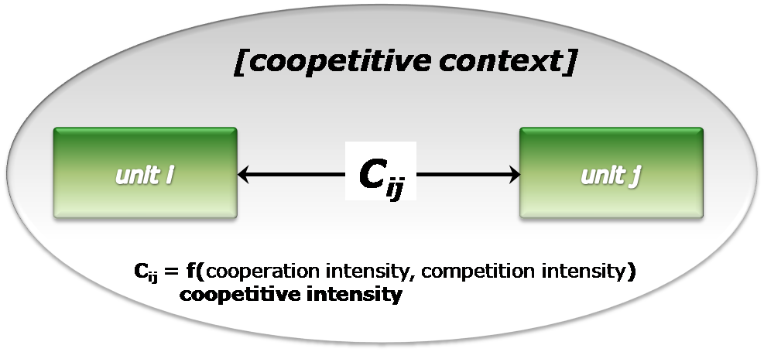
Fig. 1: Inter-unit coopetitive relationship and coopetitive context

Such relationships can be competitive and collaborative at the same time (Tsai and Ghoshal 1998; Tsai 2001; Tsai 2002). More precisely, there exist three types of coopetitive relationships: (1) cooperation-dominated relationship: consisting of more cooperation than competition; (2) equal relationship: cooperation and competition are equally distributed; and (3) competition-dominated relationship: consisting of more competition than cooperation (Bengtsson and Kock 2000). To uncover intra-organizational coopetition, we draw on a network-oriented perspective. Within this view, we study relationships between organizational entities. More precisely, we measure intra-organizational coopetition by a new approach of social network analysis. Herein, we understand the intra-organizational context, discussed above, as a social network, which consists of certain entities and their interrelations. Social network theory therefore tries to find patterns of behaviour within complex networks in order to explain the behaviour of the entities contained in it (Foster and Seidman 1989). From our viewpoint, these behaviours can be influenced by intra-organizational competition and intra-organizational cooperation. Intra-organizational competition can be expressed in extend of overlap in products or services offered by certain intra-organizational entities. With this, intra-organizational competition may be defined as a rate of ``parallel or overlapping activities inside the boundaries of the firm" (Birkinshaw 2001, p.22). Therefore, competition can for instance arise between two or more business units, which offer the same product. Furthermore, it can arise e.g., between two or more different technologies or between strategic business units. Hence, intra-organizational competition is characterized by customer-, competitive-, and success-orientation and frequently applied by profit and/or value centre organizations (Wunderer 2006). As the market paradigm postulates, markets are founded, in a large part, on competition. The corresponding concept of ‘bringing the market inside’ in order to foster corporate entrepreneurship pursues an increase of efficiency and motivation for employees to greater effort (Hamel 1999; Birkinshaw 2001; Malone 2004). Halal even states that (internal) markets are the new foundation of management. In this manner, markets are able to provide the necessary freedom and encouragement to support intrapreneurial employees in implementing their ideas (Halal 1996).
Intra-organizational cooperation, for instance can be manifested in knowledge sharing between the entities of an organization. In order to create new value, the different parties in an organization cannot act in isolation – ideas come from people – to turn them into successful innovations people have to interact with each other (Brandt 1987). Following (Halal 1996), we understand `corporate communities' as systems with primarily cooperative relationships within organizations.
Consequently, this research aims at studying the linkage of internal competition with internal cooperation, that is how to “connect economical efficiency with social efficiency” (Wunderer 2006, p.71). Thus, we comprehend intra-organizational coopetition as compromise between internal market and corporate community (cf. the concepts of Halal 1996; Wunderer 2006). In our understanding, each of these arrangements includes a component of the other in order to function - like the idea of Yin and Yang, as illustrated in Fig. 2.
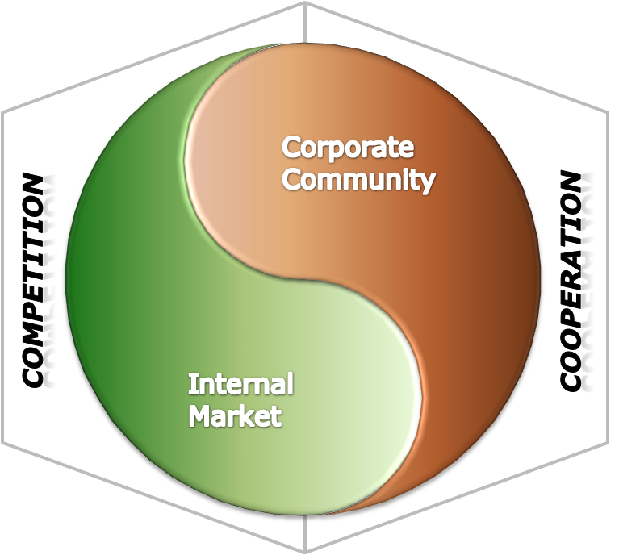
Fig. 2: Coopetition as a balance between cooperation and competition
within internal (corporate) communities and internal markets

An example for intra-organizational coopetition is GE. The company has four R&D labs, whereas - on the one hand - the labs have to learn from each other in order to gain benefits from new knowledge, on the other hand they have to compete with each other for internal critical resources (Luo 2005). This means, GE’s structure can be characterized as coopetitive and therefore as joint occurrence of internal market (resource-based view) and corporate community (knowledge-based view).

Linkage of coopetition and Corporate Entrepreneurship
Coopetition is investigated in an intra-organizational context, particularly within modular, established organizations. The central objective of this research is to contribute to the understanding of whether internal coopetition is able to support or even encourage internal entrepreneurial behaviour within established organizations. Accordingly, the research attempts to study the relationship between different entities (e.g. customer focused business units) within organizations.
Economic behavioural theory is founded on the assumption that economic actors are prone to opportunistic and self-interest seeking behaviours (Williamson 1975). This tenor corresponds to the principal paradigm in game theory. Game theorists put course to the assumption that every individual aims at maximizing her or his own profit. Therefore, a player will select from a set of alternatives the individual strategy, which will satisfy most comprehensively his own goals (Jost 2001). Thereby, it is unimportant, which goals the player pursues. Consequently, this redounds to the question: Should particular entities (e.g., business units) choose a competitive and/or collaborative strategy, in order to maximize their individual profit?
In parallel, collaborations even within an organization are primary driven by self-interest. In an economic understanding, each partner is searching for his individual profit within the collaborative behaviour. Therefore, this research follows the principal paradigm of game theory and studies how it can contribute to investigate the challenges as discussed in the foregoing. For example, the Prisoners Dilemma or `Two-Person Dilemma' (Rasmusen 2006) - a well-known game theoretical model - can be consulted to explain competitive and/or cooperative strategies in the behaviour of the players. Interestingly, theoretical game theory teaches that players are likely to pursue cooperative strategies, even within the competitive situation of the Prisoners Dilemma.
In this research, we follow Rosenstiel (2003) and his argumentation that human behaviour is principally influenced by individual (personal competence and motivation) and situational (environmental facilitation) factors. Also other scholars like (Porter and Lawler III 1968; Greenberger and Sexton 1988; Sathe 1989; Echols and Neck 1998) have considered a similar dyad for structuring antecedents of internal entrepreneurial behaviour. Accordingly, management scholars repeatedly argue that entrepreneurial behaviour of individuals and structure of organization influencing corporate entrepreneurial success interactively. Hence, we consider the dyad as well, categorizing two individual factors: motivation for entrepreneurial behaviour (e.g. enhanced self-image, financial rewards, etc.), capabilities of the employees to behave entrepreneurial (e.g. skills for innovative problem solving or soft skills like affinity to cooperate with others) and two situational and organizational factors respectively: the permission to behave entrepreneurially (i.e. granted by top management support) and the expectation to behave entrepreneurially (i.e. anchored in the corporate culture i.e. the organizational climate)
For the interrelations of those factors, see Figure 2:

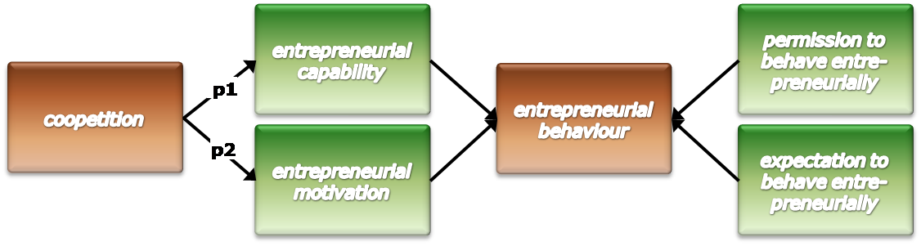
Fig. 2: Impact of coopetition on internal entrepreneurial behaviour

However, in this paper, we focus on the individual factors that impact on entrepreneurial behaviour. Entrepreneurial behaviour can be understood as result of the interaction between the individual, the organization, and the external environment (Sathe 1985). Many researchers share the opinion that corporate entrepreneurs have to have very similar characteristics as independent entrepreneurs. They are driven by initiative, flexibility, creativity, a strong desire for independence, and the willingness to take risks. Even though, the complex motivational and organizational forces affecting entrepreneurs' actions and behaviours need additional research attention (Kanter 1985; MacMillan, Block et al. 1986).
In the ideal way, the corporate entrepreneur acts “… within the corporate environment, as if he or she were an independent entrepreneur” (Knight 1997, p.285). Therefore, a corporate entrepreneur is motivated by very similar motives like independent entrepreneurs. The merit of an entrepreneur is not only to have good ideas but bringing them as profitable products to the market. Such individuals are driven by, joy in social power, joy in creating something new, and joy in success and victory over others (Schumpeter 1912, p.133, 138, 141). In this understanding, a corporate entrepreneur implements successful products from the beginning and (sometimes) against the existing corporate strategy. Therefore, corporate entrepreneurs are the “dreamers who do” or “those who take hands on responsibility for creating innovation” (Pinchot 1985, p.ix). In this context, intra-organizational competition could, managed in an appropriate way, increase the efficiency, create flexibility, challenge the status quo, and encourage employees to greater effort and foster them to act like entrepreneurs on the intra-organizational market (Birkinshaw 2001; Birkinshaw and Lingblad 2005; Hayton 2005; Luo 2005).
Therefore, we propose:
P1: A coopetitive environment increases employee’s motivation to behave entrepreneurially.
Cooperation within the organization is based on solidarity, social interaction, or emotional exchange. Relations herein are arranged for a long-term time horizon and can be characterized by stronger connections between internal groups or individuals as relationships are established (Wunderer 1999; Wunderer 2006). Luo (2005) posits the areas technological, operational, organizational, and financial, as content of cooperation for subunits of multinational enterprises. In this connection, Tsai (Tsai 2002, p.180) studied knowledge sharing activities between competitors and stated:
“the cooperative aspect of such knowledge sharing refers to the collective use of such knowledge to pursue common interests. The competitive aspect refers to the use of shared knowledge to make private gains in an attempt to outperform the partners (Khanna et al. 1998).”
This concept corresponds to the concept of Surowiecki (2004) - who states that ‘crowds’ can make much wiser decisions than so called ‘experts’. These findings are in line with several other studies, which found that collaboration realized by knowledge sharing improves people’s capabilities, and with it, the entrepreneurial output of the specific units (Gupta and Govindarajan 1986; Tsai 2001; Tsai 2002; Drejer, Christensen et al. 2004; Luo 2005). Corresponding to this, Hisrich (1985/1986), for instance, discovered information sharing activities that positively influence the potential for employees to become idea developers. Hence, we propose:
P2: A coopetitive environment increases employee’s capabilities to behave entrepreneurially.
Along with these propositions, we intend to consider the situation or scope, in which an intra-organizational interaction takes place. In theory, scope stands for the fact that games can change completely in different situations or through changes of the players, the added values, the rules, and/or the change of tactics. The scope, we consider is manifested in the content (the resource) entities compete or cooperate for and of the situation (e.g. project phase) they are within.

Empirical Approach
To assess the interrelations between coopetition and internal entrepreneurial behaviour, we have operationalized the variables used. Therefore, additional to the definition of the variables there is need to define the operational definition of the variables (Sproull 1995). This definition specifies how the variables are measured in a detailed manner: Coopetition here is measured by a new approach of social network analysis. The intra-organizational context, discussed above, is understood as a social network, which consists of certain entities and their interrelations. In general, every organization is a social network and therefore needs to be investigated in this manner (Nohria and Eccles 1992). Social network theory provides approaches around two principles. First, it is an explicitly relational and structural approach. Second, it is able to explain individual behaviour (Foster and Seidman 1989) - in case of this work entrepreneurial behaviour. Social network theory therefore tries to find patterns of behaviour within complex networks in order to explain the behaviour of the entities contained in it. Hence, it concentrates on the relationships and interactions in a predefined social network.
The interactions investigated within this research concept take place between equal sub-units of the same organization, so the entire organization builds the social network to investigate. Following the social network approach, we differentiate between micro and macro level analysis and define egocentric networks in the form of ego and alteri. Ego herein is the particular respondent, alteri are the others about whom the respondent is asked (micro level). By composition of all the egocentric networks, we are able to evaluate the complete social network (Jansen 2006). To measure the C_{ij} (cf. Fig. 1) between entities i and j, we rely on a new approach. In traditional social network analysis, social networks are built upon relationships between individual respondents. For instance respondent A is asked about his conceivable one-way relationship q to person B (δ(A,B)), person C (δ(A,C)), and person D (δ(A,D)). Afterwards, B is asked about the one-way relationships to A, C, and D. The process continues in the same way. In the case of these four persons, one will get 12 (4*(4-1)) unilateral statements about the mutual relationships between the four persons. From this, the social network – which consists of mutual bilateral relationships, is built. For instance the bilateral relationship Δ between A and B could be calculated from Δ(A,B)=(δ(A,B)+ δ(B,A))/2.
As the unit of analysis in this research is not single employees, we need to uncover the relationship between certain entities within the social network. The idea is to ask the individuals not about other individuals within the social network, than about the one-way relationship to other entities within the network. As illustrated in Fig. 3, unit i consists, amongst others, of respondent A and respondent B. Unit j consists, amongst others, of respondent C and respondent D. Here, we ask respondent A about his conceivable mutual relationship δ(A,j) to the people of entity j, and so on. The calculation of the one-way relationship δ(i,j), then is calculated as average value, that is δ(i,j)=(δ(A,j)+δ(B,j))/2. The mutual bilateral relationship between unit i and unit j then follows by Δ(i,j)=(δ(i,j)+δ(j,i))/2=C_{ij}.

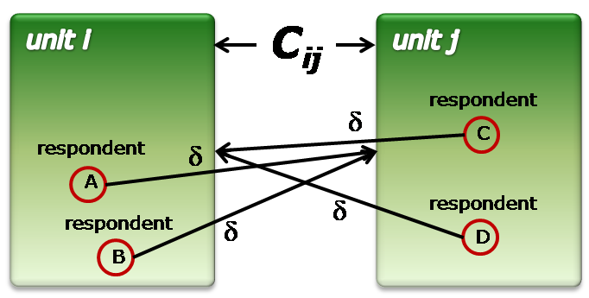
Fig. 3: Approach to measure the relationship between two entities

In a pilot study, we evaluated whether this social network approach could serve as a data source for the research. Here, at minimum five (to nine) persons of each entity were interviewed about their relationship to four entities. To facilitate the operationalization of coopetition, the pilot study is twofold with two independent 5-item scales. The first scale targets on the competitive intensity (e.g. actually perceived competition, current market overlap, or resource competition) and the second one targets on the cooperative intensity (satisfying relationship, informal and formal communication, or knowledge sharing) of the particular interconnection among the entities. The coopetitive interaction between i and j was then interpreted as function of the competition intensity ‘cpi’ and cooperation intensity ‘coi’, or C_{ij}(cpi ,coi) as illustrated in Fig. 1. As a result we are able to build and illustrate (by multidimensional scaling) the coopetitive network that mirrors the actual relationships of the organization.

Outlook
The next step in this research is the application of the pilot study in suitable real organizations. That is, we target on organizations that have modular organizational structure, where we are able to find clearly defined subunits to investigate their interrelations. Accompanied by that, we will work toward refinement of the hypotheses, especially concerning the connection between the mechanisms of coopetition and the situational context. This will result in an extension of research model.
The next step will be to concretize the dependent variable ‘internal entrepreneurial behaviour’ and the deduction of concrete recommendations for business practice. That is, how to implement an entrepreneurial culture, which fosters and supports entrepreneurial thinking and acting and is suitable to entrepreneurial employees. The latter takes into account that big bureaucratic companies are observing a loss of the brightest people, who are leaving corporations to become small business entrepreneurs, today (Kuratko, Hornsby et al. 1993; Merrifield 1993; Hamel 1999). Therefore, we target on organizational environments that combine the self-responsibility and autonomy that corporate entrepreneurs need to develop their ideas with the precept to support - actively and efficiently - the enterprise strategy through problem-solving, social competence, and result-orientated thinking and acting.
We believe that established organizations can utilize the mechanisms of coopetition, on the on hand in order to motivate for (internal) entrepreneurial behaviour and on the other hand to make entrepreneurial behaviour more successful. If the climate of the organization would be suitable in terms of permitting entrepreneurial behaviour or even expecting it – corporate entrepreneurship will be successful (cf. Draeger 2004; Hisrich, Peters et al. 2005).

References
Achrol, R. S. and P. Kotler, 1999. "Marketing in the Network Economy." Journal of Marketing 63(4): 146.
Antoncic, B., 2001. "Organizational Processes In Intrapreneurship: A Conceptual Integration." Journal of Enterprising Culture 9(2): 221.
Antoncic, B. and R. D. Hisrich, 2003. "Privatization, Corporate Entrepreneurship, and Performance: Testing a Normative Model." Journal of Developmental Entrepreneurship 8(3): 197.
Bartlett, C. A. and S. Goshal, 1996. "Release the entrepreneurial hostages from your corporate hierarchy." Strategy & Leadership 24(4): 36.
Bengtsson, M. and S. Kock, 2000. ""Cooperation" in Business Networks--to Cooperate and Compete Simultaneously." Industrial Marketing Management 29(5): 411.
Birkinshaw, J., 2001. "Strategies for Managing Internal Competition." California Management Review 44(1): 21.
Birkinshaw, J. and M. Lingblad, 2005. "Intrafirm Competition and Charter Evolution in the Multibusiness Firm." Organization Science 16(6): 274.
Borders, A. L., W. J. Johnston, et al., 2001. "Beyond the Dyad: Electronic Commerce and Network Perspectives in Industrial Marketing Management." Industrial Marketing Management 30(2): 199.
Brandenburger, A. M. and B. J. Nalebuff, 1996. Co-opetition : 1. a revolutionary mindset that combines competition and cooperation 2. the game theory strategy that's changing the game of business. New York etc., Currency Doubleday.
Brandt, S. C., 1987. Entrepreneuring in Established Companies: Managing toward the year 2000, New Amer Library.
Burgelman, R. A., 1983. "A Process Model of Internal Corporate Venturing in the Diversified Major Firm." Administrative Science Quarterly 28(2): 223.
Burgelman, R. A. and L. R. Sayles, 1985. Inside Corporate Innovation: Strategy, Structure and Managerial Skills, Macmillan USA.
Chaney, P. K., T. M. Devinney, et al., 1991. "The Impact of New Product Introductions on the Market Value of Firms." Journal of Business 64(4): 573.
Chung, L. H. and P. T. Gibbons, 1997. "Corporate Entrepreneurship: The Roles of Ideology and Social Capital." Group & Organization Management 22(1): 10.
Covin, J. G. and D. P. Slevin, 1988. "The Influence Of Organization Structure On The Utility Of An Entrepreneurial Top Management Style." Journal of Management Studies 25(3): 217.
Damanpour, F. and M. Schneider, 2006. "Phases of the Adoption of Innovation in Organizations: Effects of Environment, Organization and Top Managers." British Journal of Management 17(3): 215.
Dess, G. G., G. T. Lumpkin, et al., 2005. "The Role of Entrepreneurial Orientation in Stimulating Effective Corporate Entrepreneurship." Academy of Management Executive 19(1): 147.
Dess, G. G. and A. M. A. Rasheed, 1991. "Conceptualizing and Measuring Organizational Environments: A Critique and Suggestions." Journal of Management 17(4): 701.
Draeger, A., 2004. Vitalisierendes Intrapreneurship: Gestaltungskonzept und Fallstudie. Mering, ErnstR. Hampp Verlag.
Drejer, A., K. S. Christensen, et al., 2004. "Understanding intrapreneurship by means of state-of-the-art knowledge management and organisational learning theory." International Journal of Management & Enterprise Development 1(2): 1.
Echols, A. E. and C. P. Neck, 1998. "The impact of behaviors and structure on corporate entrepreneurial success." Journal of Managerial Psychology 13(1/2): 38.
Foster, B. L. and S. B. Seidman, 1989. A Formal Unification of Anthropological Kinship and Social Network Methods. Research methods in social network analysis. L. C. Freeman, D. R. White and A. K. Romney. Fairfax, Va.; Lanham, MD, George Mason University Press; Distributed by arrangement with University Publishing Associates: vii, 530 p.
Greenberger, D. B. and D. L. Sexton, 1988. "An Interactive Model Of New Venture Initiation." Journal of Small Business Management 26(3): 1.
Gupta, A. K. and V. Govindarajan, 1986. "Resource Sharing Among Sbus: Strategic Antecedents And Administrative Implications." Academy of Management Journal 29(4): 695.
Halal, W. E., 1994. "From hierarchy to enterprise: Internal markets are the new foundation of management." Academy of Management Executive 8(4): 69.
Halal, W. E., 1996. The new management : democracy and enterprise are transforming organizations. San Francisco, Berrett-Koehler Publishers.
Hamel, G., 1999. "Bringing Silicon Valley Inside." Harvard Business Review 77(5): 70.
Hamel, G., Y. L. Doz, et al., 1989. "Collaborate with Your Competitors -- and Win." Harvard Business Review 67(1): 133.
Hayton, J. C., 2005. "Competing in the new economy: the effect of intellectual capital on corporate entrepreneurship in high-technology new ventures." R & D Management 35(2): 137.
Hisrich, R. D., 1985/1986. "The Inventor: A Potential Source for New Products." The Mid Atlantic Journal of Business 24 (Winter 1985/86): 67-80.
Hisrich, R. D., M. P. Peters, et al., 2005. Entrepreneurship. Boston, McGraw-Hill/Irwin.
Hornsby, J. S., D. W. Naffziger, et al., 1993. "An Interactive Model of the Corporate Entrepreneurship Process." Entrepreneurship: Theory & Practice 17(2): 29.
Jansen, D., 2006. Einführung in die Netzwerkanalyse : Grundlagen, Methoden, Forschungsbeispiele. Wiesbaden, VS Verlag für Sozialwissenschaften.
Kanter, R., 1985. "Supporting Innovation and Venture Development in Established Companies." Journal of Business Venturing 1(1): 47.
Knight, G. A., 1997. "Cross-cultural reliability and validity of a scale to measure firm entrepreneurial orientation." Journal of Business Venturing 12(3): 213.
Kreiser, P. M., L. D. Marino, et al., 2002. "Assessing the Psychometric Properties of the Entrepreneurial Orientation Scale: A Multi-Country Analysis." Entrepreneurship: Theory & Practice 26(4): 71.
Kuratko, D. F., J. S. Hornsby, et al., 1993. "Implement Entrepreneurial thinking in Established Organizations." SAM Advanced Management Journal (07497075) 58(1): 28.
Kuratko, D. F., R. D. Ireland, et al., 2001. "Improving firm performance through entrepreneurial actions: Acordia's corporate entrepreneurship strategy." Academy of Management Executive 15(4): 60.
Lengnick-Hall, C. A., 1992. "Innovation and Competitive Advantage: What We Know and What We Need to Learn." Journal of Management 18(2): 399.
Lumpkin, G. T. and G. G. Dess, 1996. "Clarifying The Entrepreneurial Orientation Construct And Linking It To Performance." Academy of Management Review 21(1): 135.
Luo, X., R. J. Slotegraaf, et al., 2006. "Cross-Functional "Coopetition": The Simultaneous Role of Cooperation and Competition Within Firms." Journal of Marketing 70(2): 67.
Luo, Y., 2004. Coopetition in international business. Denmark ; Herndon, Va., Copenhagen Business School Press.
Luo, Y., 2005. "Toward coopetition within a multinational enterprise: a perspective from foreign subsidiaries." Journal of World Business 40(1): 71.
MacMillan, I. C., Z. Block, et al., 1986. "Corporate Venturing: Alternatives, Obstacles Encountered, and Experience Effects." Journal of Business Venturing 1(2): 177.
Malone, T. W., 2004. The future of work : how the new order of business will shape your organzation, your management style, and your life. Boston, Harvard Business School Press.
Merrifield, D. B., 1993. "Intrapreneurial Corporate Renewal." Journal of Business Venturing 8(5): 383.
Morris, M. H. and D. F. Kuratko, 2002. Corporate Entrepreneurship. Orlando, Florida, Harcourt College Publishers.
Morse, C. W., 1986. "The Delusion of Intrapreneurship." Long Range Planning 19(6): 92.
Nohria, N. and R. G. Eccles, 1992. Networks and organizations : structure, form, and action. Boston, Mass., Harvard Business School Press.
Pegels, C. C. and I. I. S. Yong, 1997. "Identification Of Strategic Groups Based On Market Competition And Cooperation: A Network-Analytic Approach." Academy of Management Proceedings: 40.
Pinchot, G., 1985. Intrapreneuring : why you don't have to leave the corporation to become an entrepreneur. New York, Harper & Row.
Porter, L. W. and E. E. Lawler III, 1968. "What job attitudes tell about motivation." Harvard Business Review 46(1): 118.
Rasmusen, E., 2006. Games and information : an introduction to game theory. Oxford, Blackwell.
Rosenstiel, L. v., 2003. Führung von Mitarbeitern : Handbuch für erfolgreiches Personalmanagement. Stuttgart, Schäfer-Poeschel Verl.
Russell, R. D., 1999. "Developing a Process Model of Intrapreneurial Systems: A Cognitive Mapping Approach." Entrepreneurship: Theory & Practice 23(3): 65.
Sathe, V., 1985. Managing an Entrepreneurial Dilemma: Nurturing Entrepreneurship and Control in large Corporations. Frontiers of Entrepreneurship Research. B. College. Wellesley: 636-656.
Sathe, V., 1989. "Fostering Entrepreneurship in The Large, Diversified Firm." Organizational Dynamics 18(1): 20.
Schumpeter, J. A., 1912. Theorie der wirtschaftlichen Entwicklung. Leipzig, Duncker & Humblot.
Sproull, N. L., 1995. Handbook of research methods : a guide for practitioners and students in the social sciences. Metuchen, N.J., Scarecrow Press.
Stevenson, H. H. and J. C. Jarillo, 1990. "A Paradigm Of Entrepreneurship: Entrepreneurial Management." Strategic Management Journal 11(4): 17.
Surowiecki, J., 2004. The wisdom of crowds: why the many are smarter than the few and how collective wisdom shapes business, economies, societies and nations. London, Little/Brown.
Tsai, W., 2001. "Knowledge Transfer In Intraorganizational Networks: Effects Of Network Position And Absorptive Capacity On Business Unit Innovation And Performance." Academy of Management Journal 44(5): 996.
Tsai, W., 2002. "Social Structure of "Coopetition" Within a Multiunit Organization: Coordination, Competition, and Intraorganizational Knowledge Sharing." Organization Science 13(2): 179.
Tsai, W. and S. Ghoshal, 1998. "Social Capital And Value Creation: The Role Of Intrafirm Networks." Academy of Management Journal 41(4): 464.
Wunderer, R., 1999. Mitarbeiter als Mitunternehmer : Grundlagen, Förderinstrumente, Praxisbeispiele. Neuwied, Luchterhand.
Wunderer, R., 2006. Führung und Zusammenarbeit : eine unternehmerische Führungslehre. München, Luchterhand.
Zahra, S. A., D. F. Jennings, et al., 1999. "The Antecedents and Consequences of Firm-Level Entrepreneurship: The State of the Field." Entrepreneurship: Theory & Practice 24(2): 45.
Zannetos, Z. S., 1965. "ON THE THEORY OF DIVISIONAL STRUCTURES: SOME ASPECTS OF CENTRALIZATION AND DECENTRALIZATION OF CONTROL AND DECISION MAKING." Management Science 12(4): B-49-B-68.

