Social, Economic and Business Networks: the Key Economic Strata
A study of very small businesses and their computing experiences

Dr Jo Stanley Director, Technology, Law and Economics Unit
Anglia Ruskin University
East Rd
Cambridge CB1

Tel: 01487 822303 Email: js731@cam.ac.uk

Naomi Jeffrey, University of Manchester, Associate Researcher at the Technology, Law and Economics Unit, Anglia Ruskin University.

Cass Flowers, Technical and Operations Support Officer, Brabraham Research Station, University of Cambridge, and Associate Researcher at the Technology, Law and Economics Unit, Anglia Ruskin University.

The secular development of transit and communications has made the organisation of distributing businesses upon large and economical lines inevitable. The History of Mr Polly HG Wells [1910]
Introduction
This quotation might suggest that little has changed in the realm of small businesses in a hundred years. True, the figures for the demise of small start-ups are bleak. About 50% of them fail during their first three years. The Sunday Times Business Supplement gives an estimate for closures of start-ups in 2005 as 388,000 [23.07.2006].
However, the kind of businesses starting has changed 100 years on. Two thirds of the recent increase in mainstream starts is accounted for by 2 sectors: Business and Professional, and Leisure and Personal. In addition, the last decade has seen the advent of digital means for global exposure and even global marketing for SBs. This project looks at the emergent problems of running a very small business (a VSB) in a digital world.
1. Organisation of the Project
Small businesses are multitudinous, and the subset of micro businesses (0 – 9 employees) account for 34% of all employment in Europe. For the purposes of this study we take the size of the business as measured in computers (workstations) rather than in employees. We chose to define VSBs as those businesses using up to 10 (in certain cases 20) computers.
The reasons for this metric are as follows. As a firm builds up its numbers of workstations, new configurations and choices of computer work patterns emerge: peer-to-peer, client/server, collaborative working web-sites and so on, but these systems need installing, maintaining, managing and, in most cases licensing, thus with increase in workstation requirements, complexity may increase steeply, as may costs.
A substantial part of the time available for the pilot study described here was spent in selecting the most appropriate method to gather and analyse data from the VSBs. We conducted an initial telephone survey of companies. This informed the questionnaire we devised. We then administered the questionnaire by electronic link and visits to businesses. (We have analysed these results by standard statistical methods, which we describe below).
At this point it became clear that the most successful approach to the task was where the Principal Investigator administered the questionnaires in person, since that provided an introduction to the companies, which in turn enabled the selection and invitation of proprietors to participate in in-depth interviews.
We settled on the Grounded Theory method (GT) of generating our concepts and theories from our data. The reasons for this choice are explained fully in section 4.1 below.
2. Initial and Modified Goals of the Project
Our initial research focus was to estimate the potential value of a universal community digital business ecosystem (a DBE), with accompanying tools, to support a whole local community of small businesses within a geographical region. What would be offered would reflect the elements of the DTI Digital Adoption Ladder.
However, we were concerned that encouraging VSBs to adopt free, community-developed software, based on the Linux operating system and Open Source applications, might lead them along a primrose path away from the dominant proprietary software, and that could result in more problems than it solved, most importantly in lack of compatibility with the digital platform used by their customers and suppliers.
3. The EC Digital Business Ecosystem (DBE) Model
This section describes the EC-funded DBE project’s aspirations and goals, and indicates the amount of progress made in that project up to the present. A full account is available in the book on the EC DBE project, available on the DBE web-site.
3.1 Aims of the DBE
The DBE project was developed under EC funding with the SMEs in mind. Its goals were to counter digital complexity, harmonise and advance digital availability to local SMEs and ultimately offer a thick digital platform together with a robust toolset and the potential for cheaper technical support, so as to provide SMEs with more facilities at less cost and to eliminate the potential powder keg of legal issues arising from the licensing of proprietary software.
The European Commission and Council emphasise the requirement to use Open Source and Open Standards in both business models and technical solutions.

3.2 The Commission’s Perception of e-Evolution
The Commission has identified a set of obstacles to full Internet utilisation by SMEs. These include:
- Lack of technical knowledge and expertise
- Lack of technological solutions and interoperability
- The costs of setting up the e-business architecture, deflecting capital from the firm’s core business.
The Commission is very clear as to its requirement for these items:
- Open source basic infrastructure with …
- Standard protocols enabling interoperability and ‘seamless communication’.
The Commission’s Basic Principles for the infrastructure include:
- Independence from a specific provider
- Open data formats and protocols, and code accessibility
- An infrastructure that satisfies a specific licensing model
- Usability and maintenance not depending on the goodwill of suppliers (notably if the supplier is a monopoly). The need to replace services as more adequate ones appear (ie not be locked in).
We took to heart the advice of the leader of the DBE project, Francesco Nachira who said this:
[there is a] need to approach the very small firms in quite a different way to those verging of middle size.
Thus we chose the grounded theory method to explore the behaviour of the little companies in a digital world, rather than simply attempting to quantify their success or failure as measured against the rungs of the digital adoption ladder and categorising them accordingly.
4. The Investigation
We present here the emergent concepts that our work up to the present has suggested. At each iteration of GT across the remainder of our sample, our analysis will be informed by the emergent concepts up to this point.
4.1. The History of Grounded Theory
In studying GT we immediately encountered the problem of the forking of the method, leading to the current co-existence of 3-4 flavours: Glaser and Strauss’ seminal GT method, [1967], Glaser’s current version of GT, Strauss and Corbin’s version, and Charmaz’ constructivist approach (which seems to owe a great deal to Glaser in spirit). We therefore had no choice but to investigate the thinking behind the flavours of the bifurcated method before embarking on the work.
Grounded theory was developed by Barney Glaser, a quantitative analysis-trained researcher and the social scientist Anselm Strauss, his mentor and employer.
Their collaboration began in the 1950s with a study of hospital staff caring for their dying patients. Their method was initially known as the constant comparative method, and later as grounded theory. The publication of Glaser’s [1978] offers a tutorial emphasizing the key elements of the Glaser version.
In January 1991, prompted by the publication of Strauss and Corbin’s new text in [1988], Glaser wrote this to Strauss:
You wrote a whole different method, so why call it ‘grounded theory’? It indicates that you never grasped what we did, nor studied it to try and carefully extend it. … its success is theoretically fundamental, while your work is fractured and scattered.
Strauss declined to adjust his position on GT. That particular falling-out stimulated Glaser’s response in Basics of Grounded Theory Analysis in [1992].
Glaser’s chief objections to the derivatives of stem GT are these: the application of grounded theory to quantitative data is sidelined, which Glaser believes takes away some of its generality and power. Glaser’s position is that the over-elaboration of the original method arrives at quick and trivial outputs. That he sees as subverting the essence of the method. Glaser sees the ‘analytical strategies’ offered by Strauss as a regression his qualitative roots, where the expected outputs of the research are descriptive – what Glaser refers to as having a ‘worrisome concern with descriptive accuracy’.
These frustrations are clearly stated in Glaser’s Basics of Grounded Theory Analysis [1992], in which, chapter by chapter he tracks the Strauss and Corbin’s rendering of the method, contesting what he sees as travesties of the ‘simple basic principles’ expressed in the 1967 version. Strauss riposted that Glaser’s own texts were difficult and inaccessible. The question is: did Strauss really cause the method to be overly rule-based, or simply render it accessible?
Our reading of the situation is this: Glaser has never hidden from the student of GT the fact that those investigators who cannot conceptualise and abstract have no business using grounded theory, but neither, we feel, has he fully apprised us of the degree to which he holds investigator skill critical to the success of the method. In sum, we believe that the GT method demands a great deal of the investigator, both- insight into the meaning of incident and the keen ability to conceptualise that incident.
4.2. The Sample
Our sample was taken across business sectors, the only criterion being the size of the business in workstations, and even here, mandated by GT, we took some interviews with firms using around twenty or more computers for purposes of comparison. We used these social-cum-business groupings in the EEDA area:
- A preliminary telephone survey of interviewees taken from the Peterborough and Huntingdon area Phone Book A-Z Business Listings (not by sector); this listing served to randomise the sample.
- Questionnaires administered to the Huntingdonshire Business Network (HBN), a small, (100-member), highly socialised and tightly cohesive network of small companies with a scattering of corporate, based in a fast expanding area of East Anglia. The Principal Investigator has been a member of the network for a year. (Method of sampling: anonymised electronic questionnaire, following an introductory article in the HBN Newsletter).
- Huntingdon High Street, (Method of sampling: visit from the Principal Investigator with questionnaire to the firms). These questionnaires served as introduction to the firms, and led to invitations to in-depth interviews.
- Questionnaires administered to the Cambridgeshire Chamber of Commerce membership. This network is far larger and more distributed than the HBN. (Method of sampling: Electronic questionnaire, following an article in the Chamber’s on-line news). Unfortunately an email connection went down within the Anglia Ruskin system, and data was lost.
- Questionnaires administered by the Investigator to the local business community of the CB1 Postal District in east/central City of Cambridge. This is by far the larger part of our study, stretching from central Cambridge to the suburban (rural flavour) Cherry Hinton and the old railway settlements of Coleridge and Romsey town. The study in CB1 is one fifth complete.
The district was divided into five zones:
- The area bounded by Mill Rd to the south, East Rd to the west and Newmarket Rd to the North, stretching to the railway line in the east. This has been sampled and the results are discussed here.
- The block south of Jesus Lane and Maid’s Causeway and north-east of the city centre streets: St Andrews St and Regent St.
- A commercial area north-east of Hills Rd, south of Mill Rd, and as far as the railway line to the east.
- A block stretching east of the railway line into Romsey Town, and Coleridge, the old railway workers’ settlements.
- Cherry Hinton, a chiefly residential area, with pockets of businesses.
- In-depth interviews with invitees from the above sample who agreed to be interviewed. Thus far 8 interviews have taken place. All interviewees readily agreed to digital-recordings being made. The Principal Investigator made notes during the interviews and these were later coded and memo-ed.
5. The Results
5.1 Quantitative Analysis of the Questionnaires
Few results were garnered, most notably the electronic links yielded a poor harvest. What follows is an account of key questions, what we hoped to emerge from the responses, and what actually emerged that could also be analysed statistically to give reliable results. Questions are paraphrased.
Q1 The computing costs of the business related to the number of years the firm has been in business
We had hoped to demonstrate that only when, or especially when the business has been established approximately 4 – 6 years does the license cost of computing become significant.
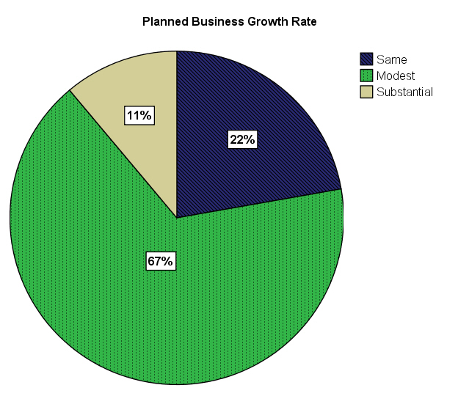
This was impossible to show with the current data results, since only five participants provided a figure for their percentage computing cost, which is what we would want to compare to the business age.

Q 2 The significance of the number of computer users in the firm
The scatter diagram below shows a very strong correlation between the number of computers and the number of computer users in the firm
This supports the idea that use of computers is key in many VSBs.
Points on the line are participants where all employees are regular computer users. There is a non-parametric correlation value of 0.89 between the number of employees and number using computers.
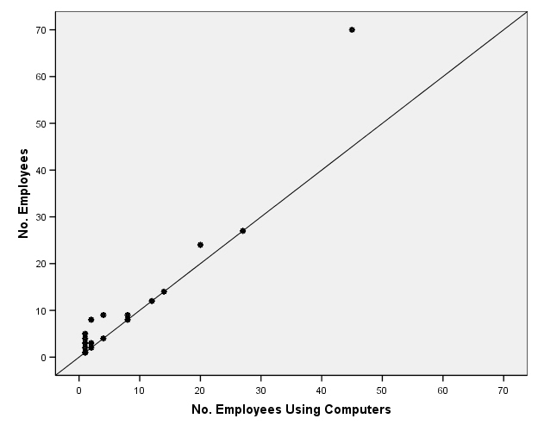
Q3 Training of Employees
The pie charts below show that with school training used, 50% of employers consider no further training is needed. This percentage has decreased from 55% where no school training is used.
On the other hand, if training has been brought in from a previous employer, the current employer is more certain of whether training is needed, yes or no – if no previous employer training is known to be used, 29% are unsure as to whether further training is needed. This suggests that if employers know less about their employee’s previous work experience, they are much less sure of what further training is needed.
Comparing the pies for the different types of previous training being present, there are very similar figures for whether further training is needed – if previous training is in place, 50% of employers believe further training is still needed. Around 10% are unsure, around 40% believe no further training is needed.
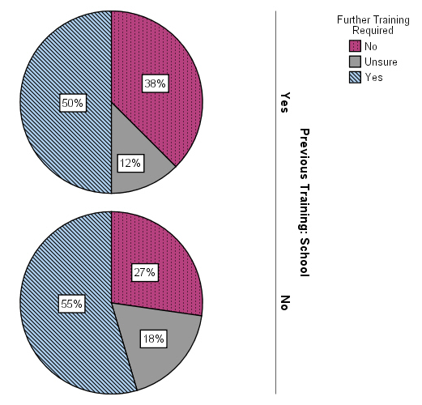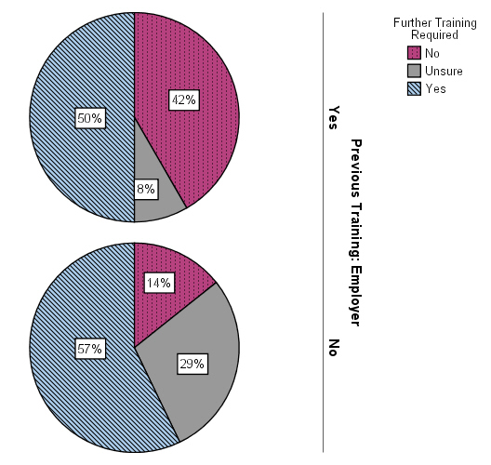

Q4 How often are the various information-worker software items used?
The purpose of the question was to determine the commonest business processes.
The bar charts show Word is used most often, followed by Excel. Powerpoint is used rather less often, as is Access (never daily). If Sage is used, it is with generally high frequency (mostly daily).

Q5 Was a computer network in the business, if so how it was configured?
The bar chart below shows that of those businesses with a network, the vast majority have a server. However, this is 8 out of the 10 who report having a network – very small numbers are not reliable.
Most organisations (11) have no server. Of those who do, six have one server, one has two servers and one has six servers.
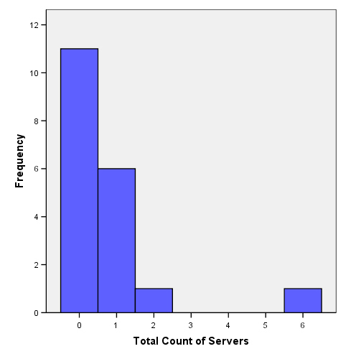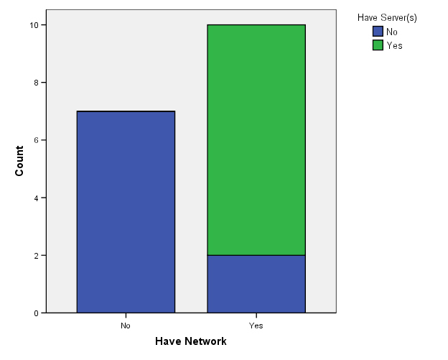
Q6 Addressed problems encountered with hardware, software, wiring and service providers.
The plot below shows that participants tended to report problems with hardware, software, wiring and service providers when the business had a network, and not otherwise. What is shown is the sum of all the responses, where “yes” takes the value 1, “unsure” has the value 0 and “no” takes the value -1. A positive sum indicates more respondents reported “yes” than “no”, and vice versa.
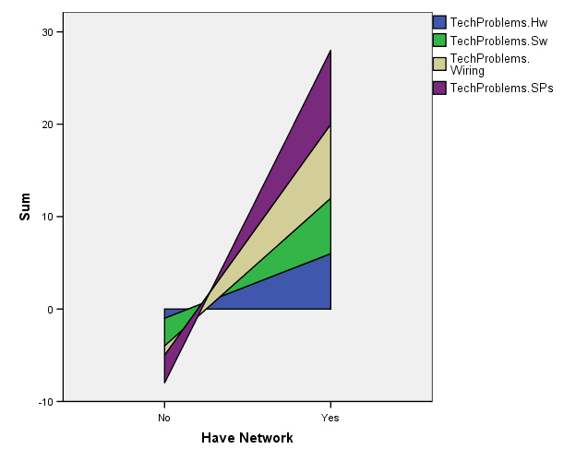
Q7 Knowledge about end user license agreements (EULAs)
This question sought to establish the extent of risk of non-compliance through ignorance: because the license is too hard to read, or because the person responsible for the licenses did not consider it important, had no time, or believed the EULA to be a mere formality. (these are also WHY questions for the in-depth interviews.)
Nearly a third of respondents were not aware of the term EULA, despite it being in common use with both proprietary and open source software.
Of those who reported reading the EULA thoroughly, half did not believe they had understood – those who reported having understood tended to read through casually, suggesting they believe EULAs contain very similar content.
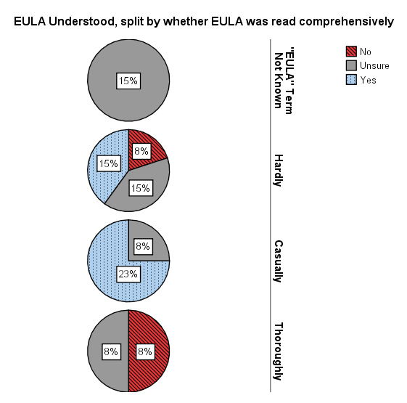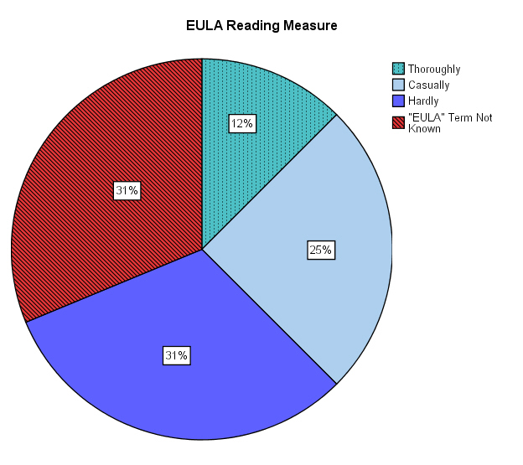

Q 8 How far on are the companies in their adoption of digital levels of sophistication?
Many VSBs are on low rungs of the DTI Adoption Ladder, having essential email use and a website but not any use of e-commerce.
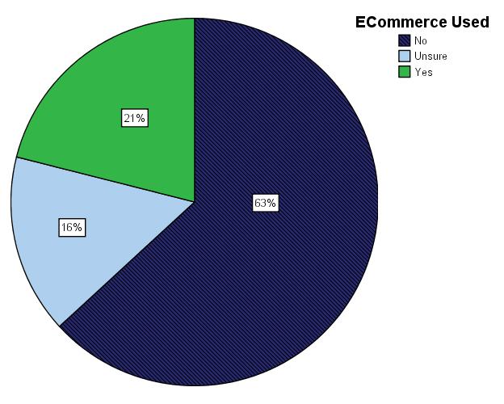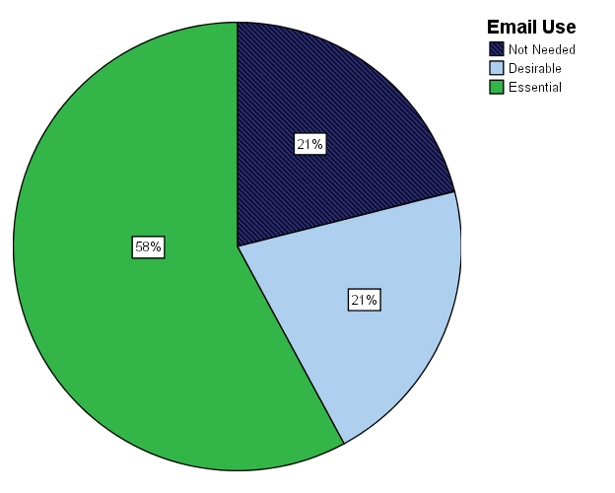
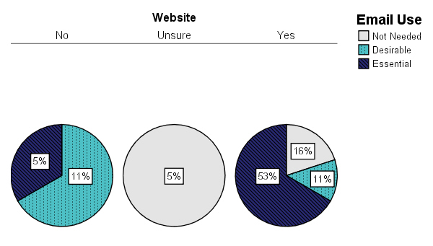
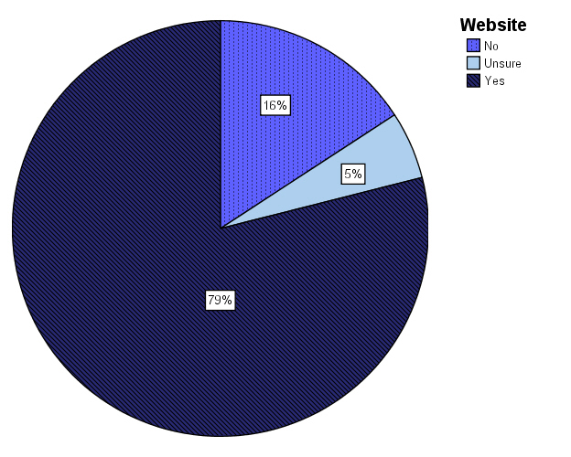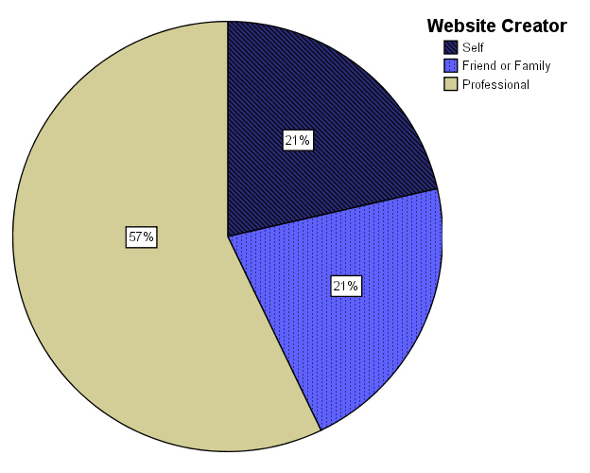
The most common method of contacting suppliers was reported to be by phone, followed closely by email. Customers are most often contacted face to face, relying far less on electronic communication methods. Consultants are again most often contacted by phone.
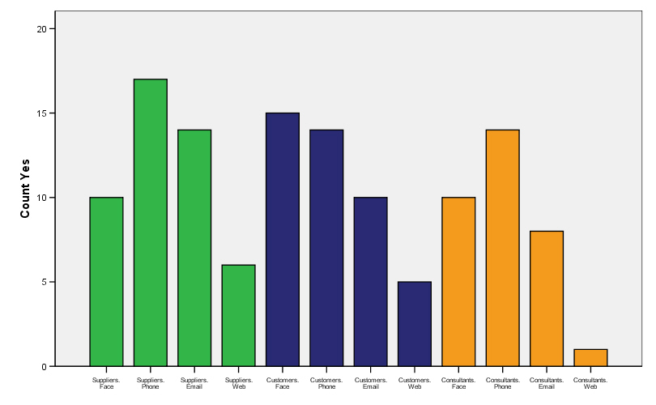

5.2 The Product of GT with Constant Comparative Analysis
5.2.1 Data Collection
As advised by Glaser and Strauss, pre-planned selection of specific groups to interview was no part of the project. Indeed we created a group in respect of our definition of VSBs, by counting workstations as opposed to employees when arriving at the size of the firm.
We lapsed occasionally from sampling VSBs into sampling SBs and chain store branches, for purposes of comparison. To illustrate, we (informally) interviewed a Church-based support group, operating from a church building. The group showed signs of market niche-ing applied to their clientele, certainly used computers, and had a web site. In short, it had some of the properties of a VSB, but we had to consider the ‘corporate’ affiliation with the Church of England as finally ruling it out. For broadly the same reasons we mostly omitted sampling the chain store branches which abound in the local shopping Mall though, interestingly some of these, in general conversation explained their use of utility computing, as did one of small business in the telephone survey, and one VSB in an in-depth interview. That tiny cohort had not one bad word for the service they received. In a further iteration of the GT method we will watch for and chronicle in detail, experiences of utility computing users where these are encountered.
Thus our collection of data was catholic. Since we are cross-sectorial, notions of physical location could be set aside for this study. Retailers were on thoroughfares, and professionals broadly tended to be in the blocks and streets behind the main thoroughfares, which led us to the loose categorisation of ‘High Street’, ‘Back Street’ businesses. But this was no criterion for sampling.
5.2.2 Core-ing out the Main Category
Glaser insists that once the core category has been identified, then further sorting of the material must serve only to clarify relationships to, and properties of, that category.
After open, then theoretical coding had been completed, it became clear that our core category was interoperability in all its guises, human to human, human to machine, machine to machine, and was most often encountered as its invert: lack of interoperability.
We then set about enriching our understanding of the properties of interoperability by reviewing incidents of it that were similar across all the data, to strengthen the category’s status, and those that differed, in order to locate the category’s properties. We noted the conditions under which the variations were manifest.
We have found it fruitful to explore the category interoperability in terms of the participant entities in interoperability relationships: interoperability amongst knowledge domains, media, humans, humans and machines, and machines.
Across these associations lie the cardinalities of relationships: one-to-many, many-to-many, one-to-one.
We have examined reports of updates and compatibility loss, in relation to media changes and program upgrades. We have recorded justifications for program upgrades, and the users’ perceptions of upgrade value for money and the drivers towards and away from upgrading software in businesses.
We have located switch points at which businesses run out of road with their current software applications, and at that point are again prepared to review the offering of applications of similar functionality. This new look may be driven by the cost to upgrade and, with growing experience, the companies seem prepared to look at freeware as well as proprietary software, or consider changing brand allegiance.
We have explored the interstices between programs where there is a failure of interoperability, and observed that companies find roles for human mediators and assistants, and use assistant software to bridge the gap. We have noted that making good the mismatches between human skills and aptitudes and technological service provision is providing a living for some of the VSBs as facilitators. We have seen how readily companies grasp middleware work-around programs, and wondered if these will weather subsequent upgrades in the software systems on either side of the middleware ‘bridge’, and noted that with such solutions the interfaces proliferate.
We have looked (albeit sceptically) for support for the belief that creative powers in people are inversely related to their technological aptitudes, and found a little candidate evidence.
We have seen the effects of incompatibilities of time zones, language, (written and spoken) which change the work habits of firms in the UK collaborating with offshore workers, and the solutions they found for working with global associates.
5.2.3 Findings
5.2.3.1 Interoperability amongst Knowledge Domains
To enable courier services to fill the missing link in the e-commerce order-to-delivery cycle, we found one consultant working on the ‘fault line’ between RFID technology and postal logistics.
There is a need to skill legal professionals in new technologies, (the target subject matter of much IPR and company law). We found an academic hybrid on this fault line, advising the developers of new University courses in ICT Law.
5.2.3.2 The Facilitation of the Man-Machine Interface
We found some evidence of technology aversion amongst authors and other very creative people. The sole proprietor of one VSB assists US artists (authors, photographers and painters) to achieve visibility in the UK. He solves their web site design problems, where the jargon of the design package and technical issues are hurdles the artist does not wish jump in person.
A leading Wine Master and eminent Restaurant and Hotel owner insisted on the ‘computer illiteracy’ of his establishment, and repeatedly deflected the conversation in asking the PI her opinion of house menu changes. He is referring his adoption of e-commerce entirely to an outside consultant, and since he is a member of a local business network, there is a possibility that he consulted their members in finding the consultant.
Three ladies clothes retailers stated that they relied on a relative or partner to supply the technological know how that the business needed, indicating that their role was on the artistic side of the business.
The hairdressers we encountered had no appointments software. This was, however, a general finding for personal services: the optician felt that negotiation was paramount in making appointments and associated electronic appointment systems with inflexibility
The hairdressers interviewed uniformly expressed little interest in computing as a business tool. The silversmith still wrote all his business correspondence by hand. The focus of these groups was the person and tastes of the customer.
A will-writer thoroughly enjoyed interviewing his clients, and steering them through the maze of legal traps by a sequence of counterfactual scenarios. However, he disliked the task of formalising the material using the expert legal software.
5.2.3.3 The Essence of Face-to-face Human Interoperability
Many woman proprietors insisted that human contact was essential in business. For illustration, one ladies clothes retailer recounts that listening to a lonely caller at the shop generated future custom by word-of-mouth. She considers that when she buys, she has customer-specific orders in mind, matching garment to regular customer for a special occasion.
A herbalist and clairvoyant reader, who initially worked from home, subsequently set up a High Street shop to gain more contact with the public. She believes that because a web site is broadcast (one-to-many) and not one-to-one then trust cannot be established. She also laid stress on the personality of the salesperson being 80% responsible for the sale.
She commented that word-of–mouth is unmatched as a marketing tool, stating that she found peers are intensely effective in disseminating commercial information amongst themselves, but that across generations, word-of–mouth can lose its power as the age difference between imparter and listener increases.
This trader advocated a policy of selecting from the electronic toolkit, but was not persuaded that human imagination, flexibility and business personality could be translated into an electronic representation.
5.2.3.4 One Sender Many Receivers
The question of the visibility of a company to its market raises a plethora of interoperability issues. Traditional advertising is, on the whole, considered expensive by VSBs. Email was considered the most important means of contact between the VSBs and their suppliers and customers after the phone. But here issues of cost and legality are met with.
Interviewees pointed to legal blocks by postal and telephone preferences to accessing to potential clients.
Mass email sends were described as ‘flawed’. One interviewee recommended the services of a mail services specialist but pointed out that such services come at a cost. The parsimonious small businesses tended to solve their problems by work-around software solutions.
A web designer accustomed to sending sophisticated content by email learned to use redundancy, guarding against failure at the receiver end by sending image, text, and a link to a web site. He also learned to test his web designs on four kinds of common browser, and now also tests on a text-only browser for the benefit of disabled recipients.
Standards in such as HTML, XHTML and pdf were cherished for their common currency. Those attempting to fix document appearance where that was of the essence – a web designer and a technical author – complained most of losses of formatting by failure of backward compatibility between versions of word processors, and glitches during conversion into standard formats.
5.2.3.5 One System Many Upgrades
A technical author reinforced the message of substantial lost time in her description of failures of current word processors to read past formats in tables and numbering, where continuity is essential to the manuals she produces.
She also commented that if images were imported into word-processed documents, and the original discarded, there might be important loss of authenticity, flexible handling and ability to return to the source document. We have coined the term ‘The Librarian’s Dilemma’ due to a college librarian’s description of the issues involved if early digital holdings are to be maintained, and the last electronic reader program for a particular document format disappears from the Library community.
5.2.3.6 When to Upgrade
Overwhelmingly the companies wished this to be a business decision, rather than a coerced technical distribution of the new upgrade. They saw the point of update as a likely to be a point of failure also, with business time being lost. The CIO of a small ironmongers felt that upgrades frequently lost simple, familiar and useful functionality, and added unnecessary functionality. A will-writer remained happily with his initial WordPerfect-based software for 6 to 7 years, until it was no longer supported.
One Linux aficionado suggests that a switch to an Open Source operating system as ‘no worse than a version change in proprietary software, and easier for start-ups. Few of the companies we spoke to showed any interest in changing from the prevailing Windows operating system with which they were familiar.
Overwhelmingly the companies saw software upgrades as unnecessary until the purchase of new hardware was contemplated or their present systems broke. One reported that he would need to be convinced of a ‘technological leap’ before he would be induced to upgrade. However, another interviewee with experience of the upgrading habits of much larger companies believed that small firms were more flexible in the matter of accepting the need to upgrade, if only because of the comparative scale of the operation.
But this picture changed when it came to specialist professional software. A kitchen designer believed that they updated their specialist design software every few months. An accountant keeps five versions of the Sage accountancy package, so as to be compatible with his various clients. The will-writer is obliged to use a particular the legal text which is accompanied by its own software.
5.2.3.7 Parsimony, Simplicity and Interoperability
One interviewee started his company by exchanging shares in the company in return for an Open Source server software build. His method of parsimony was to consult experts – some friends - who loved to explain and discuss solutions to technological problems purely as an intellectual exercise, and to ‘call in favours’ on the barter principle. He used and still uses word of mouth as the predominant marketing tool, with only an occasional boost from PR. The interviewee regards some, but by no means all, public relations services as money ill-spent, and the fruitless pursuit of contracts for work, notably with the majors, as time ill-spent.
The owner of a company that answers questions online has a policy of simplicity at the business’s interfaces. Users communicate their questions using the ubiquitous SMS which gives virtually no interoperability problems. Enquirers are charged a premium SMS flat rate however complex or easy the question. The response is expressed with very few exceptions, in a maximum of 153 characters. Search-workers only require an open connection and a browser in order to do the work, and are paid a flat rate per question. The only complexity in this system is the backend software for routing the calls.
5.2.3.8 Complexity and Interoperability
The CIO of a small ironmonger’s firm commented on the multiplicity of supplier interfaces. Some of the larger suppliers coerced e-commerce ordering on their own web sites, which left no record in the ironmonger’s files; e-commerce systems differed from supplier to supplier. Sometimes a list of goods ordered on e-commerce sites was printed back to the trader out-of-original-order and incomprehensibly ordered, which wasted time in checking and auditing. Middleware could help to solve the problem but was very expensive, and suppliers seemed unwilling to invest. Problems in e-commerce communication had to be solved over the phone.
5.2.3.9 Interoperability When Working with Offshore/Global Associates
The information searchers in our question-solving firm are drawn from a global community, and number several hundred. The pattern of work of each worker is occasional, but collectively the system must run 24/7, therefore several hundred searchers are employed. Searchers, once recruited by passing an online test drop in or out of circulation according to their other work load and preferences.
5.2.3.10 On-line Working and the Human Computer Interface
Our will-writer felt that online wills would be a disaster for the client, since the choices of action offered were not accompanied by sufficient information, nor expert prompts to achieve the result that the client actually needed.
6. Networks and Interoperability
6.1 The Stratification and Linking of Networks
Mark Granovetter wrote in 1986 that the embeddedness of business networks in their social context made for successful business networks.
Granovetter has, in addition, investigated the proposition that ‘weak ties’ between a pair of networks are critically important for the way they can link diverse network types, with the concomitant 2-way streaming of information vital to both sides. Such a weak tie can be an Academic who joins a local business network, bringing with her information on research and student skilling and taking home news of developments and openings on the local business landscape.
6.2 The Industrial Background to Computer Networks
6.2.1 The Meaning of Network
No man is an island John Donne Meditation XV11
It is a logical extension of social and business networks that a computerised platform to facilitate transactions between members should be constructed. ‘Computer networks’ is a very broad term. We are just as much ‘on a network’ when we use the same file formats as others as when we communicate on a physical network peer-to-peer or, via a client machine, with the office server.
Very specific problems arise when the intrinsic nature of a market shows network effects. The software market falls into this category. Such markets tend to have an installed base, that is, a substantial number of customers that are set up with a particular brand of good or service that makes it easy for them to communicate amongst themselves. Those outside the network, however, cannot readily communicate with those inside. Markets for such goods frequently substantially ‘belong’ to the first comer in the field. There is an extra value to new consumers who purchase the prevailing good or service: the breadth of intercommunication it brings with it, and this can consolidate a first-comer’s advantage.
This is the case in, for example, the computer operating system market, where clusters of software applications have grown up around the dominant operating system, Windows. The ‘gravity effect’ of the Windows operating system is so intense that independent software vendors (ISVs), who write many of the applications used in businesses, have little choice but to write their applications to the platform on which nearly all software will run. If the market dominant ‘closes’ its interfaces to other products by proprietising those interfaces, formats etc, this makes it difficult, for interoperability reasons, for other operating system producers (whether open source or proprietary) to enter the market and compete. An applications barrier to entry is thus erected willy nilly by the ISVs, in response to the operating system dominance, against new competitors for the market, and long-time consumers become locked into the product of the vendor they began with. The cost of ‘consumer switch’ [to the would-be entrant’s product] may be high. If the number of applications written for the would-be entrant’s platform is sparse (almost certain to be the case in the early reaches of the entrant’s project) the consumer is severely punished for the switch.
In an operating system market, for example, all groups: consumers, ISVs, and competitors (the other operating system suppliers) feel the effects of consumer lock-in via proprietised interfaces.
6.2.2 The Migration Funnel
…… All mankind is of one author and is one volume; when a man dies, one chapter is not torn out of the book, but translated. John Donne Meditation XV11
The pattern of updates in Microsoft operating systems has become one of upgrading on a very frequent basis. On update, some backward compatibility is almost invariably lost.
Gejlsbjerg and Stanley explored this ‘migration funnel’ in the case of Microsoft’s network server operating systems shortly after the European Commission’s Microsoft Decision:
When a [Windows] Domain having a legacy system is first installed with Windows 2000 it is in mixed mode. This can be changed to native mode but the change is not reversible. In native mode, Windows NT 4.0 (earlier) Domain Controllers cannot participate in the Domain and therefore a server that is only interoperable with Windows NT 4.0 operating system can no longer be used. The full advantage of any upgrade to Windows 2000 is only felt when workgroup servers in the Domain (other than the Domain Controllers) are Windows 2000-compatible; for example they support Microsoft Kerberos [the Windows authentication system for users]. Microsoft therefore recommends:
To receive maximum benefit from Windows 2000 technologies and fully realize your migration-related goals, it is recommended that you switch your Windows 2000 Domains to native mode as soon as possible.
Conclusions
Since the motivation of the companies is paramount in determining what is valuable in their use of computation as a business tool, the real issues will emerge as we probe motivations of the small businesses; what they expect from their electronic services, and hence what we would recommend as the most appropriate help from the computer industry, government and local business networks.

Barclays Bank Small Business Survey for [2004].
Eurostat figures [2003] stated that 98% of all European Union firms are SMEs. The DTI regional statistics [22nd December 2004] indicated that at least 98.9% of Sees were ‘small’: 0 to 49 employees.
. See www.digitalecosystem.org.
The European Commission’s progress report Towards a Network of Digital Business Ecosystems Fostering Local Development, Francesco Nachira, European Commission DG INFSO. [2002], [Referred to hereinafter as ‘The Report’]. The DBE project ended in [October/November 2006], however there are moves towards forming a networked project to continue developments in the spirit of the DBE framework.
The European Council held in Lisbon [23/24th March 2000]. ([13/03/2001], – COM(2001)136 final). See also 28.5.2002 2002 COM(2002) 263, eEurope 2005: an information Society for all: An Action Plan to be presented in view of the Sevilla European Council, 21/22 June 2002). This describes the ‘Lisbon Strategy’.
Nachira Report at 5.
The Commission report suggests that the SMEs, above all other firms, have an interest in ‘fully compatible, open, interoperable ICT solutions that stay relatively stable across time’, and hence an avoidance of the lock-in problem.
The report amplifies: there is, for example, the worry of making an initial expensive mistake and the mounting costs of maintenance (see the Microsoft licensing agreements and their recent software assurance scheme). Obstacle removal suggested by the Commission is the use of open source software, together with open and distributed common infrastructure. (Report at 19).
Nachira’s Report at 15.
The Report at 22.
Glaser and Strauss: The Discovery of Grounded Theory [1967]
Awareness of Dying, Barney Glaser and Anselm Strauss (Chicago: Aldine Publishing [1967])
Theoretical Sensitivity [1978]; Sociology Press.
Strauss and Corbin Basics of Qualitative Research: Techniques and Procedures for Developing Grounded Theory [1988].
Cited in the opening passage of Basics of Grounded Theory Analysis, Barney Glaser [1992].
See discussion of intuitive knowledge and symbolical knowledge in Definition of Intuition William L. Davidson (Mind, Vol. 7, No. 26, pp. 304-310).
Discovery Glaser and Strauss at 52. The authors believe that to be a wholly permissible activity.
Utility computing: purchasing one’s entire computer service just like any other utility, having a contract and agreement as to tariff with the provider.
Theoretical Sensitivity at 121.
A phrase suggested to me by one interviewee.
The inverse of common currency standard adoption is when a major software publisher takes an Open Standard and proprietises it. The Massachusetts Institute of Technology (MIT) developed the Kerberos authentication system for Open Systems during the 1980s. Kerberos is public domain software. It was a (proposed) Internet standard under the IETF procedure for appointing standards. Microsoft has extended Kerberos in Windows 2000 in a way that removes much multilateral open networking functionality from the software when it operates in a mixed Windows/Unix/other environment.
The Librarian at Lucy Cavendish College Cambridge first brought this to my attention.
Using a total of 37 computers across all functional areas.
Reported by Bob Dowling, Open Source expert at the Cambridge Computer Labs.
David Roberts, The Information Forum - TIF ‘s - CEO (members number the largest UK companies) observed that the average TIF member had 16,000 Windows desktops, and estimated that, under Microsoft’s software assurance scheme, members would need to come up with $1B extra expenditure over four years for Windows desktops alone. TIF concluded that effects would be severe and the CIOs saw no point in upgrade at the time SA was being mooted.
Parker v 4 updating to v 5.
Enquiries range from where a solicitor might find a café in a strange town near the courthouse to meet a client before court time, through how to cook a particular dish to quite complex scientific queries.
The catholicity of questions accepted , the flat rates charged, and paid to customer and searcher respectively all reflect the simple, un-tiered interface of the business.
The test is based on speed, ability to perform a quality search, and grammatical rendering of the response. It appears that 25% of those who take the test do so simply as a challenge, similar to the Mensa test. Only 1-2% of those tested pass, and half of those are accepted, yet there is no shortage of applicants.
Papers on this theme by Mark Granovetter include Economic Activity and Social Structure: the Problem of Embeddedness, (Am J Sociology at 811 1986), Business Groups and Social Organisation (in Handbook of Economic Sociology, ed Neil Smelser and Richard Swedberg [2005], Princeton Univ. Press), The Impact of Social Structures on Economic Outcomes, Mark Granovetter, (Journal of Economic Perspectives, Vol 19 No 1, at P33-50).
The Strength of Weak Ties, Mark Granovetter, (Sociological Theory, Vol 1 [1983] at 201 – 233).
Examples are: exchanging files that have the same format, and swapping applications that run on the same platform.
Network effects, or network externalities, means that a good’s value is not intermediated in a market. The value to a buyer of an extra unit is higher when more units are sold, everything else being equal. (Nicholas Economides The Microsoft Antitrust Case [2001] s2.)
Since it is not cost effective to write to more than one platform, for example to both Apple Mac and Windows.
The ‘entry barriers’.
See Anna-Rosa Gejlsbjerg and Jo Stanley Network Protocols: the Essential Intellectual Facility, BILETA, [2005].
See Step-by-Step Guide to Managing Active Directory (www.microsoft.com/windows 2000).
See also para 170 of the EC Decision in the Microsoft case.
Saved in:\Windows\System32\Kerberos.dll.
Microsoft, Deployment Planning Guide, at Chapter 10: Determining Domain Migration Strategy, Migration Goals. Downloaded from http://www.microsoft.com/windows/techinfo/reskit/dpg/default.asp.

