Exploring the implementation of best practice: a processual perspective

Barbara Rousaki, PhD Researcher
University of Surrey
Faculty of Management & Law
Guildford, Surrey, GU2 7XH
Tel: +44 (0) 1483689668 Email: b.rousaki@surrey.ac.uk

Professor Andrew Lockwood, Forte Professor of Management and Deputy Head of School, Faculty of Management & Law, University of Surrey

Dr. Angela Roper, Savoy Educational Trust Senior Lecturer in Hospitality Management
Faculty of Management & Law, University of Surrey

Objectives: This paper is a part of a larger research study on the adoption of a quality management framework (Hospitality Assured) meeting the criteria of the European Foundation for Quality Management Excellence Model. The paper investigates how eight organisations have diffused it over a period of time. The objective is to develop a processual framework on how firms initiate and implement these initiatives into their organisational environment and to compare it with the other empirical models.

Prior Work: To date research shows that the adoption of quality management practices, such as the Total Quality Management (TQM), European Foundation for Quality Management Excellence Model (EFQM), the Malcolm Baldrige Award, are examples of best practices that have had a substantial impact on the performance of firms. Evidence suggests that firms may not always be able to manage the implementation and transfer process effectively (Bessant, 1996; Cohen, 1990; Szulanski, 2000) and have identified the adoption of best practices as an area where UK firms need to improve (Leseure et al. 2004).

Approach: The paper is based on a longitudinal study of process change in eight organisations. Qualitative data were collected to gain in-depth understanding of the phenomenon under investigation. The process phase was the primarily unit of analysis therefore data were collected from the early adoption phase, dedicated adoption and discontinued phase. The analysis is based on thirty-four semi-structured interviews with managers and employees, eleven observation meetings and secondary documents date back seven years. The analytic process adopted followed the conventions of template analysis.

Results: The ‘adoption’, ‘ramp-up’ and ‘integration’ stages of Szulanski’s model (1996) and the ‘adaptation/set-up’ of Bessant et al., (2003) have all emerged as macro-processes in this study’s best practice model. The ‘reflection on improvement’ emerged as a new macro process because it was identified as an important stage that seemed to improve the retentive capacity towards the integration stage. Senior managers, process leaders and process facilitators supported the decision and implementation process. Their leadership skills, absorptive capacity and job tenure greatly impact on the adoption and acceptance. Internal benchmarking influenced the decision to adopt process.

Implications: Adapting quality management practices is the strategy that SMEs need to keep them competitive. The greatest opportunity for SMEs to work smarter is to recognize the need for developing and sustaining a business strategy that re-invests in such best practice. Constant re-assessment discourages complacent behaviour and triggers entrepreneurial attitude. SMEs should recognize and support the individuals who can facilitate such strategies. Policymakers should focus on regional and national incentives and the development of networks that encourage the usage of best practices and peer-peer learning.

Value: The majority of the research into the use of quality management practices has been carried out in large manufacturing enterprises. This research adds to the body of knowledge in the little explored context of the service sector. The paper also responds to the need for strategy research towards a greater emphasis on the processual nature of the phenomenon.
Key words: processual, implementation, best practice, continuous improvement
Introduction

Managing change is not just about managing dramatic changes such as downsizing and re-engineering. It also involves the effective adoption of practices such as quality management schemes. To date research shows that the adoption of quality management practices, such as Total Quality Management (TQM), European Foundation for Quality Management Excellence Model (EFQM), and the adoption of quality certification systems such as ISO9001 are examples of best practices that have had a substantial impact on the performance of firms(Coulambidou & Dale, 1995; Finn & Porter, 1994; Ford & Evans, 2001).

The purpose of this paper is to present the adoption process of a quality management framework (Hospitality Assured) meeting the criteria of the European Foundation for Quality Management Excellence Model. The paper investigates how eight organisations have diffused it over a period of time. The objective is to develop a processual framework on how and why firms initiate and implement these initiatives into their organisational environment. This process- thinking approach attempts to respond to the call for a more processual strategy research on “catching reality in flight” (Pettigrew, 1992:11). In other words on how and why things – people, organisations, strategies, environments – change, act and evolve over time (Langley, 2007).

The first section of the paper shows how the notion of ‘best practice’ is used in the study and it then emphasises the importance of investing in the adoption of best practices such as quality management systems that when managed well can stimulate organisations to work smarter through recursive and adaptive processes. The second section provides evidence form the literature that demonstrates the problem of organisations in acquiring, exploiting and diffusing management practices and it also provides some reviewed models of best practice adoption. The paper then describes the methods used in this study to investigate the adoption of a quality management scheme and it then presents the resulting processual framework from the findings. The final part discusses the contribution of this study’s framework with the other reviewed models and provides also managerial and policy-making implications.

Implementing best practice and continuous improvement through quality management systems

The concept of continuous improvement that has driven the quality movement since the 1980s still responds to the need of organisations to constantly seek better performance. Quality management practices are increasingly being identified as an important strategy in service for the goal of continuous improvement and business performance measurement. Developed and driven by the industry, such schemes serve a number of purposes including offering to customers a measure of confidence, raising the profile of the accredited organisation and the professionalism and standards of an industry as a whole.

Most importantly they are used as (external and self) assessment practices which may result in improvement to managerial processes through stimulating recursive or adaptive practices. Quality management systems give an assessment of an organisation’s performance against the management framework criteria, with the objective of identifying key strengths and opportunities for improvement. The adoption of the industry framework criteria may give the sense to the participants of a structured routinised process or recursiveness of the practice. As Clark (2000: 67) notes: “Recursiveness means the socially accomplished reproduction of sequences of activity and action…” On the other hand through the process of constant re-assessment key strengths can be leveraged and refined (Ford and Evans, 2001). Also opportunities for improvement can be identified which lead to adaptation of practices that stimulate organisations to perform better. Jarzabkowski (2004) stated that when studying the actions and interactions of strategy teams, the duality of recursiveness and adaptation demands close attention since it underpins much of the daily practice of managers and can be explained by the constant change in practice, arising from the interaction between micro and macro contexts. However, as Paroutis and Pettigrew (2007) claim our understanding of the specific activities that constitute recursive or adaptive strategizing is still fairly limited.

Investigating the adoption of quality management systems in small and medium organisations is very important. Research highlights bad implementation strategies (Hansson & Klefsjo, 2003) and the ability of employees in defining new performance measures (Sousa et al. 2006) as the major obstacles to the adoption of quality management systems in small and medium sized organisations. Brah et al. (2002) also reported that the size of a company and the extent of its experience with TQM influence the implementation and the resulting level of performance quality. Hudson et al. (2001) also concluded that a discrepancy between theory and practice was identified in the development processes employed by SMEs, including a lack of strategic planning, lack of communication between managers and the lack of a structured process for development. However, there appears to be a lack of empirical processual research on which stages appear more problematic for SMEs.

Adoption process of best practice: evidence of a problem

Evidence suggests that firms may not always be able to manage the implementation and transfer process effectively (Bessant et al., 1996; Cohen, 1990; Szulanski, 2000) and have identified the adoption of best practices as an area where UK firms need to improve (DTI, 2003; Porter & Ketels, 2003). Leseure et al. 2004 conducting a systematic literature review on the adoption of promising practices concluded that, although there is evidence to suggest that an adoption gap exists, the root causes of this gap cannot at present be diagnosed from the available evidence. Other studies also confirm serious adoption and implementation problems in the UK. These studies suggest (Leseure et al.2004) that:

- 'A disturbing number of continuous programmes fail' (Bessant et al. 1996).
- Disappointing rates of best practices adoption are caused by passive, cost-focused rather than value-focused organizations (Birdi et al. 2003)
- Although UK companies conduct benchmarking activities and identify best practices, they do not go through any implementation efforts, often because the performance gap is so large that it seems impossible to bridge (Davies and Kochhar 1999,2000).
- UK appears to have the lower planned future investments in best practices than Australia, Japan and Switzerland (Clegg et al., 2002)

However the majority of this existing research on the adoption process is focused on large companies in the manufacturing sector and only a limited number of studies are actually supported by empirical research and describe how they thought best practices were adopted and integrated within firm (Ahire and Ravichandran, 2001; Bessant, 2003; Szulanski, 1996). Leseure et al. (2004: 176-177) developing this literature further, described conceptually the adoption process in terms of five overlapping stages (Figure 1):

- Initiation and adoption decision (Szulanski, 1996)
- Set-up or adaptation (Bessant, et al. 2003)
- Implementation (Leseure et al. 2004)
- Ramp-up (ramping-up to performance, Szulanski 1996)
- Integration (Szulanki, 1996) or use

The literature review also stressed that the different implementation stages are not necessarily sequential in real life, nor can be completely programmed in advance (Chakrabarti & Rubenstein, 1976; Newell et al. 1998). Similarly Leseure et al. (2004) emphasised that in practice, the adoption of a management practice should be a more continuous and iterative process than that which Figure 1 depicts. The purpose of their model was to provide a timeline-based context of reference to aggregate the evidence together. They concluded that further research is required on this subject in non-manufacturing sectors and more research is needed in identifying the adoption stages where UK organisations have the most problems.

This paper investigates eight organisations on their adoption of a quality management system. Four organisations (one small & three large) were currently being at the early stages of implementation, one small has discontinued the adoption while the other three organisations (small, medium and large) were currently being at the integration phase of the practice. The study aims to develop an empirical best practice adoption model from studying the experiences of these organisations being in different implementation stages. The relevance of the literature’s conceptual model (Figure 1) with this study’s resulting empirical model (Figure 2) will also be addressed.

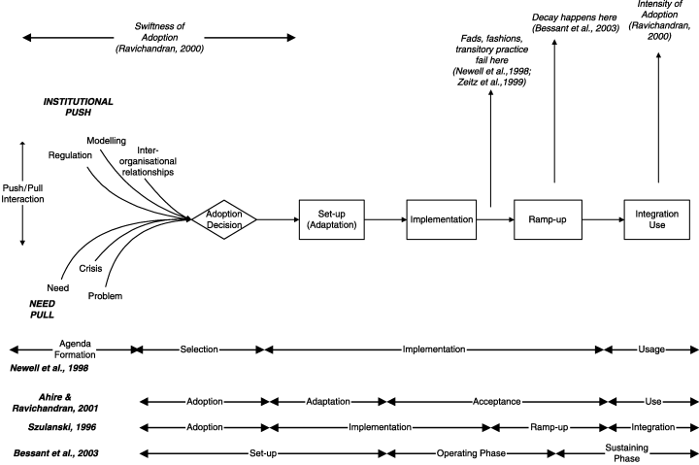

Figure 1. Model of the adoption process of administrative innovations
Source: Leseure et al. (2004:175)

Methods

Research Methods
Most recently Langley (2007) and others (Pettigrew, 1992; Van de Ven, 1992; Langley, 1999; Khanna et al. 2000) have expressed the need for more process thinking in strategy research. This research project seeks to fill this gap in research and addresses these issues from a processual perspective. Although most of the processual studies(Child, 1972; Dawson, 2004; Pettigrew, 1997) have different focus, they don’t only share a common methodology and research strategy of longitudinal case studies and collection of in-depth data but also a shared conceptual and theoretical overlap in their concern for:
- the context in which changes are occurring;
- the substance or content of the change programme; and
- the process of change

The content of the change programme
Table 1 illustrates the content of the quality management framework which was used as a vehicle to understand the implementation process. Hospitality Assured is the standard for Service and Business Excellence in the hospitality industry recognised and endorsed by the British Quality Foundation and the Quality Scotland Foundation as meeting the criteria in the EFQM Excellence Model which is owned by European Foundation for Quality Management. Hospitality Assured is considered as the only standard within the industry that focuses on the customer experience.

The ten steps comprise 49 key requirements or criteria. These are all measurable objectives. The standard however is not prescriptive. It does not lay down precisely how objectives will be met - they will vary organisation by organisation, according to that organisation's customer promise (Institute of Hospitality, 2007).

Table 1: Core Values and Concepts of the Hospitality Assured criteria
1. The customer promise | 2. Business planning
3. Operational planning | 4. Standards of performance
5. Resources | 6. Training & development
7. Service delivery | 8. Service recovery
9. Customer satisfaction improvement | 10. Customer research

The context
The ‘hospitality field’, understood as hotel, conference and contract catering organisational setting, was selected as the research site. Due to the limited number of cases that can usually be studied, it makes sense to choose cases in which the process of interest is “transparently observable”. The study used eight hospitality organisations that are either early, dedicated or discontinued adopters of the industry standard scheme. The cases are selected through means of ‘recommended selection’. The selected companies have been recommended by industry and academic informants as suitable organisations that have been involved in the Hospitality Assured process and have suggested that their experiences can add value to this research study. The Institute of Hospitality (the professional body that owns the Hospitality Assured process) had recommended a gatekeeper for each company as a primary contact. The gatekeeper was then asked to identify three or four staff members that have been involved in the process and are able to give their perspective.

Data collection methods for the process
The processual research approach in this study sought to accommodate and uncover the different accounts and experiences of employees and owner/managers on the process of the adoption. Within this qualitative approach the competing narratives, multiple histories and expectations were deemed to be important in our understanding of how the non-linear processes of best practice adoption operates.
The qualitative data were gathered in eight service sector organisations with retrospective collection (2003-2007) for a five year period of time and one year real time data (2006-2007). Data were triangulated consisting of multiple interviews, observation of meetings and documentary searches. The analysis is based on thirty-four semi-structured interviews with senior and lower level managers and employees involved in the initiation and implementation process. Interviews lasted typically one hour and they were audio taped.

The interviews focused on the open-ended questions regarding the introduction and the implementation of the management scheme. Eleven observations of daily and weekly meetings across the cases, lasting from half to one hour were conducted throughout the year of real-time collection. This enabled the identification of daily activities and the meaningful practices associated with operational planning. The interpretation of the meeting was enhanced with the provision of previous minute-meetings and informal discussion with participants.

Data Analysis
All interviews were tape recorded and transcribed verbatim. Given the size of the dataset, the qualitative data analysis package N-Vivo7 was used to enable effective data management. The analytic process adopted followed the conventions of template analysis (King, 2004). This is a systematic method for identifying themes in textual data and organising them hierarchically, such that broad themes (such as ‘initiation stage’) encompass successively more narrow ones (for example, ‘sources of awareness’, ‘role of the initiator’). To ensure that the interpretation of the data was reliable, two researchers analysed a sample of the transcripts. Disagreements in coding were discussed and a final version was agreed.

The table below presents the contextual characteristics of the eight participant companies and the data collections methods.

Table 2: Organisational context and data collection methods
Case | Organisation description |  | Size | Number of assessments | Empirical data | Secondary data  (assessment reports and company documents)
1 | Accommodation, Conference & Study Centre |  | small | 1 | 9 interviews  2 meeting observations | 2006-2007
2 | International conference centre |  | medium | 7 | 4 interviews  3 meetings | 2004-2007
3 | Conference & training venue |  | small | 7 | 3 interviews | 2004-2007
4 | University catering services |  | small | 1 | 2 interviews | 2005
5 | Contract catering |  | large | 2 | 4 interviews | 2005-2007
6 | Hotel |  | large | 1 | 4 interviews  3 meetings | 2006-2007
7 | Catering services |  | large | 6 | 4 interviews | 2003-2007
8 | University house services  (size large) | Cleaning services | small | 1 | 2 interviews | 2006-2007
8 | University house services  (size large) | Accommodation services | small | 1 | 1 interview | 2006-2007
8 | University house services  (size large) | Site services | small | 1 | 2 interviews | 2006-2007
8 | University house services  (size large) | Catering services | small | 1 failed | 1 interview | -

Process findings

In summary the key findings are gathered around the identified process modes, the identified process roles and the identified micro and macro processes:

Process modes
The participant organisations were found at the time of the study (2006-2007) to be under the following different process modes:

- 4 organisations (3 large and 1 small) at the early adoption phase (new to the process, max 3 yrs implementing the scheme, max 2 assessments)
- 3 organisations (1 small, 1 medium, 1 large) at the dedicated adoption (more than 3 years implementing the scheme, minimum 6 assessments)
- 1 small organisation at the discontinued phase (have stopped formal accreditation procedures at 1st assessment)
- 1 unit (within the large organisation at the early implementation) at a stand-by phase (have failed to pass accreditation and waiting to be re-assessed)

Process roles
Different internal and external roles were identified throughout the process. The internal were:
- process leaders
- process facilitators
- senior initiators/supporters
- process followers

The external were:
- process and standards inventors
- professional directors of the scheme

Macro and micro overlapping processes
Despite many differences in the specific contexts for the process adoption – different markets, different size, and different process mode experience – the study found important commonalities in the micro processes of each organisation and with the macro processes of the literature. The principal themes generated from the template analysis were gathered initially around the micro- processes which were then compared with the macro processes from the existing literature.

Figure 2 illustrates the micro and macro processes that the organisations went through during their adoption. The term process is used instead of stage or phase to emphasise the dynamic and non static nature of the process.

- Adoption decision process
In this study the initiation stage entailed the role of the senior manager who became aware of the management practice through professional and trade association and networks. The need to adopt the practice became more apparent to the operational managers through the pilot self-assessment that all organisations go through before they decide to adopt the scheme.

“…we highlighted the fact that we had probably reached flat line, you know we’ve been together 11 years most of us. We’ve been climbing a hill and we got to a flat point and we needed a “kick up the ass”. We needed something to set our sight so we started climbing again… and the boss came across this programme and he went through it”
Hotel process leader at early implementation, May 2007

- Adaptation process
In this study this process started with senior management allocating responsibilities and roles. The leader of the process in the majority of the cases was the person who was thought by senior managers as the most appropriate for that role. His or her leadership skills played a significant role to this process.

“Mine enthusiasm and some others, you know mine to start the ball rolling, I was the catalyst that got it rolling, then I pulled other people on board, I convinced them that this could work, and when we had a few wins, you know they believed in it”
Hotel process leader at early implementation, May 2007

Then the process leader had the task to find the appropriate process facilitators/champions from different departments to maximise the acceptance and diffusion. Leaders and facilitators had the task of adapting and interpreting the ten criteria of the quality management system to their organisation. That task was more difficult and time consuming for smaller organisations because the process leader had less financial resources for immediate investments and less time due to other responsibilities.

“…because it was a change management situation so what we had to do a lot Bing Bang, lots of noise, lots of obvious easy changes that we could make. And then putting the structures underneath to underpin it and make it work. That’s how you have do change, you have to make lots of noise”
Conference centre process leader at early implementation, February 2007

- Reflection on improvement
This process starts when organisations feel they are ready to get formally assessed. One and a half years on average took for the new adopters to finally decide that they are ready to get assessed. In some cases the process leader admitted that they had focus on some standards on purpose because they had already processes in place. Their intention was by the second assessment to have filled in the gap in the other areas as well. One process leader also admitted deliberately preparing the staff prior the visit for the assessors.

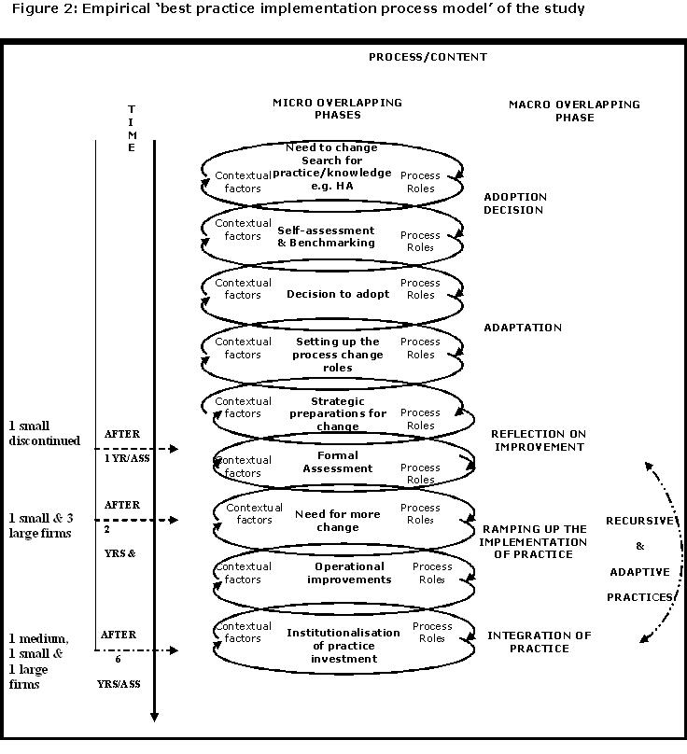

“I re-produced the 10 steps and gave them a brief outline of what each one mean…I sort of identified which sections they would probably be asked about and also a sort of :” don’t worry, this is why we are doing it, it’s to give you a chance to show off” because people were quite nervous about it.”
Contract catering process leader at early implementation, April 2007

On the other hand two (out of the three) experienced adopters claimed that they had initially skipped the adaptation process and they proceeded to their formal first assessment almost immediately after the decision to adopt. The also claimed that preparing the staff for the assessors would be like cheating and would not the serve the whole purpose of the assessment.

“We didn’t do a lot of launching, we didn’t do the big launching of the standard because when we looked at it was already fitting in to our business framework… we already had business excellence which is a European Standard, international standard and we have been recognised already by Europe before Hospitality Assured came in. But the beauty when we start in Hospitality Assured standard was that it fits in to what we do of our framework…”
Conference process leader at integration, March 2007

- Ramping-up the implementation of the practice
Increased number of assessments seems to lead the way to the ramping-up process. The effects of this process are only apparent from the data collected from the experienced adopters because these organisations had already been seven or six times formally assessed.

“I think the biggest change has being the mindset, that we do things for best practice and not for 2 men with suits that come for one day a year, we do it because it is good for the business and at more senior level, is stimulating to have this degree of pressure because you want to make sure you perform, you want to make sure the venue works well”
Conference process facilitator at integration, May 2007

The pressure of the assessment’s deadline seems to act as a significant stimulator for senior management to generate ways for smarter performance. Staff turnover especially at the senior level was cited as a significant barrier that slows down the speed of this process. On the other hand high retention of senior staff management, especially for small independent companies might lead to complacent behaviour. Quoting a process facilitator:

“I think when you have got high retention of senior managers, that sort of external assessment motivates the staff to never be happy, to always seek another challenge and that’s what we do…on the other hand whenever there is a change in senior personnel, you are vulnerable, if the standards are not right how do you turn them around fast enough without reinventing the wheel?”

- Integration process of the practice
For the three experienced adopters Hospitality Assured has already being embedded into the company, they treat it as “the norm” and therefore they do not disrupt their operations or conduct special preparations for the assessment. They use it mostly as a performance indicator, as an acknowledgment of their efforts and as a benchmarking tool. They treat Hospitality Assured as an investment decision which supports their strategic content and direction to the board of directors.

“I think that’s the beauty of what we have done with Hospitality Assured in terms of making them aware because they don’t even think that is Hospitality Assured; they think that it is a way of working here…”
Conference process leader at integration process, March 2007

Experienced organisations have already realised that the process works when more people are contributing to the diffusion of the practice.

“One thing which I think we have done pretty well is instead of having two people effectively responsible for Hospitality Assured which we did 4 years ago, we have filtered it all out and now everybody understands that they can contribute to Hospitality Assured, in much the same way, everybody contributes to us achieving our business plan and our targets.”
Conference process facilitator at integration process, May 2007

Discussion
The resulting best practice model comes closer to the empirical model of Szulanski (1996) and the conceptual model of Leseure et al. (2004) in terms of the macro processes (Figure 1).However due to the limited number of cases studied no generalisations can be made.

In particular the ‘adoption’, ‘ramp-up’ and ‘integration’ stages of Szulanski’s(1996), and Leseure et al.’s model and the ‘adaptation/set-up’ of Bessant et al., (2003) have all emerged as macro-processes in this study’s best practice model.

At the adoption decision process the internal benchmarking assessment against the industry criteria revealed the first areas for improvement and that acted as significant facilitator for the middle and operational level managers to foresee the benefits. This comes to confirm the importance of benchmarking at the selection stage of the process (Davies and Kochhar, 1999).

The role of the leader and the support received from senior management were perceived as significant factors that facilitated the whole process and especially the adoption and adaptation process. The lack of leadership was also the element that led one of the organisations to discontinue the process. Also the existence of good communication channels allowed quicker information flow which speeded up the process especially in larger contexts. Senior management job tenure was also mentioned as a positive element which facilitated the speed towards integration. On the other hand getting and keeping people involved was one of the most challenging tasks in large and small contexts because of the industry’s high staff turnover. Smaller organisations perceived this task even more difficult because some of their employees did not come from a hospitality industry background and so were not familiar with the industry language of the management framework.

The size of the firm seemed to influence the speed of the adoption especially at the adaptation and ramp-up process. This might be due to the increased strategic planning and financial and time resources required during these processes. Previous research had already showed that many of the failures of quality management systems in small organisations are related to bad implementation and lack of strategies and processes (Brah et al., 2002; Hudson et al., 2001). This study identified the potential problematic areas during the process. However size did not seem to influence organisations negatively at the integrations process.

The ‘reflection on improvement’ emerged as a new macro process because it was identified as an important stage that seemed to improve the retentive capacity towards the integration stage. During the iterative process of ‘reflection on improvement’, ‘ramp-up’ and ‘integration’ process the three organisations seemed to have the opportunity:
- to adapt to the new improved practices that stimulated higher assessment scores and
- to keep up with routinised practices that have proved to increase performance.

Therefore during these three macro-processes leaders and facilitators injected new ideas, made unused processes redundant and therefore eliminated unnecessary work and freed up resources. This interaction resemble the duality of recursive and adaptive practices that also strategists might face during their choice between structured ways of acting that are based on routines while at the same time developing adaptive and creative approaches to strategy development and implementation (Jarzabkowski, 2004). The adoption of quality management schemes may stimulate this interaction however more research is needed.

Organisations at the adaptation process perceived the quality management system as a change agent. Also this is a critical process in terms of disrupting the daily operations of the organisation and was strongly affected by time (two years strategic preparation for new adopters). On the other hand organisations on the dedicated mode tend to be more intent on creating such a climate in which change and improvement is the accepted norm.

The ‘ramping up to performance’ appeared as a very crucial process for the capacity of the company to exploit opportunities to learn (Bessant et al., 2003) and also to proceed for operational improvements that were identified from the previous reflection process (formal assessment).

It should be noted that in reality none of the stages is ever completed, or comes to an end (constant allocation of process responsibilities and process facilitators, constantly communicating the need and the benefits to adopt the scheme, continuously create and update the operational and strategic preparations and the appropriate tools (meetings, documents, workshops) and financial resources. This is also caused by the challenge of getting and keeping people involved especially in the hospitality industry where staff turnover is high. Smaller organisations perceived this task even more difficult because some of their employees did not come from a hospitality industry background and so were not familiar with the industry language of the management framework.

Best practice may originate either by management fads (Mitroff & Mohrman, 1987), real innovations (Dunphy & Stace, 1990), or just imitations from other organisations (DiMaggio & Powell, 1983). This study however did not identify the source or the innovativeness of the practice as the critical point that determines an efficient adoption process. As Abrahamson (1991) claims from fad and fashions efficiently innovative practices can emerge. To this end best practice adoption for this study is not simply about creating or imitating new or proven efficient ideas; best practice integration is about diffusing these ideas into the organisation, engaging everybody into the adoption process and make the benefits recognizable by everybody.

Implications

Policy
The majority of the small organisations in the study received significant benefits from their involvement in that process, especially in forcing them to document their core processes and transforming them in explicit knowledge. Professional institutes can develop various strategies such as peer-to-peer learning and targeted gatherings connecting industry associations and sectors to support small and large organisations especially in the implementation phase which appeared to be more problematic.

Also organisations seemed to need more support and transparency on what is required from them in order to get ready for the assessment. This will save them time and would enable them to focus their efforts in more substantial improvements. Professional institutes that manage quality management schemes may also consider involving experienced practitioners and professional assessors in the assessment.

The development of professional bodies should be encouraged tO coordinate the exchange of knowledge and best practice among small and medium independent organisations. Professional bodies that assess companies through quality management schemes know which companies perform best practice in certain areas. They know also which companies have weaknesses in these areas. Policy that aims at helping SMEs should promote, educate and reinforce owner/managers towards entrepreneurial thinking in taking the risk and share best practice secrets with competitors and non competitors.

Managerial
It is very difficult in smaller organisations to find the right people that are willing to take risks. And also the even more challenging task for owner/managers in small contexts to critically reflect their leadership capabilities and foresee how well themselves or somebody else from the company could better lead the process.

Evidence also showed that previous related experience with quality management initiatives gives confidence and builds a good process infrastructure. Adapting quality management practices is the strategy that owner/managers need to keep their organisation competitive because it is a way to avoid being insular and blinkered. External assessments provide a fresh set of eyes. Also for young and less experienced entrepreneurs or managers having a deadline for external assessment is a very effective way of keeping their employees on top of their workload. At senior level these degree of the assessment pressure can stimulate thoughts and can force unused processes to remain redundant, thus eliminating unnecessary work and therefore frees up resources.

Investing resources in external and internal business and quality assessments is a significant strategy that stimulates enterprises to work smarter. The evidence showed that such investment promotes change and continuous improvement through constant re-assessment. Constant re-assessment discourages complacent behaviour and triggers entrepreneurial attitude. The greatest opportunity for SMEs to work smarter is to recognize the need for developing and sustaining a business strategy that re-invests in such best practice and supports the individuals who can facilitate the whole process from initiation to integration. When this process of continuous improvement is effectively managed it can help create a shared corporate focus and successful implementation of strategy for growth.

