Risk Based New Venture Valuation Technique

Whittington P. Vara, Clinical Professor

Center for Entrepreneurship & Innovation, University of Florida

1964 Glen Field Crossing Court, St. Augustine, Florida 32092
Tel: 904-502-0103 Email: wvara@ufl.edu
Type of Paper: Practical
Objectives: Research suggests integrating real options, the present value of future cash flows and appropriate comparables should provide an excellent starting point for valuing a new venture. This paper provides a practical approach to achieve such a unified, risk-based new venture valuation model.
Approach: To arrive at the objective, this paper defines the components of commercialization risk so that the point when a new venture's business risk is no more or less than any other on-going business can be determined. At this future point in time (time of normal business risk=t_{n}), the potential value of the new venture can be estimated by using comparables. The new venture's comparable value at t_{n} is then used to adjust the revenue and cost assumptions of the financial model to insure the value calculated using the present value (PV) of the future cash flow is similar to the comparable value. Finally, between the start of the new venture and the future t_{n}, critical activities are defined that specifically reduce the components of commercialization risk. Once identified, these activities are defined as value changing events (VCE) because when risk is reduced the value of the new venture is increased. The value at each VCE is then calculated after assigning a risk factor (real options) and using the standard PV of a future cash flow technique.
Results: Once the financial model and valuation model are linked via the cash flow statement, the revenue and cost assumptions of the financial model can be adjusted to determine if a balanced investment is possible. A balanced investment is defined as when the initial investment and initial value satisfy the founders (equity given up) while the initial value and the value at t_{n} provides the investor the anticipated return on investment.
Implications: The true value of any new venture is based, in large part, on its ability to generate cash. Unfortunately, simply calculating the new venture’s value using the standard PV cash flow technique is unattractive because validating the financial model by evaluating the underlying assumptions can be too subjective. The proposed risk based valuation technique provides a means to validate the financial model using comparables. Further, the use of value changing events to introduce the various stages of commercialization risk into the valuation process provides the practical advantages of real options.
Value: Although this risk based valuation technique may not provide the “true” value of a new venture, it does provide a logical, systematic approach that can be the basis for negotiating the new venture’s actual value.
Keywords: valuation, investment, start-ups, venture finance, real options, start-up investment

Introduction:
In many ways, valuing a new venture is the most critical step in successfully securing the investment to fund the enterprise. If the value is too low, the founders may be giving up too much equity too early in the life of the company. If the value is too high, the investor will likely not achieve the desired return on investment target and never make an offer. Balancing these two seemingly conflicting expectations requires injecting objective information into a fundamentally subjective process.

Exacerbating these conflicting expectations is the problem of information asymmetry that exists between the founders and investors. Each party maintains an information advantage in their respective areas of expertise: the founders with the business opportunity and the investors with the investing environment. If this information asymmetry is not minimized during the negotiation process, finalizing a deal is unlikely.

The challenge of assigning a value to a new enterprise that meets the expectations of the entrepreneur and investor cannot be overstated. Conventional valuation techniques cannot be used since most new ventures have no financial history and few assets upon which to conduct a valuation. In addition, the prospect of positive cash flow is projected to be months if not years in the future. Faced with this dilemma, most entrepreneurs simply delay tackling the task of assigning value to their enterprise until they are face to face with a potential investor.

To make matters worse, when entrepreneurs are finally forced to come up with a value for their business, they tend to assign a value based on their own interest without considering the interest of the investor, much less the value the market is likely to assign. For example, if an enterprise needs a $2 million investment, the founders may suggest the value is $8 million because they are willing to give up 25 percent of the company. Although the math works, and the value certainly achieves the founders desired outcome, it does not allow for the investors perspective of a good investment and has no direct relationship whatsoever with the market value of such an investment.

The problem of determining the value of a new venture with no financial history, no assets and a negative cash flow position for the foreseeable future will be addressed by integrating three valuation techniques: (1) present value of the future cash flow, (2) real options and (3) comparables.

Background:

The present value (PV) of a future cash flow is by far the most frequently abused method entrepreneurs use to “prove” the value of their new venture. PV is the most used technique because it is a well understood technique for determining the present value of a future stream of cash. It is the most abused method because too many founders create financial projections with unrealistic assumptions resulting in “hockey stick” revenue streams, which most seasoned investors simply ignore. Therefore, any new venture’s value based on PV is inherently discounted by investors as an unrealistic proposition. As a result, before PV can be used to determine a new venture’s value, the founders must provide evidence the financial model generating the cash flow is grounded in reality.

Even though the cash flow from a new venture will always be suspect, it still must be the basis for assigning the fundamental value for the enterprise. After all, the essential value of any business is, in fact, the result of its ability to generate cash. How to appropriately apply PV is a part of the overall valuation problem.

For the informed investor, incorporating real options into a new venture’s value calculation offers interesting possibilities. Although financial options are well understood within the financial community, extracting these same principles from real options theory and applying them in practice have been problematic. The primary concept of real options, as in financial options, is that uncertainty of a future outcome can be reduced over time. In other words, real options provide a means for recognizing the consequence of learning over time on a new venture’s value.

Real options also provide the ability for an investor to make three choices at specific intervals: invest further in the project, modify the project or abandon the project. The major criticism of PV as a valuation technique for new ventures is it assumes the risk of the expected cash flows (discount rate) is constant. Real options, however, factors in the changing uncertainty of the expected cash flows.

Of all the available valuation methods, using comparables appeals most to both buyer and seller because it most closely approximates the actual market value. This requires finding a recent purchase of a similar business and using that sales price as an indicator of the likely value for the new venture. The most common source of comparable information is the stock market. Everyone agrees the market value of a publicly traded business is reflected in the stock price because the company’s value is being verified each time a stock is bought and sold.

Unfortunately, since new ventures are not bought and sold on the public markets, finding accurate comparables is particularly difficult.

Although all three of the above valuation techniques has its unique set of benefits and limitations, proper integration of the best aspects of each will result in a robust risk based valuation technique.

In order to present this risk based valuation technique, commercialization risk and financial modeling need to be reviewed.

Commercialization Risk:

Commercialization risk is a generic phrase that typically encompasses all risks associated with bringing a business concept to market. All new venture commercialization risks are subjective in nature and therefore rely on the knowledge and perception of the individual. In most cases, the information asymmetry between the entrepreneur and investor results in the investor and entrepreneur not perceiving the commercialization risks in the same manner. A goal all entrepreneurs must have when dealing with investors is to minimize this information gap so that this perceived risk is similar to both parties.

For the purposes of this discussion, all commercialization risks are assumed to fall within the following three categories: (1) development risk, (2) customer acceptance risk and (3) marketing and sales risk. These three risk categories also follow the normal flow of the commercialization process.

Development risk deals with content and technology and consists of all activities required to answer the question: Can this product or service be built or delivered? The development risk is low when the specific features and benefits of the product/service are known. This risk is minimized once the product/service has been successfully delivered to the customer and consists of all activities prior to “beta” or pilot testing.

Customer acceptance risk consists of activities required to answer the question: Are we building the right thing? The customer acceptance risk is low when a specific market segment has been defined where the unmet or underserved needs match up with the specific features and benefits of the product/service being developed. All activities associated with successfully completing “beta” or pilot testing fall into this category.

The marketing and sales risk deals with positioning the product or service into close enough proximity to the target market so that a purchase decision is made. All activities associated with implementing the marketing and sales strategy fall within this category. This risk usually affords the highest risk in any new venture’s commercialization effort. The marketplace is littered with products/services that had low development and customer acceptance risks but failed in the market. The marketing and sales risk is considered low once positive cash flow is sustained.

These three risk categories have two characteristics. First, they are cumulative. The overall commercialization risk will be the sum of the individual risks. A low risk in one category does not offset a high risk in the other two. Therefore, to achieve low commercialization risk, the perceived risk in all three categories must be low.

The second characteristic of the three categories of commercialization risk is they are serial. From an investor’s perspective, the customer acceptance risk cannot be reduced until the development risk is minimized and the marketing and sales risk cannot be reduced until the customer acceptance risk is minimized.

This supports the natural flow of the commercialization process. For example, the customer acceptance risk can only be minimized once the specific market segment with needs that match the product/service features and benefits has been identified. This cannot happen until the development risk is minimized and the product/service’s features and benefits are finally known. The same can be said for the sales and marketing risk: Until the market segment has been identified, a low risk marketing and sales strategy cannot be developed.

Financial Modeling:

The role of financial modeling is critical to successfully determining the value of a new venture. As mentioned in the background, the cash flow of a new venture must be the basis for any valuation. How the cash flow is derived is the problem. For the model to have credibility with investors, it must use market based revenue and cost assumptions and contain granular details. For valuation purposes, the model must also result in month-to-month financial statements (income statement, balance sheet and statement of cash flows) that cover 60 months.

This model will combine managerial and financial accounting principles. Market based assumptions are used to determine the revenue and cost basis for the pro forma financial statements. In the United States, it is important that all financial statements conform to General Accepted Accounting Principles (GAAP). This conveys the founders have an understanding of financial accounting principles which is important when dealing with investors.

The market and sales assumptions are used to drive the model’s revenue engine, while the business model assumptions will determine the subsequent costs required to generate the revenue.

The Operating Cash Flow (OCF) is used to determine the enterprise’s value as opposed to Free Cash Flow because the OCF indicates how well the new venture’s business model is succeeding. Free Cash Flow can be impacted by other activities not directly related to the business model.

Relationship between Commercialization Risk and Financial Modeling:

As a part of the new venture planning process, a business plan must be developed that describes the compelling nature of the investment opportunity. To successfully accomplish this task, the narrative of the business plan must convince the investor the development risks and customer acceptance risks are sufficiently reduced to merit evaluating the financial aspects of the new venture. In other words, the revenue stream has credibility only after the investor is convinced the product/service can be developed and the target customer will respond favorably when the product/service is delivered.

The output of the financial model (pro forma financial statements) is the mathematical representation of the marketing and sales strategy. In other words, the marketing and sales risk can be visualized through the projected financial performance as represented by the financial model.

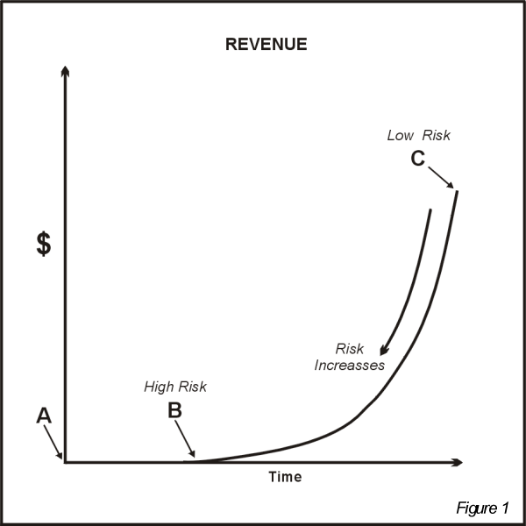

The revenue curve (one aspect of the pro forma statements) in Figure 1 helps explain this concept. In this graph, "point A" represents today, "point B" is when revenue begins, and "point C" is the last dollar of revenue recognized in the 60-month pro forma statements.

The first dollar of revenue (point B) has high risk because the marketing and sales strategy is unproven. Even if the company has market data indicating the marketing and sales strategy should generate the revenue suggested at "point B," from the viewpoint of "point A," this revenue still has significant risk since no sales have yet resulted from the new venture’s marketing and sales strategy.

On the other hand, if the company performs as planned and achieves the projected revenue stream (follows the curve B to C), that last dollar of revenue (point C) is certain to be achieved because the marketing and sales strategy is proven. Therefore, the marketing and sales risk increases from "point C" to "point B."

Understanding this concept of marketing and sales risk as viewed through the pro forma financial statements is paramount when placing a value on a pre-revenue company.

Risk Based Valuation Technique

The risk based valuation technique consists of: (1) establishing a future value for the new venture using PV, (2) validating this future value using comparable companies, (3) applying real options principles to assign a current value to the new venture and (4) adjusting the financial model to attain a balanced investment.

A mythical software company that requires a $1 million investment is used as an example. This company is pre-revenue and has plans to complete a working prototype prior to beta testing. The software product is unique and will be introduced in a new market not yet served by several major software manufacturers. After successful sales, the company plans to private label the software to one of these major software manufacturers while retaining the manufacturing rights. Using private labeling as a means to grow a company is often referred to as an Original Equipment Manufacturing (OEM) strategy. The pro forma cash flow statement indicates the amount of investment needed to complete the prototype is $400,000, to complete the beta test is $200,000 and to cover expenses until the first OEM client is signed is an additional $400,000.

Any attempt to assign a value to a new venture will always have a subjective component. Much of the proposed technique is no different. What is attempted, however, is to provide as much objectivity as possible in assigning the company’s pre-revenue value.

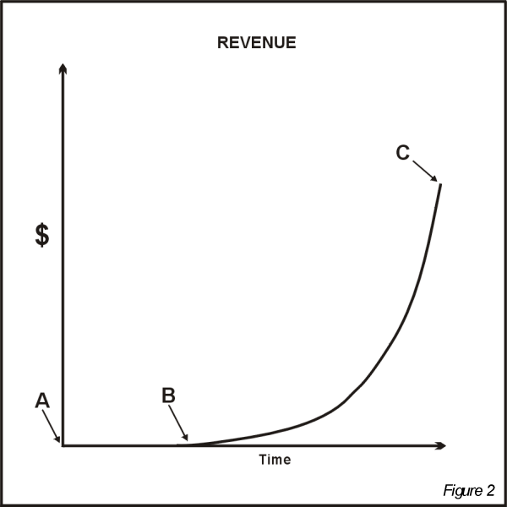

A company’s pre-revenue value can be determined using this technique only if the Operating Cash Flow (OCF) is derived from pro forma financial statements and a business plan having the following characteristics (Refer to Figure 2):

- The business plan’s narrative minimizes the perceived development and customer acceptance risk to the point where the investor can agree the revenue stream is likely to begin at point B.
- The investor acknowledges that the pro forma income statement underestimates revenue and overestimates costs. Therefore, the investor acknowledges that the resulting revenue curve (line B to C) is likely to occur and contains upside potential.

Establishing Future Value using PV:

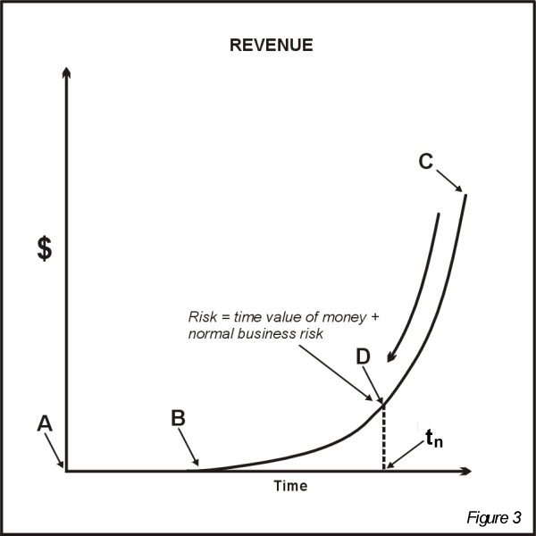

As mentioned previously, the revenue line (B to C) in Figure 3 can represent the risk associated with the marketing and sales strategy. The revenue at point B has high risk (unproven marketing and sales strategy) and the revenue at point C has very low risk (proven marketing and sales strategy). Therefore, the marketing and sales risk increases from point C when following the revenue line back in time.

To begin the valuation process, a point between point B and point C must be established where the "marketing and sales strategy has first been proven." At this point D, all commercialization risks (as previously defined) have been eliminated from the enterprise. In fact, the risk of investing in this company at point D would merely consist of the time value of money plus normal business risk. Any investment in this enterprise at point D will have no more or less risk than investing in any other ongoing business. In other words, an investor will not assign a commercial risk premium on this enterprise when investing at point D.

At that point on this revenue line (point D) the risk will approach a normal risk. Therefore, at this time in the future, point t_{n}, an investor would require only a normal return on an investment.

As a rule of thumb, this critical point in the company’s future, t_{n}, will occur once twelve months of consecutive positive OCF has been achieved. This sustained period of positive OCF indicates the fundamental business model is working. At t_{n}, the development risk has also been eliminated since the product is fully developed and the customer acceptance risk along with the marketing and sales risk are both minimized due to the enterprise’s success in achieving sustained positive cash flow.

Once t_{n} has been established for this company, point D is assigned the normal risk of 20 percent. This risk represents a combination of the time value of money and the normal risk associated with an ongoing business and is a reflection of the economic environment. In this case, risk can be viewed as "what an investor expects as an acceptable return on a normal investment."

Using risk as the discount rate, the PV of the OCF is discounted at 20 percent to establish the company’s future value at time t_{n}. For this example, assume this calculation results in a value of $20 million. As a result, the financial model indicates the future value of this company, at time t_{n}, is likely to be $20 million.

Validating Future Value using Comparable Companies:

The next step in the process is to validate this estimated future value for the company. Because t_{n} is a point in time when the company has normal business risk, comparable companies (Comps) can now be found. Prior to this point in time, locating Comps for the new venture requires finding companies that have similar commercialization risks which is exceedingly difficult, if not impossible. Once the company achieves t_{n} however, finding comparable companies to validate the projected value is possible.

First, locate several public companies that operate in the same or similar markets and use a similar business model. The more characteristics the Comps have in common with the new venture the better. The recent financial performance of these comparable companies will be used to generate specific financial ratios that can then be used to estimate the new venture’s value at t_{n.}

Price to earnings (P/E ratio) is a common and readily available ratio that can be used to describe the financial performance of a company with respect to the underlying value of the company. The numerator of this ratio, price per share, is the market value of the company divided by the number of outstanding shares. The denominator, earnings per share, is the net income divided by the number of diluted shares. Diluted shares include common shares, options and/or other potential future liabilities which reflect the overall capital structure of the company and can result in a lower P/E ratio. This ratio is useful when the companies being compared have similar capital structures.

The P/E ratio is now multiplied by the new venture’s projected annualized Net Income at t_{n}. The result is the value the market suggests the company would have at t_{n} based on the current value of similar companies. It is critical to use several Comps to estimate the range of values the market is likely to assign the new venture.

In the case of the software new venture example, any value higher than $20 million using the Comps’ P/E ratio will validate the financial model, while a value less than $20 million will indicate the financial model’s revenue and cost assumptions must be modified because the model does not “predict” the correct value for the company at t_{n}.

Using this example, if the pro forma revenue curve were achieved, not only does the financial model indicate the future value of the company would be $20 million at time t_{n} (by discounting the OCF at 20%), but the market also suggests that same value (by using Comps). Therefore, it is reasonable to expect a person to exchange a $1 million investment at t_{n} for only five percent of the new venture’s equity.

Applying Real Option Principles:

The proposed technique incorporates several real options’ concepts without making any real options’ calculations. According to the modified Black-Scholes equation for real options, six factors affect value: (1) value of the underlying asset, (2) exercise price, (3) the options time to expire, (4) uncertainly of the future cash flows, (5) risk-free rate of interest and (6) dividends paid out by the underlying asset. In the proposed technique, only the first four factors are used. Fortunately, these four factors have the most impact on the overall value of the real option.

Establishing a market validated value for the new venture at t_{n} provides a reference point for determining the current value of the new venture. The value of the company is much lower than $20 million at “point A” because the risk at “point A” is significantly higher than the normal risk (20%) at t_{n}. This inverse relationship between risk and value is critical when applying real options.

To account for the change from a high risk at point A to a normal risk at t_{n}, a series of risk-reducing events must occur between these two points in time. The business plan must describe these critical milestones to justify this systematic reduction in risk. These critical milestones are termed value changing events, because when accomplished, the risk is reduced and the value of the company is subsequently increased. The entrepreneur must clearly establish what these major value-changing events are and when they will occur.
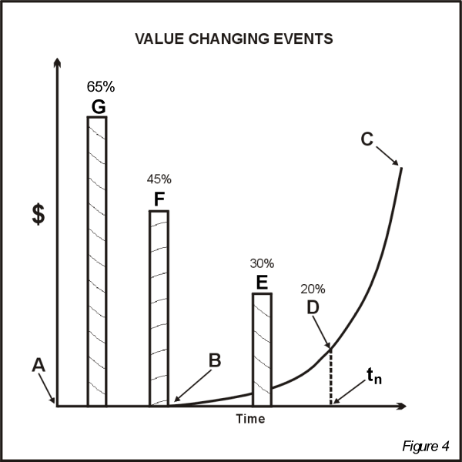

In the software new venture example (see Figure 4), three such value changing events have been identified prior to “point D”: (E) first OEM contract is signed, (F) beta test is completed, and (G) prototype is completed. Each of these three events represents a risk-reducing activity associated with the three categories of commercialization risk.

- Development Risk (Event G) – Prototype completed. Converting an idea or concept to a physical “thing” will reduce the development risk.
- Customer Acceptance Risk (Event F) – Beta test completed. A successful Beta test will provide feedback on the customer’s perception of the product and lead to changes in the product design to insure high customer acceptance.
- Marketing & Sales Risk (Event E) – First OEM contract signed. This event signifies the successful implementation of the marketing and sales strategy which will reduce the risk in this area.

This example indicates that at least one value changing event should occur within each of the three commercialization risk categories. Each of these events represents a reduction in the commercialization risk and therefore an opportunity for the company’s value to increase after each objective is achieved.

Once the value changing events have been established, the entrepreneur performs a simple comparative analysis to assess the reduction in risk from one value changing event to another. This process is purely subjective and depends on the specific circumstances of the new venture. A likely scenario for such a risk analysis with respect to the software new venture example follows:

- Point D (at t_{n}) has already “earned” a risk of 20 percent. Signing a large OEM account at event E does not guarantee that the revenue at point D will be achieved, but it does significantly increase the likelihood. Therefore, event E is assigned the risk of 30 percent. (The 20 percent assigned to point D plus an additional 10 percent of risk.)

- Event F signifies the successful completion of the beta test. This does not directly lead to signing a large OEM account, but it does indicate a high degree of customer or market acceptance and therefore a corresponding reduction in risk from event G. Therefore, a risk of 45 percent is assigned to point F (15 points added to 30 percent).

- The prototype is completed at event G. Although this event does not insure the beta test will be successful, it does indicate a significant reduction in the development risk. A risk of 65 percent is assigned to event G (20 points added to 45 percent).

Once completed, this analysis describes a high risk (65%) business opportunity diminishing to a normal investment risk (20%) provided the three value-changing events are achieved. A business risk of 65 percent can be restated as once the prototype is completed there is only a 35 percent likelihood the revenue at point D will be achieved.

The same PV calculation is made using the risk as discount rates to determine the company’s value at the completion of events E, F, and G. In this example, assume the new venture’s value at the completion of each event is: E - $10 million, F - $6 million and G - $2 million.

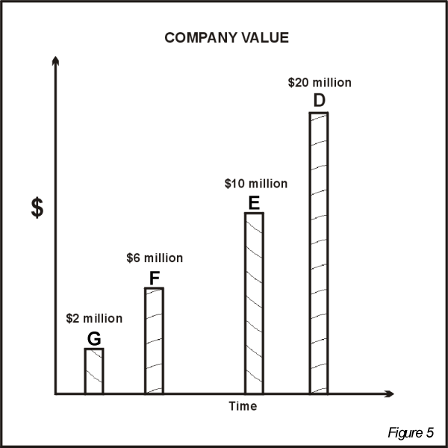

Therefore, with a market justified value of $20 million at t_{n} and taking into consideration the uncertainty of the OCF (a real option principle) based on three value changing events, once the prototype has been completed, this software company will likely have a value of $2 million.

From the entrepreneur’s viewpoint, this valuation is disappointing since a $1 million investment would translate into giving up 50 percent of the new venture’s equity. From the investor’s perspective, investing $1 million at the beginning of the project would expose the entire investment to a 65% risk which may be too high. An additional real option principle, inserting a time period when the opportunity will expire, can now be applied to address these concerns.

Table 1: Impact of Staged Investment
Point | Discount Rate | Valuation | Required Investment | Retained Equity
D | 20% | $20 million | 0 | 72.7%
E | 30% | $10 million | $ 400,000 | 72.7%
F | 45% | $ 6 million | $ 200,000 | 76.7%
G | 65% | $ 2 million | $ 400,000 | 80.0%

If the entrepreneur only requests and receives enough funding to complete each value changing event (based on the cash flow needs of the company), the total equity given up over the life of the project is reduced from 50 percent to approximately 27 percent.

From the investor’s perspective, this approach only exposes $400,000 to the highest risk and each subsequent investment, if made, will have a corresponding lower risk. In addition once each value changing event is completed, the investor is able to assess whether further investment is warranted and under what conditions. Therefore, the true benefit of incorporating real options when valuing a new venture is it takes into consideration the value of learning and inserts flexibility. In this case, the investor and the entrepreneur will know more about the future of this business opportunity when each value changing event is achieved. By staging the investment to correspond to cash flow needs and the completion of critical value changing events, the founders are able to conserve equity and the investor is able to minimize the investment’s overall risk.

The four factors from the modified Black-Scholes equation used in this technique are:
- The value of the company using PV.
- Exercise price expressed as staged investments
- The options time to expire expressed as the time to complete the value changing events.
- Uncertainty of future cash flow expressed as the risk (discount rate) assigned to each value changing event.

Balancing the Investment:

A balanced investment is one where specific investment goals of the founders and the investors are satisfied. In general, from the founders’ perspective, the primary goals are to receive the requested funding while conserving their equity position. From the investors’ perspective, the primary goals are to make the smallest overall investment while achieving a target Return on Investment at the earliest possible liquidity event.

The founders’ goals can be achieved by balancing the initial investment versus the initial valuation. In this instance, exchanging 20 percent equity for the initial investment shown in Table 1 is probably a good balance for most entrepreneurs. If, however, the initial investment is too high or the initial valuation is too low, the investment will be out of balance for the founders.

Most private investors in the United States are seeking an ROI of ten to one. At the point of liquidity, they expect to return $10 for every $1 invested. Although they will settle for less, they will not make that initial investment unless they have confidence a 10:1 ROI is achievable. With this perspective, a balanced investment for the investor requires the earliest liquidity event to have a value ten times the initial investment. The example used in this discussion shows the first opportunity to implement an exit strategy (initial public offering, acquisition, etc.) is at t_{n} which has a value of $20 million. In this case, the initial valuation and exit valuation are indeed in balance.

Unfortunately, when this technique is first applied to any investment opportunity, the investment is rarely in balance. Attempting to bring the investment into balance requires: (1) revisiting the market data and adjusting the marketing and sales strategy and/or business model, (2) adjust the revenue and cost assumptions in the financial model to accommodate any change in marketing and sales strategy and/or business model, (3) generate the new OCF and (4) calculate a new valuation. As a part of calculating a new valuation, the value changing events and their corresponding risk/discount rates must be revisited.

For the few business opportunities worthy of investment, this iterative process will be repeated several times until the three critical investment parameters come into balance: (1) initial investment required, (2) initial valuation and (3) the valuation at normal risk, t_{n}.

Although most business opportunities are not worthy of investment, by completing this iterative process, the founders will be able to understand any inherent deficiencies of the new venture while the idea remains on paper.

Impact of Risk-Based Valuation Technique:

In most cases, the intrinsic difficultly of determining a new venture’s value results in the founders failing to even make the attempt. They may spend an exorbitant amount of time developing a detailed financial model that describes every aspect of their proposed business opportunity. However, by not attempting to address the valuation problem, the entrepreneur forces the interested investor to unilaterally determine if the investment is balanced from their perspective. This places the founders at a tremendous disadvantage in the pending negotiations. The investment may be rejected because the investor fails to see a balanced investment, when in fact, adjustments could have been made to the marketing and sales strategy and/or business model to achieve a balanced investment for both parties.

Entrepreneurs who invest the time and energy in implementing this technique will have a better understanding of their business opportunity. This technique forces them to integrate marketing research data throughout the financial model that eventually migrates into the valuation of their company. In fact, there are two approaches when applying this technique: (1) Use reasonable and achievable market assumptions to determine if the investment is balanced or (2) Create a balanced investment and determine if the market assumptions necessary to achieve the balanced investment are reasonable and achievable. Either approach will ultimately have similar outcomes.

For business opportunities that survive this process and appear to be balanced investments, this technique provides a logical, systematic approach to assigning a value to a pre-revenue new venture. When confronted with an interested investor who disagrees with the resulting value, the subsequent discussion will center on parameters the entrepreneur is thoroughly knowledgeable. For example, the investor may challenge the discount rates, the value changing events or other assumptions driving the financial model. The entrepreneur should be perfectly positioned to justify their use. In the case where the potential investor is more of an expert than the entrepreneur, the investor’s suggestions can simply be inputted into the financial and valuation models and the results are then evaluated.

Both parties benefit from such a discussion and interchange where the inherent information asymmetry between the founders and investors can be minimized. This approach requires both parties to share information until either a balanced investment is achieved or the business opportunity is rejected.

At the end of the day, the true value of a new venture is whatever the entrepreneur and investor agree it is. This risk based valuation technique simply provides a more objective foundation to base that negotiation.

Limits of Risk-Based Valuation Technique:

Although this technique can be used with a wide variety of business opportunities, new ventures that require extremely large initial capital expenditures and/or have extremely long development cycles are not ideal candidates. These types of investments do not follow the normal pattern of achieving t_{n}. New ventures that plan to reach t_{n} in less than three years are best suited for this technique, since the financial model’s cash flow only extends to 60 months.

References:

Copeland, Tom & Antikarov, Vladimir 2003, Real Options: A Practitioners Guide, Thompson Corporation, New York.
Leslie, Keith J & Michaels, Max P. 1997, ‘The real power of real options’, The McKinsey Quarterly, Number 3, pp. 4-23.
Smith, Janet K. & Smith, Richard L. 2000, Entrepreneurial Finance, John Wiley & Sons, Inc., Hoboken, NJ.
Timmons, Jeffry A. & Spinelli, Stephen. 2004, New Venture Creation, Entrepreneurship in the 21st Century (6th Edition), Irwin-McGraw Hill, Boston, MA.

Choosing operating cash flow over free cash flow is made on a case by case basis. There may be instances where free cash flow is a better indicator the business model is working (i.e. a business that requires a continuous inflow of capital expenditures).
If the company is introducing new products or introducing new distribution channels at or after point D, new marketing and sales risk would be introduced and the required twelve months of positive OCF would need to be extended until these new risks are minimized.
Normal risk is always relative to the investment environment at the time. In this case the assumption is the public markets are providing an average 15% return to the average investor and an additional 5% is added to make up for the illiquid aspect of a private investment. A higher or lower normal risk can also be used as the investment environment changes. For example, in a time of high inflation, a 20% normal risk would necessarily need to be higher.
Include a perpetuity growth factor with the PV calculation to account for the company’s cash flow beyond 60 months. Only include the OCF beginning at t_{n} to the end of the 60 month pro forma.
If the companies being compared do not have similar capital structures and the P/E ratio does not appear to be a good metric, another ratio that factors in value can be used. For example Value to Net Earnings which would simply remove the number and type of shares from the equation all together.
An alternative approach is to calculate the P/E ratio for the new venture at t_{n} and compare this result to the P/E ratios of the Comps.
The revenue and cost assumptions driving the financial model must be adjusted so that the resulting OCF generates a value at t_{n} that is less than or equal to the value suggested by the Comps’ P/E ratio. If the new set of assumptions do not seem reasonable, then the business opportunity may not be feasible in this market. For the remainder of this discussion, assume the Comps do, in fact, justify the $20 million valuation at t_{n}.
The discounted cash flow calculation for each milestone only includes the OCF beginning at that specific point in time to the end of the 60 month pro forma plus the perpetuity growth factor.

