TGZ Bautzen - Objectives of an Innovation Centre
in a less developed region in Saxony

Jürgen Besold, Managing Director

Technologie- und Gründerzentrum Bautzen GmbH
Preuschwitzer Straße 20
02625 Bautzen, Germany

Tel: +49 3591 3802020 Email: tgz@tgz-bautzen.de
Website: www.tgz-bautzen.de

Abstract

The Bautzen Innovation Centre (in German: Technologie- und Gründerzentrum Bautzen - TGZ Bautzen) is located in the middle of eastern Saxony (Upper Lusatia) close to Poland and the Czech Republic in the south-east of Germany. The industry of the region is characterised by Small and Medium-sized Enterprises (SMEs). The prime objective of the centre is to promote regional economic development through the creation of innovative structures and the start-up and growth of new technology-oriented enterprises. Since 1995 the management of TGZ has contributed to the development of innovative industrial or industrial service enterprises, either by assisting the creation of new enterprises, or by supporting existing SMEs. TGZ Bautzen provides professional help for entrepreneurs by establishing partnerships in R&D, in technology and in marketing. TGZ Bautzen influences the economic development of the eastern part of Saxony by forming networks and organising cluster-initiatives. Bautzen Innovation Centre collaborates with the University of Cooperative Education in Bautzen to improve the transfer of knowledge and know-how to the regional enterprises. It carries out technology-transfer projects in the most promising technology areas of the region and cooperates with institutions and enterprises not only in Germany but also from Poland and Czech Republic, as well as other European countries. One example of a successful regional network of companies is the co-operational network “Team 22” in the field of mechanical engineering. Another project of Bautzen Innovation Centre is the network “Continuing Education for SMEs in Upper Lusatia”. Most of the start-ups established at Bautzen Innovation Centre are involved in the network activities of TGZ. The fastest growing IT-company of the region was established by former graduates of the local University at Bautzen Innovation Centre.

The experience of Bautzen Innovation Centre shows that the process of innovation occurs mainly through the interaction of companies and institutions that are structured at local and regional level. In particular, the pro-active co-operation with the local university has stimulated a knowledge driven entrepreneurial culture in Upper Lusatia. Partners from outside the region are included to close any missing links in regional value chains. Although the core activities of Bautzen Innovation Centre are focused on technology-oriented start-ups, its activities are not restricted to this. TGZ Bautzen is instrumental in supporting innovation within a context of local and regional consensus and partnership.

Key words: Innovation Centre, technology transfer, start-ups, training/education, regional networks, innovation strategy

1. Introduction

Since the reunification of Germany in 1989, the infrastructure of Saxony has been completely renewed. Saxony now has a well-developed network of motorways, high-speed rail services and an advanced telecommunications infrastructure. The development movement of Innovation Centres (technology-oriented incubators, Science and Technology Parks) in Saxony also started in 1990. By providing high-quality accommodation, often close to academic institutions, the Innovation Centres are ideal sites for science and technology-based start-ups as well as for established companies. Saxony Innovation Centres offer services to companies wishing to acquire and develop new technologies. They create and support technology-oriented start-ups and also promote regional economic development. TGZ Bautzen is part of the Technology and Innovation Centres network in Saxony, but it has developed a specific profile of its own.

2. General Information

2.1 Regional and historical context

Saxony is a European region in Germany with about 4.3 Million inhabitants. The Free State of Saxony is one of the sixteen states of the Federal Republic of Germany, and is located in the south-east of Germany with borders to Poland and the Czech Republic. The eastern part of Saxony is called Oberlausitz (Upper Lusatia), an area of 4,500 square kilometres with about 665,000 inhabitants. The area of Upper Lusatia is a triangle formed by the borders between Germany, Poland and the Czech Republic (see Fig. 1), with Bautzen – a town with one thousand years of history – located in the centre of this region. Following the enlargement of the European Union we are able to say: Upper Lusatia is right at the heart of central Europe.

Figure 1: Geographical location of Oberlausitz (Upper Lusatia) - the eastern part of Saxony

There is a long entrepreneurial tradition in Saxony. 200 years ago, especially in the eastern part of Saxony, textile manufacturing started to grow. Mechanical engineering followed in the 19th century. At the beginning of the 20th century typical products of the classic old economy like bicycles, cars and trains were made in eastern Saxony /1/. After the Second World War East Germany’s private industry was nationalised. When Germany was reunited in 1989, big industrial units were divided into small and medium-sized enterprises (SMEs) and a new economy had to be built.

2.2 Innovation Centres in Saxony

Technology intermediaries have an important role to play at regional level, working in partnership with the economic departments of the local authorities. Their most important objective is knowledge transfer to regional companies to fill knowledge gaps and to stimulate innovation leading to higher value added products and services /2/.

Since 1990 the government authorities in Saxony have made considerable efforts to promote high-tech business start-ups. One important policy in achieving this goal has been the development of Innovation Centres. Now there are 21 Innovation Centres in Saxony. Figure 2 shows the geographical distribution of the Saxon Innovation Centres.

Figure 2: Geographical distribution of the Innovation Centres in Saxony

In the last 15 years, Saxon Innovation Centres have created 1,600 new companies and about 13,500 jobs. At present there are 700 companies with 4,000 employees who are tenants of the Innovation Centres in Saxony. Most of the companies are less than 5 years old, and the rate of insolvency is less than 8 %.

Three types of Innovation Centres have been established in Saxony:

- Innovation Centres near an academic institution such as a University
- Innovation Centres within an industrial area
- Innovation Centres within an area characterized by a low level of industrialization

The first type of Innovation Centre focuses on providing maximum interaction between Higher Education Institutions such as universities or research centres and tenant companies. High-tech companies enjoy a healthy intellectual and physical environment within these Innovation Centres and also the access to scientific R&D.

Innovation Centres of the second type are mostly located on old industrial sites. These centres were established to promote the industrial development of the region. Due to the decline in traditional industries from 1990, local authorities began to consider Innovation Centre development as a means of promoting new industries. The aim of these Innovation Centres is to create innovative industrial or industrial service enterprises to replace employment loss from older industries such as textile and coal and the construction sector.

Seven of the Saxon Innovation Centres are established in less developed regions, and most of these centres are located near the borders with Poland and the Czech Republic. These Innovation Centres are mainly instruments for local and regional economic development which have to operate within a context of local and regional consensus and partnership. Mostly these Innovation Centres are in a difficult position. The local potential of start-ups is very low and the region is not so attractive for investors and highly qualified staff as other parts of Saxony. These Centres can only be successful if the centre management is very active in building links to local companies and regional authorities.

TGZ Bautzen belongs to the second group. Nevertheless, Upper Lusatia is a less-developed region in Europe. We are still an Objective 1 area of the European Union.

3. Bautzen Innovation Centre

3.1 History and general information

Bautzen Innovation Centre was established in 1995 on an old industrial site, where, up to 1990, 2,000 employees manufactured lorries for the armies in Eastern Europe. This production has now ceased.

TGZ Bautzen is a not-for-profit organisation, the shareholders being the town of Bautzen, the district of Bautzen and Bautzen Savings Bank. We work with our own management team to run the Innovation Centre and to carry out projects promoting regional economic development including local networks.

Bautzen Innovation Centre has essentially three key strategic objectives:

- Support of start-ups (incubator)
- Knowledge and technology transfer
- Regional economic development

3. 2 Space and support facilities

TGZ Bautzen offers flexible accommodation of a high standard. Three buildings have been designed for multiple occupancy. We provide 10,130 square metres total floor space for start-ups and technology-based companies. Single manufacturing areas vary in size from approaching 1000 square metres to 20 square metres, office areas from 150 square metres to 15 square metres respectively. Meeting and seminar rooms are available, also exhibition areas, a library and a cafeteria.

In June 2004 we opened the latest complex of our Innovation Centre (see figure 3), and we already have 14 enterprises based in the new building creating about 280 brand new jobs, most of them in the IT-service sector. The excellent technical infrastructure of the buildings includes an internal fibre-optic network, 2 Mbps Internet connections and voiceover IP.

An up-to-date international conference centre is established in house no. 1. Our conference centre combines attractive facilities with the latest technology. Up to 250 persons can be accommodated in the various rooms which can be used for conferences, exhibitions, banquets and workshops, whilst conferences with international delegates can be catered for by means of our high-tech conference interpreting system.

4. Strategic objectives

4.1 Support of start-ups

General support and specific results
Helping new businesses to start, grow and succeed is a major priority for TGZ Bautzen. For this purpose we offer up to three start-up courses every month. The three-day-courses are focused on business plan preparation. After attending the training course, participants can have a further individual meeting to address specific aspects of their business. Once a year we organize a one-day workshop with general information on self-employment.

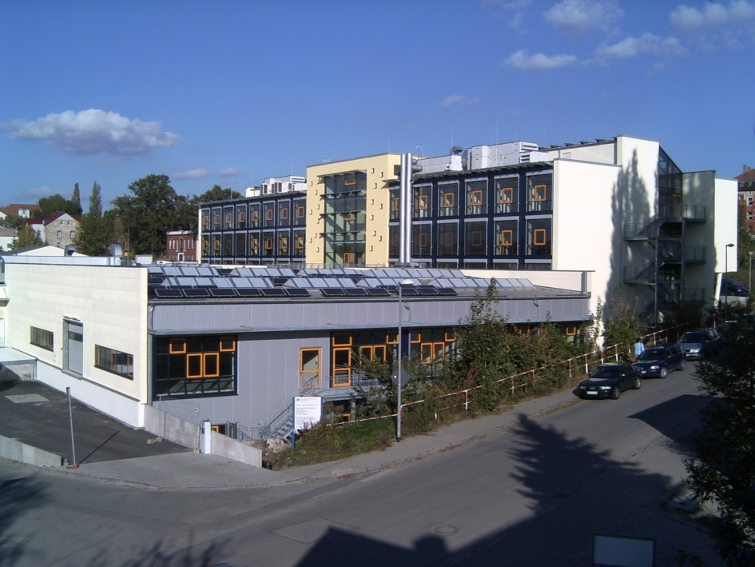

Figure 3: House no. 1 of Bautzen Innovation Centre

TGZ Bautzen offers competent support from highly qualified staff to newly established companies. The in-house management team is active in building links with universities, industry and the public sector. In addition to the individually designed support offered to tenants, the management also provides support and advice to new businesses in the region.

Two success stories should be described in detail:

Success story 1: LMR Service and Consulting GmbH
The LMR Service and Consulting GmbH was established at Bautzen Innovation Centre in November 2003. LMR started as a service provider for manufacturers of the electronic sector. LMR repairs some thousand notebooks per month. GERICOM, Fujitsu Siemens, Targa and NEC/Mitsubishi are customers of the LMR company. 2004 LMR has strategically broadened the scope of its activities into the fast growing LCD TV market. 2006 LMR left the Innovation Centre. The company invested in an old industrial site in Bautzen and established a TV manufacturing base there. The company operates with about 150 employees in Bautzen. LMR has also developed its business activities to Poland and South Africa.

Success story 2: BIT – Bautzen Internet Technologies GmbH
At the beginning of 2004 two graduates of the University of Cooperative Education Bautzen who after graduating worked for the big German software company SAP asked us to plan a start-up specialising in internet-based support for customers of their employer. First we analysed the potential for IT specialists in our region and the neighbouring regions in Poland and Czech Republic and established there would be enough IT-graduates for the new company. In February 2005 the start-up company BIT was founded at Bautzen Innovation Centre, and now has more than 100 employees, one third of them former graduates of the University of Cooperative Education Bautzen. The management of BIT will broaden its business activities and grow the team over the next few years. This exceptional development is underpinned by close co-operation between the start-up company, the Innovation Centre and the local University. Bautzen Innovation Centre is building the infrastructure for the growing company and the University is educating personnel for BIT.

71 companies, half of them start-ups, have settled in TGZ Bautzen since 1996. Figure 4 shows that most of the tenant companies are small. In 65 companies the number of employees is less than 10. Up to now the rate of insolvency is just 6 %.

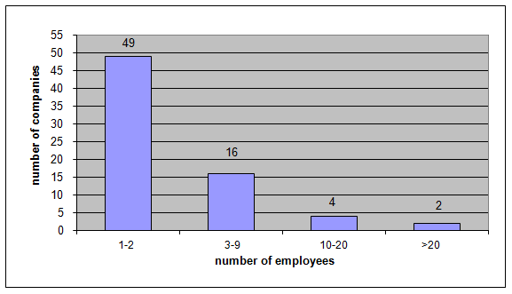
Figure 4: Employees of the tenant companies at Bautzen Innovation Centre since 1996

  - Knowledge and technology transfer – innovation strategies

Transfer mechanisms
TGZ Bautzen aims to contribute actively to technology advancement in Upper Lusatia by stimulating interaction and technology transfer between SMEs, industry, Higher Education Institutions, research centres and the public sector. There is no one single model of knowledge and technology transfer. Innovation involves complex interactive processes between research institutes and businesses including:

- the creation of science-based start-ups (spin-off firms)
- training for the implementation of new technologies
- joint strategic and applied research between academic institutions and companies

Contrary to the general idea that everything is globalized, including technology and know-how, the process of innovation occurs mainly through the interaction of companies and institutions that are structured at local and regional level. We have identified that SMEs in Upper Lusatia prefer to cooperate with local Higher Education Institutions. There are two Universities of Applied Sciences, one University of Cooperative Education and one International Graduate School in our region. The enlargement of the EU improves the possibilities for technology transfer from our neighbor countries Czech Republic and Poland but up to now we have witnessed only a small number of successful cross-border transfer activities.

Proactive co-operation with the local university
Regardless of specific regional surroundings, all Innovation Centres have to strengthen the links between Higher Education Institutions and the companies on site. We can currently observe that the role of Higher Education Institutions in most European countries is changing. Traditional academic universities are developing into entrepreneurial universities /3/. Innovation Centres should play a proactive role and collaborate with local universities in managing this change.

The University of Cooperative Education in Bautzen offers so called “sandwich” courses, whereby during their study the students have regular work placements in companies. The students obtain a diploma or a bachelor degree after three years. Bautzen Innovation Centre has for many years supported the University of Cooperative Education in Bautzen by offering work placements, organising information days concerning the course system and by further promotional activities. Staff members of Bautzen Innovation Centre deliver lectures in innovation management and entrepreneurship. The success story of Bautzen Internet Technologies described above is an excellent example of the co-operation between the Innovation Centre and the local university. A significant number of knowledge-based jobs have been created, and in turn the newly-established IT-service company influences the curriculum of the IT study at the local university. The company also strengthens the co-operation of the university with key players in the new economy in Germany, such as SAP.

Innovation Centres as key players in regional innovation strategies
Many European regions have developed so-called Regional Innovation Strategies (RIS). The aim of this type of strategy is to create a regional economy based on knowledge and technological innovation. Innovation Centres can be key players of such strategies, in close collaboration with local authorities and other partners in the innovation system. Innovation Centres can link together these partners. Technology-oriented companies and Higher Education Institutions are traditional partners for Innovation Centres. The technology intermediaries have to identify the technology fields with high relevance not only to the tenant companies but also to SMEs in the region. These technologies are priority areas for collaboration between the Higher Education Institutions and the enterprises. Transfer projects of the technology intermediaries should be focused on these technologies.

Bautzen Innovation Centre identified the technological priorities of SMEs and the local universities in the eastern part of Saxony in co-operation with all other Innovation Centres and the universities /4/. In the ellipse of figure 5 we can see technologies identified as highly relevant to SMEs and which also have a strong research focus in the universities in Upper Lusatia. The most important technologies here are information and communication, energy, construction, environment, automation, new materials and engineering technologies. On the other hand, we also find in Upper Lusatia technologies which are relevant to SMEs but which have no research focus in the local universities, for example textile technologies. In this case technology transfer from Higher Education Institutions outside our region is necessary.

Innovation Centres should contribute to the removal of obstacles to innovation. In particular, centres within industrial areas and less developed regions can enhance regional growth strategies by technology transfer projects with local companies.

0
10
20
30
40
50

5,0
10,0
15,0
20,0
25,0
research focus of universities
relevance to SME´s
ICT
energy technologies
construction technologies
environmental technologies
automation
new materials
engineering technologies
surface technologies
biotechnologies
medical technologies
micro systems technology
food technologies
optical technologies
laser and plasma technologies
traffic and logistic technologies
textile technologies

Figure 5: Relevance of selected technologies to SMEs in comparison to the research
focus of the universities in the eastern part of Saxony (Upper Lusatia)

Specific technology transfer projects of Bautzen Innovation Centre
Technology transfer as coordinated by TGZ Bautzen focuses on energy efficiency and the use of renewable energies - key factors in protecting the global climate. Furthermore, they reduce the dependency on foreign energy sources and create local employment.

We are active in the following fields of work:

- energy efficiency including power heat transfer
- use of renewable energy sources
- analysis of the energy use of buildings

Over 30 SMEs are involved in our projects in this field, as well as a large number of experts and consultants from academic institutions. In the future we will also deal with new strategies for regional mobility. We are keen to further the use of alternative drive assemblies, such as electric and gas motors and fuel cells.

  - Regional economic development

The economy of the surrounding region of Upper Lusatia is predominantly SME-based. There is only one major industrial centre comprising two manufacturing plants of Bombardier, the multinational rail vehicle manufacturer. Local industry is dominated by enterprises in the mechanical engineering sector, the construction and food sectors, the plastics industry and industrial service enterprises. Some of the old industries such as textiles have been drastically reduced. Only a small number of the SMEs in Upper Lusatia have their own products; most are subcontracters.

In East Germany many small and medium-sized enterprises are increasingly open to co-operation and networking, realising these are essential to achieve synergy and counterbalance the disadvantages of their smaller size compared to larger West German competitors. In order to overcome the principal weaknesses of SMEs in the face of the challenges of a global economy, it will be necessary to strengthen inter-company co-operation, especially in less developed regions like Upper Lusatia.

Co-operational network TEAM 22

TGZ Bautzen influences the economic development of the eastern part of Saxony by forming networks and local SME clusters. One example of a successful regional network of companies that benefits by combining local resources for local and global markets is the co-operation network “Team 22”.

Figure 6: Groups and number of companies
within the co-operation network Team 22:

1. Manufacturers of machines and equipment (10)
2. Subcontractors and service companies in the
metalworking sector (16)
3. Metal-construction and welding companies (12)

The co-ordination of Team 22 by TGZ Bautzen’s management team includes:
seminars and workshops
exhibition stands at national and international trade fairs
links with universities and other academic institutions
a database service

The network portal www.team22.de enables users to match their individual needs rapidly with every company in the database. When a match is achieved, the portal allows a direct line of communication to be established. The Centre management is available to provide advice on any subcontracting issue or problem. In the future we will also include companies from Poland and the Czech Republic in Team 22.

Bautzen Innovation Centre has already initiated several projects for the members of Team 22 to strengthen their competitiveness. The network management has organised sector-specific training courses for the companies. The management also provides support and advice to new businesses in the mechanical engineering sector. TGZ Bautzen aims to contribute actively to technology advancement in the sector by stimulating interaction and technology transfer between SMEs, key players in the sector, research institutes and the public sector. At present a project is ongoing with support from the national programme “Network Management in East Germany (NEMO)”.

Figure 7 shows the agencies involved. The network members are divided into three groups:

- Manufacturing companies in the fields of mechanical engineering and plastics industry
- Industrial service companies, e.g. in the area of construction and design
- Mechanical engineering departments of Higher Education Institutions

Figure 7: Structure of the NEMO-network project

Faced with competition and structural changes, firms are being forced to specialise even further and strengthen co-operation with partners who can more efficiently supply the services they need. The critical factor in maintaining such partnerships is trust. All activities of the network management must aim to generate a cooperative alliance between all network members or subgroups. So far four working groups have been established in the NEMO-network project:
- Rapid prototyping
- Lightweight construction materials
- New construction methods
- Hard surface coatings

In addition, bilateral co-operation has been initiated between individual project partners.

Local network “Continuing Education for SMEs in Upper Lusatia”

In a knowledge-based society individuals must update and complement their knowledge, competences and skills throughout life to maximize their personal development and to maintain and improve their position in the labour market. Innovative SMEs need a well-educated workforce - for example, in the field of mechanical engineering, competitiveness depends on having a workforce with a high level of engineering skills.

In our region and the whole of East Germany there are specific reasons for strengthening continuing education for SMEs:

- skill shortage in industrial R&D after 1989
- increased demographic changes
- migration of university graduates from East to West Germany

Skill shortages in industrial R&D after 1989
In East Germany we have a skills shortage in industrial research and development (R&D). After 1989 and reunification, the number of employees working in industrial R&D in East Germany declined from about 80,000 below 20,000 (see figure 7).

Figure 8: Decrease in employees in industrial R&D in East Germany after 1989 /5/

Increased demographic changes
Figure 9 shows the forecast decline in population in Germany and in Saxony for the next 3 decades. We see that the decline in population in Saxony is much higher in comparison to Germany as a whole. We will not discuss the demographic change in detail but we have to recognise that society is ageing. In 2020 people over 60 years old will dominate the population of Saxony while the smallest group will be people under 20 years old.

This demographic trend will influence education and training. Companies need to invest more in training for older workers. We have to develop a management strategy that sets out to improve the quality of work for older workers and to make the best use of older workers’ skills and experience. Older workers typically have much less access to training. However, experience clearly shows that many older workers can and want to continue to learn but traditional training delivery systems and methodologies are not necessarily suited for this age group. Thus there is a need to develop more appropriate and better-targeted training schemes for older workers.

Figure 9: Decline in population in Germany and Saxony /6/

Migration of university graduates from East to West Germany
Figure 10 shows a forecast for graduates in engineering technologies in Saxony. We know that only part of the present student population will stay in Saxony. If we take this into consideration we must recognise that there will be a shortage of young engineers in Saxony in future.

Figure 10: Forecast of Saxon university graduates in engineering technologies to 2020 /7/

Most SMEs have not yet realised the importance of developing their own people. Although there is an unemployment rate of about 20 % in Upper Lusatia, we already need qualified employees and engineers in specialist technology sectors.

In 2000 Bautzen Innovation Centre initiated a network project “Continuing Education for SMEs in Upper Lusatia” subsidised by the European Social Fund (ESF). Project activities focus on training courses for both management and staff of SMEs. In a network of about 20 regional training institutions and consultants we are offering training courses geared to the needs of SMEs. Areas of training activities are for example:

- information and communication technologies
- implementation of new technologies
- quality management (QM)
- marketing strategies
- business languages
- company organisation

In addition we are organising regular workshops on the development of education and training in SMEs, the enlargement of the European Union, the co-operation with companies from Poland and Czech Republic and the options for increasing the employment of women. Figure 11 shows an overview of our training activities up to now.

members of the network: 23

training programmes delivered : 292

SMEs benefiting: 1,024

participants benefiting: 2,224

quota of women / %: 41

Figure 11: Activities of the local network “Continuing Education for SMEs in Upper Lusatia”

This network project is characterised by a high level of flexibility. Training programmes are offered throughout the region by the network members. We work with small groups: courses can be started with a minimum of 6 participants. A training programme can be as short as 24 hours and we often divide extensive subjects into several shorter modules. It usually takes no more than a month from an application for a training programme to commencement of the course. Due to this flexibility a high number of SMEs and their employees are involved in our project.

Companies in the mechanical engineering sector, including the network members of Team 22, are part of the target group for the training and education network “Continuing Education for SMEs of Upper Lusatia”. The engineers and skilled workers being trained today will shape the manufacturing industry of tomorrow. There is an urgent need for more applicants for degree courses and vocational training programmes in mechanical and electrical/electronic engineering. Furthermore, study programmes must give greater emphasis to team-working skills, with the aim of training engineers and skilled workers to become advocates of complex, globally-innovative solutions. Therefore the partnership between Team 22 and the educational network is important for the success of both initiatives.

5. Conclusions

TGZ Bautzen contributes to the economic development of Upper Lusatia by hosting and providing assistance for technology-based start-ups as well as for existing enterprises from both the old and new economies. We identified technologies with high relevance to SMEs and with strong research focus at the universities in Upper Lusatia. These technologies are priority areas for collaboration between the Higher Education Institutions and the enterprises. Transfer projects of the technology intermediaries should focus on these technologies. Innovation Centres can influence the economic development of their surrounding region by fostering the development of regional cluster initiatives and networks. At the regional level clusters should improve the quality of economic activities and in particular create or sustain highly qualified jobs. This in turn opens the way to the speedy implementation of innovation and facilitates a rapid response to customer needs and market trends.

The region of Upper Lusatia in the south-east of Germany is undergoing a major transformation which started in 1989 and continued with the enlargement of the European Union 2004. The region also faces increasing demographic change with an ageing population and the migration of young qualified people from East to West Germany. However, Upper Lusatia is also moving toward a knowledge-based society. One important tool in achieving this goal is lifelong learning for SMEs.

References

E. Hartstock: Die Oberlausitz – so wie sie war, Droste Verlag GmbH, Düsseldorf, 1992,
ISBN 3-7700-0977

UK Innovation Report, Department of Trade and Industry, December 2003,
http://www.dti.gov.uk

www.bepart.info

J. Besold et al.: Die Region Oberlausitz-Niederschlesien – Innovationspotentiale und Perspektiven im Dreiländereck, ifo dresden studien 38, ISBN 3-88512-437-8, ifo Institut für Wirtschaftsforschung, München, 2005

Konzack, Scientific Agency Berlin, 1998

Statistical Federal Office of Germany, Statistical Office of the Free State of Saxony, forecast of the ifo institute for economic research, Munic/Dresden, 2004

Technical University Dresden, planning board, 2004

