Surprising Similarities: American and Saudi Women Entrepreneurs
Ms. Naeema Farooqi, Lecturer, Business Studies Program
Dar Al-Hekma College, PO Box 34801, Jeddah 21478, Kingdom of Saudi Arabia
Tel: +966-2-6303333 ext 290 E mail: nfarooqi@dah.edu.sa
Doctoral candidate, School of Politics and Communication Studies
Roxby Building, University of Liverpool L69 7ZT, UK

Ms. Debra Murray, President, Managing Member
Blue Spring International - a HealthStyle International Company
DDM Management, Inc.
Abstract:
This paper was conceived when four WPO (Women’s President’s Organization) members came to Dar Al-Hekma College to conduct a training program for Saudi women entrepreneurs. This was a first for the Kingdom’s women entrepreneurs. The visiting American women entrepreneurs owned and operated their own million dollar plus businesses and had extensive personal experience. Ms. Naeema Farooqi was the local consultant for the Marketing module and co-trained with Ms. Debra Murray. The discussions during the workshops led to a joint study carried out with research.

Prior Work:
Prior research work in women entrepreneurship and comparative studies between countries and continents has taken place. But a comparison revealing surprising similarities among Saudi and American business women – cultural groups widely popularized as extremely diverse – was both exciting and interesting. Theories are related to both Saudi as well as American practical perspectives. Saudi Arabia is often portrayed as an unlikely setting wherein women could establish and operate their own businesses, let alone have any similarities with women-owned businesses in one of the most advanced countries in the world, the United States. Saudi culture, with its uniqueness, customs and business practices, does indeed have some different challenges, yet the study found many analogous relationships to connect the two.

Approach / Methodology:
The research was conducted amongst 40 established business women, 20 each from the United States and Saudi Arabia. The initial preliminary research was done during the workshop sessions in April 2007. Over the next weeks more data was gathered from both the Saudi and American sides. All business women had to be actively involved in the business and not just preside on the board of the company. Businesses chosen were between small to medium-large companies belonging to any industry/trade. The number of employees could be 4-20+. Data was then compared and analysed for presentation.

Results and Implications:
Initially, the researchers held the premise that due to vast cultural and professional differences, there would be little or no similarities between the two groups. However, research proved otherwise, when several similarities were established, which are the focal point of this presentation.
This opens discussion to probe further, given that similarities can be found in such diverse groups, whether women entrepreneurs all over the world can be considered to share similar challenges, opportunities and have the same strengths which make them unique.

Value:
Value is added to other educators, researchers and students from this insightful finding to encourage further research amongst other apparently different cultures as well. For women entrepreneurs/practitioners, this research can enhance business dealings amongst themselves globally. Some areas of research along the same lines could be: European and American women entrepreneurs; Arab and other Muslim country women entrepreneurs; Indian and Japanese women entrepreneurs; etc.

Keywords: Culture, Entrepreneurship, Mentoring, Saudi business women, American business women, Empowerment, Leadership and Global business practices.
There is a growing trend of interest regarding women entrepreneurs all around the world. Following this trend, the Global Entrepreneurship monitor indicates that entrepreneurial activity amongst women entrepreneurs and self-employed ventures have increased significantly in 34 countries studied (Minniti et al; 2005). In Canada, for example, the number of women self-employed has increased four fold between the years 1976 and 1997, while for men entrepreneurs the number did not reach more than double (Hughes, 1999). It is also widely recognized that women play an important role in the overall growth process of a country (Minniti et al, 2005). Small and medium size businesses, possibly such as those set-up by women, are now widely applauded for their positive contributions to their local economy all over the world. This has dramatically increased the interest of scholars in researching this field of women and entrepreneurship. Furthermore it has also resulted in greater interest from policy makers to encourage this form of economic activity.

Langowitz and Minniti attribute the building of entrepreneurial attitude on subjective perceptions rather than objective conditions. They have correlated self-confidence with opportunity perception and the propensity to starting a business. This may also vary between women and men entrepreneurs (Langowitz, N, et al; 2007). A study about Hungarian women entrepreneurs found they classified their personalities as energetic, social, high in terms of independence and self-confidence, perfectionist, anxious, flexible, and goal-oriented (Hisrich & Fulop, 1994). Building upon the same attribution theory as presented above it can be suggested that these subjective perceptions can also be ascribed to the surrounding environment and culture.

According to a study conducted by the OECD, a significant amount of entrepreneurial activity is generated in North America. Women entrepreneurship accounted for 41.2% in Canada, while in the United States it was at 39.2%, and Mexico followed with 36.1% (OECD 1998:25). North America has always been considered the hub of all entrepreneurial action, a trend emulated in Australia and then in Europe. In Saudi Arabia, the number of women entrepreneurs is marginal, yet, despite the conservative culture and environment, the numbers have managed to grow slowly, steadily and painfully.

Korunka, Frank, Lueger and Mugler state that the start up of new business ventures is a complex process which, to an extent, depends on person-environment interactions that influence the business creator and the creation process(Korunka, et al; 2003).

These ideas formed the basis of our research premise. With divergent economies, cultures and social set up, both the Saudi and American women would be influenced by their environment in different ways resulting in the formation of an enterprise and an entrepreneurial mind set.

Islam is a progressive religion and does not stop women from working in all spheres of productive life. It sets boundaries within which women can work to their optimum potential. Khadija Bint Khuwailid, the wife of Prophet Mohammad (peace be upon him), was the first Muslim business woman. Clearly the Prophet (peace be upon him) approved and supported his working wife some 1400 years ago, and this is the prime example for any other Muslim woman to follow. Today, the hijab and other much talked about issues such as not being able to drive, have overshadowed the real expectations of Saudi women entrepreneurs who are using the so-called restrictions on them to cater to an entire market of women consumers who have the demand for niche products as well as purchasing power to match.

A delegate present at the Women in Business Conference held in London in 2004 commented on Saudi business women:

The Saudi Arabian delegates were intelligent, interesting, funny and above all optimistic. Listening to them speak about their jobs, their children and their ambitions, they could have been women from anywhere in the world. (Middle East; 2004)

Dr. Thoraya Ahmed, Executive Director of the United Nations Population Fund (UNFPA), told the Saudi Arabian English language daily, Saudi Gazette, during a March 2001 interview:

One goal I hope to achieve through my position is to show that Islam is a very progressive force. Islam is a force that can bring progress to society. Islam is pro-women and we have to show how it is pro-women. I think that the West has not seen the real Saudi Arabia and maybe part of our responsibility is to open up and show that Saudi Arabian women have made a great deal of progress. (Hanley D; 2001)

Just like most growing economies, Saudi Arabia is an emerging economic force and business women are being encouraged by the Saudi government with new incentives and initiatives. Saudization and growing opportunities for working women is marking the beginning of a new era in the Saudi society, used to covering up the role of women in black wrapping. The successful election of Saudi women like Lama Al Sulaiman to the board of the Jeddah Chamber of Commerce in 2005 is an indication of the progress women are making in spite of the many publicised restrictions.

Peter Drucker, the management guru, defined entrepreneurship as neither a science nor an art. In his words, “It is a practice”. This paper attempts to explore this practice with apparent differences yet unknown similarities which were found between the Saudi and American women entrepreneurs.

The methodology used in this preliminary study is interviews and is justified at this early stage of research since very little data is available on Saudi women, let alone Saudi women entrepreneurs. Primary data was gathered from both American and Saudi women and then analyzed.

Prior work:
Much literature is available regarding entrepreneurship but less about women as entrepreneurs and even less about Saudi women entrepreneurs. Harvard International Review, in a report, cites that approximately 20,000 businesses in Saudi Arabia are owned by women, and this does not include the many non-registered businesses (Patni; 1999). According to the study, in Riyadh, the capital city, women own one-third of all enterprises. Fatin Bandagii, from the Women Business Centre at the Jeddah Chamber of Commerce, gives a more conservative estimate of 3,000 businesses operating under women.

The most common business ventures among Saudi women entrepreneurs, most of the ventures being unregistered, are beauty salons, catering companies, as well as tailoring shops and photographic services. Some women are now starting companies to provide web design and development services; wedding planners; and event management services. In Jeddah, women are driven by their entrepreneurial ambition as well as their inclination to have more freedom by being self-employed. They are job creators, hiring women like themselves and causing a ripple effect in the society, where they lead by example. Many of the employees in businesses such as beauty salons and photography studios, usually venture out to open competing businesses on their own once they have gained substantial experience. The increasing size of the market and its growing needs, however, allow enough clientele for all as each may cater to a completely different consumer segment.

Saudi women are entering new fields of employment, no longer limited to the traditional medicine and education spheres of work. According to Pharaon, women constituted 7% of the wage-earning workforce and are employed in banks, in the computer operations of utility companies, in television and radio programming, and in some ministries. They also work as clerical assistants, journalists, university professors, social workers, physicians and nurses, and are active in women's charitable organizations (Pharaon, 2004). Responding to the increasing number of women joining the information technology and banking sectors, many colleges offer specialized degrees in these fields that are often taught in English, to prepare women to meet local needs as well as global challenges. Women are also mentoring each other by opening up training sessions to train women into their own businesses on a small scale. Al Multaqa, located in an upmarket area in Riyadh, is an example of an entire mall for women by women, and men are not permitted to enter. Every worker in the mall, from the manager to the cleaner, is a woman. The change in opportunities for Saudi women in general, and Saudi women entrepreneurs in particular, is occurring due to the importance the Kingdom is placing on supporting women’s contribution to socio-economic development. This is being achieved through a number of initiatives, one of the most important of which is educating women and girls at all levels and in various disciplines, including newly-introduced, non-traditional (in the Arab world) courses, such as Banking, Architecture, Graphic Design and IT, which are typically taught in the English language.

In a study conducted by Baughn, Chua and Neupert, it was found that support for women's entrepreneurship appears to be embedded in overall attitudes about entrepreneurship and gender equality along with economic considerations, which encourage or discourage entrepreneurial activity (Baughn, Chua & Neupert, 2006). This is reverberated by modern Arab scholars. Mai Yamani, a lecturer at King Abdul Aziz University in Jeddah and the School of Oriental and African Studies in London, states that modern Arab women are more educated and thus receive better jobs, and subsequently will have a higher standard of living than previous generations and will participate more effectively in the workplace. In addition, some Arab women go abroad for higher or vocational education, despite knowing that job opportunities for them in Saudi Arabia are still scarce. This may be one of the reasons why so many educated Saudi women are starting their own businesses (Patni; 1999).

Saudi women apparently do have the financing available to support their entrepreneurial spirit, with women's bank deposits estimated to be worth billions of dollars, according to Afaf al-Hamdan, Director of the Women's Investment Services Centre (WISC) at SAGIA (Patni; 1999); what they may be in need of now are different ways of multiplying and sharing their wealth while satisfying their entrepreneurial spirit. According to Washington Report on Middle East Affairs, thirty percent of individual bank accounts in Saudi Arabia belong to women. As discussed previously, not only do women attend universities, but some own and run businesses, including some of the biggest. All of these advances have occurred within a system of sharia (Islamic law) and give control to women over their social and financial destinies (Hanley; 2005).

Having positive role models is another factor which helps women into entrepreneurship and Saudi women entrepreneurs are no exception. Lubna Olayan is the CEO of Olayan Financing Co.; she looks after the interest of 40-odd companies in the Middle East. She is a major private investor and has significant influence in the Kingdom. She has broken down barriers in the business sector amongst men and changed the typical Saudi stereotypes. In 2004, the Saudi Hollandi Bank elected her to its board and made her the first woman to fill such a position in a Saudi public company. She also co-chaired the 2005 World Economic Forum in Davos, Switzerland, and has brought laurels to the Kingdom’s international image.

Olayan tends to downplay her positive impact on perceptions of Arab women's roles. But wherever she goes, especially since the Jeddah speech [during the Jeddah Economic Forum], she is a star. She reminds everyone that Saudi women are capable of running not only the house but also major companies. It is in no small measure thanks to her that the advancement of women in Saudi Arabia is finally reaching a point of no return (Al Saud; 2005).

Approach / methodology:
The research is in its developmental stage with potential for future researches since only a minimal amount of comparative data is available on Saudi and American women entrepreneurs. It was conducted amongst 40 established business women, 20 each from USA and Saudi Arabia. The initial preliminary research was done during the workshop sessions in April 2007. Over the next weeks more data was gathered from both the Saudi and American sides. Interviews were conducted and questionnaires were used. Some video clips were also recorded and transcribed. All business women included in the study had to be actively involved in the business and not just sit on the board of a company. Businesses chosen were between small to medium-large companies, belonging to any industry/ trade. The number of employees could be 4-20+. Data was then compared and analysed for presentation.

Results and implications:

Figure 1
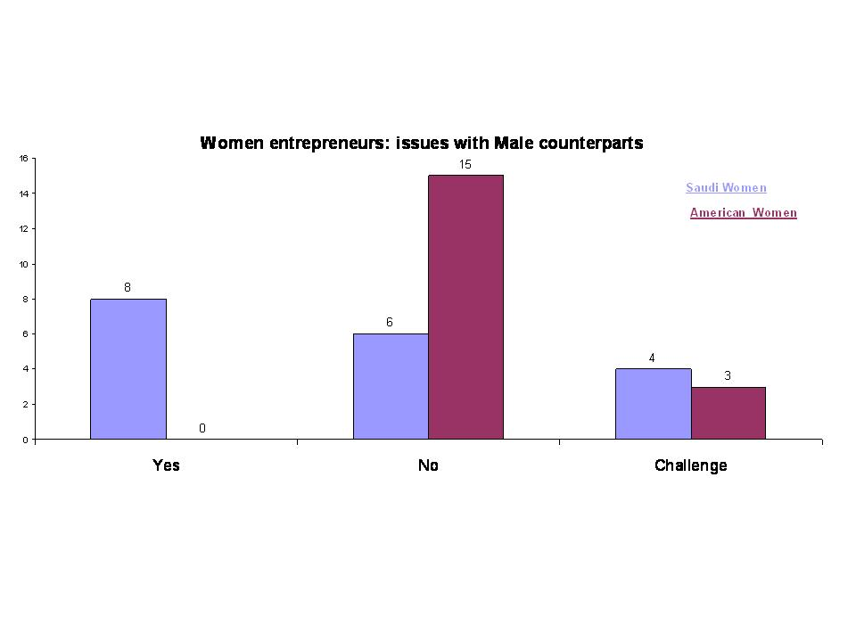
One of the hypotheses at the initial stages of the research, which resulted from the workshop sessions conducted at Dar Al-Hekma College in April 2007, was that Saudi and American women face the same or almost similar discrimination from their male counterparts. In fact, this premise led to an interesting argument during the workshop, which triggered the interest to research this topic further (see Figure 1). Although the discussion during the workshop concluded that women entrepreneurs face the same issues with men in both countries, the response to the question, represented graphically above, shows that Saudi women have in fact more issues with their male counterparts. This is likely due to the culture and norms of the Kingdom, wherein the society is segregated on the basis of gender and women are not allowed to work in the same offices as men. However, they are allowed to work in separate offices with minimum interaction between the sexes. According to our preliminary research findings, none of the 20 American women entrepreneurs responded by answering yes when questioned about whether they face any issues with their male counterparts. Eight Saudi business women said that they had issues, while 6 of them said they did not face any issues. Their reason on further exploration was found to be having a good infrastructure by hiring male managers (mandoob) who did all the government and public dealings on their behalf, thus allowing them to interact less with male outsiders. These women entrepreneurs reported having more peace of mind at the cost of the manager’s salary.

Both the American and Saudi women entrepreneurs did, however, face quite similar challenges when working around their male counterparts. Common challenges reported were discrimination faced in closing deals, women’s inability to bribe and a general attitude of male counterparts to think of the women entrepreneurs as weak and non-serious business owners. These thoughts were shared by both the American and Saudi entrepreneurs.

Saudi Arabia has a significant business sector driven by female entrepreneurs, but this 'shadow economy' remains unregulated and many of the women involved are marginalized from the wider business world. While Saudi women officially make up just 4 per cent of the total workforce – or 10.7 per cent of the indigenous workforce – unofficial estimates from the Planning & Development Ministry puts their contribution at 30 per cent of gross domestic product (GDP). The JCCI election is a sign that this is changing and that the role of women in the Kingdom's economy is increasingly becoming recognized (Meyer, C; 2006).

Figure 2
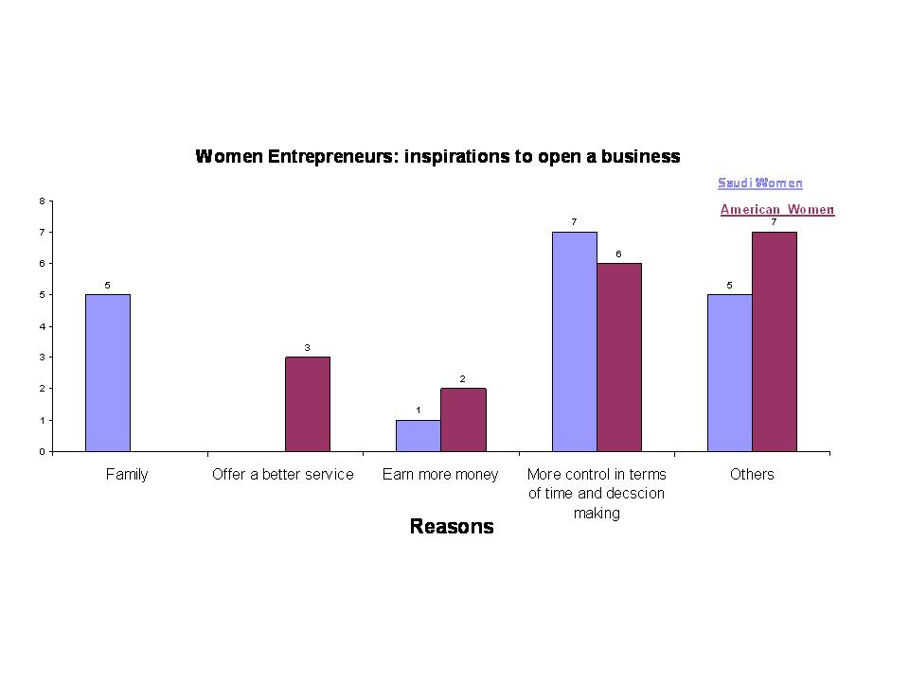
As depicted in Figure 2, the interesting question regarding who and what inspired the respondent to open her business, had more similarities than differences. Some responses of the American and Saudi women displayed a distinct opinion regarding one or the other factor. For Saudi women entrepreneurs, family was an inspiration to open businesses. They had their mothers or parents and in some cases their bothers, who inspired them to venture into the business world. This is an interesting dimension since internationally Saudi women are often characterized as ignored and oppressed and without any support from their family. Some American entrepreneurs, on the other hand, sought to improve services as currently offered by other existing businesses and felt they could do a better job. Entrepreneurs from both countries wished to earn more wealth by going into their own business. In addition, both Saudi and American entrepreneurs also wanted more control of their time and were attracted to the independence and freedom of ‘being their own boss’. Other reasons which were given were more professional challenges, more excitement, and meeting personal and financial goals.

This finding resonates with an independent study carried out by Neider that involved an investigation of female entrepreneurs in Florida. Of 52 female entrepreneurs, over half had an entrepreneurial parent as a role model. Over 90 percent opened businesses in the service sector, and most made extensive use of male mentors and personal business advisors (Neider, L; 1987).

Figure 3
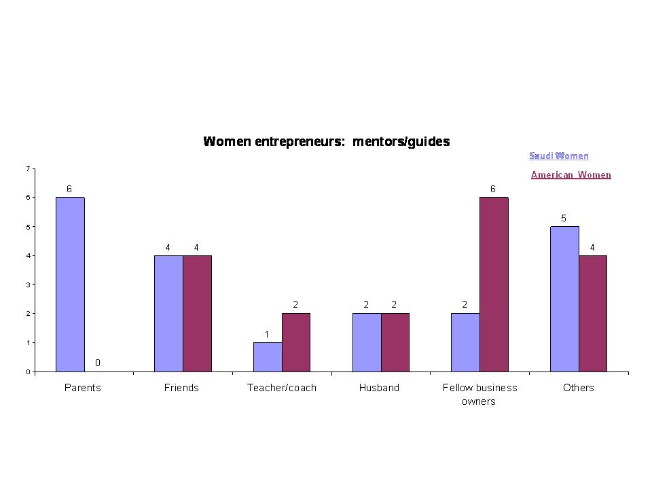
In Figure 3, respondents were asked who they look upon as their mentor and guide and, with the exception of one dimension, the responses were closely comparable between entrepreneurs of both countries. Parents were oftentimes the mentors for Saudi entrepreneurs, while their US counterparts looked upon other sources for guidance. This variance may have occurred since some of the Saudi entrepreneurs interviewed belonged to family businesses and had been promoted and trained by their parents who guided them into business, as it is usually a challenge for women to move around strange men, due to cultural constraints and norms of the society. Family business in this scenario works as a perfect training ground for female family members since they will only interact more closely with their fathers and brothers, both of whom are their mahrams (related male guardians), which makes it socially acceptable as well as an ideal base for future succession planning.

The other dimensions of this open ended question led to more or less analogous findings between Saudi and American women entrepreneurs. Both look up to their other business friends and associates for advice and guidance. Both also have teachers from universities and colleges as their mentors, although more teachers act as coaches for the American women. Husbands, for both nationalities of our respondents, were mentoring their spouses successfully and this was an interesting insight since in the Middle Eastern culture, the husband is often stereotyped as the protector of his womenfolk, not letting them participate in, or contribute to, the financial affairs of the household, let alone have their own businesses. It was, however, interesting to note that the Saudi women who ranked their husbands as their mentors were younger in age than other respondents who did not indicate their husbands as mentors. This finding, although of little significance in terms of 20 as a total number of respondents, points towards future research on younger Saudi entrepreneurs as compared to older Saudi entrepreneurs. With the continued progress and development of the Kingdom, perhaps the younger generation of men are realizing that it is harder to depend on one family income and are therefore seeking educated working women who can contribute positively to the family and the economy. It is no longer a taboo or embarrassment to permit your wife and sisters to work, especially if they are educated and have the drive to achieve.

The next dimension addressed in this question is regarding other fellow business owners as mentors and guides. The response received from American women entrepreneurs was quite high since there are more women entrepreneurs to network with and many platforms such as the WPO (Women Presidents’ Organization) and Young Executives Venture Organization, to facilitate this interaction. On the other hand, in Saudi Arabia, women entrepreneurs, despite growing gradually, still remain small in number to truly benefit from the sharing of ideas and information. Furthermore, there is no formal Saudi business women’s organization, except the Women’s Centre at the Jeddah Chamber of Commerce, to encourage women to interact and network with each other. Such platforms for regular meetings ought to be provided in the future to offer help, support and facilitate discussions of shared problems and possible solutions as well as becoming a voice for instigating new rules, perceptions and possibly a few norms.

The last dimension of this question explored whether other individuals may be mentoring the female entrepreneurs, and bankers, lawyers, professionals and relatives were found to be common sources of advice and guidance for both Saudi and American women entrepreneurs. The Saudi women, however, ranked higher on having other individuals as mentors. This facet can also be researched further. An interesting fact:

As much as 40% of Saudi private wealth is in female hands, according to Mai Yamani, the daughter of a former oil minister and now a research fellow at the School of Oriental and African Studies in London. A quarter of the property in Riyadh, the capital, and half the property in Jeddah, the Kingdom’s second city, is owned by women (WINN; 1995).

Figure 4
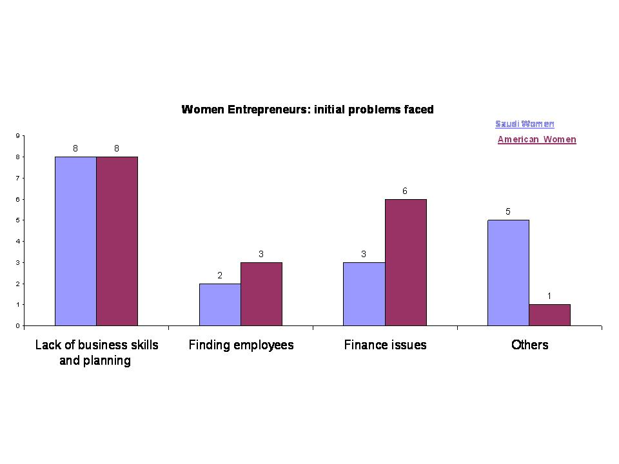
The last aspect of the interview addressed the problems faced by the women entrepreneurs. Lack of business skills was the most common problem, rated highest by an equal number of Saudi and American respondents. This may show a trend that entrepreneurs from both sides venture into business with an idea but not necessarily a plan and procedure. Employing the right people is a common issue faced by entrepreneurs in both countries; however, more US women entrepreneurs listed it as a problem as compared to their Saudi counterparts. Financial issues were reported by more US women entrepreneurs, although bank financing and small projects financing is more popular in the US and there are no taboos against interest and credit as is prevalent in the Shariah (Islamic laws) compliant Saudi Arabia. Another similarity between the two groups was maintaining work-life balance and effective time management strategies to better manage life between family and business.

Indeed, the challenges of home and family are likely much the same for Saudi and American women. They both may struggle with putting their families first and still running a successful business and meeting the needs of their employees and team members. This may often make them feel stressed and torn between two goals. The expense of childcare is quite high in the US, while in Saudi Arabia, hired help is cheaper and easier to find but the quality of that help is not measured or standardized by any rules. Female entrepreneurs can also have household duties and personal family responsibilities that reduce the time they have available to spend on their businesses. The stress of two obligations may pose a challenge to both Saudi and American business women, and probably is applicable to most women in similar circumstances around the world. Learning to find balance and personal health is a top concern for the women entrepreneur – whether Saudi or American.

The last dimension of problems faced was not surprisingly higher for Saudi women entrepreneurs. It listed issues of having a male partner or manager to interact with external parties as the highest problem, followed by licensing, lack of guidance, as well as insufficient family support in some cases, as being the concerns of these Saudi women. Finding trustworthy suppliers was another dimension mentioned by both Saudi and American entrepreneurs. These findings are comparable to the study of Hungarian women entrepreneurs, since they also have identified more or less the same areas for improvement within the public sphere:

The Hungarian women entrepreneurs recommended a Western-style business-education system. Specific courses mentioned included international management (5), business management (4), entrepreneurship (3), marketing (20), and finance, investment, public relations, accounting, tax, legal, strategic planning, computer language, and basic business. Other recommendations for improvements in education included continuous management training (5), professional training (3), training more skilled workers (2), training courses for government officials who affect business in the city council (2), and entrepreneurship courses for middle and high school students (Hisrich & Fulop, 1994).

Conclusion:
The preliminary research conducted has generated enough interest in the researchers to continue addressing this area in more depth, and further research is necessary to truly add value to the available literature. It is important and timely to investigate entrepreneurship amongst Saudi women and use their US counterparts as successful case-studies to learn from and model from as differences seem fewer than similarities.

All entrepreneurs are challenged by the ‘World being Flat’ – having the same goods in America as in Saudi Arabia – mostly from China. Everyone is competing with what other emerging countries have to offer. This has created a glut of low priced goods internationally that all must compete with. The way businesses can stand apart, in Saudi Arabia and in America, is through excellent service to customers and those that depend on quality. Both Saudi and American businesses are challenged by how to differentiate themselves in a worldwide market – and this can be done by the uniqueness of their customer care.

Saudi and American women have many of the same options available in starting a business – outsourcing parts of their business and effectively utilizing technology such as the World Wide Web are both opportunities to start business with lesser resources. Call centres in India are available to both groups.

Both Saudi and American women entrepreneurs are equally challenged to understand why they are in business, what sets them apart and makes them unique, and how they make a profit. This sense of purpose must be conveyed to their team members, family members, investors and the public. Saudi and American women all have passion for what they do or want to achieve. This makes their message to others compelling and convincing. Both are equally challenged by hiring a good workforce and creating a good team. They can meet these challenges by offering others an opportunity they may not have had elsewhere. They can excel by training, nurturing and being positive to their employees and offering them a chance to be a part of a special team. They must all take care at getting the right people on their teams and making sure they are in the right places to grow and contribute to the growth of the company.

Both Saudi women and American women are very nurturing, which makes them good employers. They are intuitive and treat the members of their team like extended family members. They can do the same for their customers. This can give them an advantage over a male-run business.

Saudi and American women face many of the same challenges relating to outside financing. They must have a market for their business, they must have collateral, they must invest in their own business, they must make a profit, and they must have a good credit record. (This is traditional financing.)

As Saudi and American women market their companies, they must each go through the same steps to identify their markets. With globalization and technology, a Saudi and American company may be competitors even though they are located across the world from each other. This is where understanding local marketplace is important; knowing the laws and requirements of the home country or region can give the business an advantage over another business originating elsewhere.

Women entrepreneurship is a growing trend all over the world. Western nations have embraced it and are building their economies with much contribution from women to the country’s GDP. Countries such as Saudi Arabia are recognizing the importance of women’s contribution, and infrastructure development and government pilot programmes are being launched to support and ease Saudi women into self-employment. One such effort recently undertaken by NCB (National Commercial Bank) is the promotion of women’s home-based businesses through its community service unit:

The bank’s AlAhli Program for small enterprises as part of the community service bank, which primarily aims to provide employment opportunities and special mechanism to train small-business sector for young men and women. NCB has trained 175 under the program over the past year, and 37% of the total succeeded in establishing their businesses from home (Arab News; 2007).

Female entrepreneurship, whether being studied and researched among Saudi or American women, as demonstrated and attempted in this paper, or indeed among women entrepreneurs from other countries, is found to be embedded in the social relations of ethnicity, gender, class, the family, finances, support system, encouragement, perception, etc. We conclude that female entrepreneurship is complex and multi-layered, and needs multiple measures and multi-dimensional approaches to understand fully its changing nature and dynamics derived from the cultural and multi-faced backgrounds.

References:

Al-Saud, A, (2005) Lubna Olayan. Time Canada, Vol. 165 (16)

Arab News, (2007) http://www.arabnews.com/?page=6&section=0&article=101042&d=10&
m=9&y=2007&pix=business.jpg&category=Business

Baughn, C. C., et al (2006). The Normative Context for Women's Participation in Entrepreneruship: A Multicountry Study. Entrepreneurship: Theory and Practice, 30(5), 687+. Retrieved September 9, 2007, from Questia database: http://www.questia.com/PM.qst?a=o&d=5017554427

Hanley, D (2001) Saudi Arabian Women Dispel Myths and Stereotypes: Washington Report on Middle East Affairs, Vol. 20(4)

Hanley, D (2005) Empowering Saudi Arabian Women: Washington Report on Middle East Affairs, Vol. 24(7)

Hisrich, R. D., & Fulop, G. (1994). The Role of Women Entrepreneurs in Hungary's Transition Economy. International Studies of Management & Organization, 24(4), 100+. Retrieved September 11, 2007, from Questia database: http://www.questia.com/PM.qst?a=o&d=5000303141

Hughes K.D. (1999) Gender and Self Employment in Canada: Assessing trends and Policy Implications, research Report document number 18381. Canadian Policy Networks, Ottawa

Korunka, C., et al (2003). The Entrepreneurial Personality in the Context of Resources, Environment and the Startup Process-A Configurational Approach. Entrepreneurship: Theory and Practice, 28(1), Retrieved September 9, 2007, from Questia database: http://www.questia.com/PM.qst?a=o&d=5002579194

Langowitz, N, et al (2007). The Entrepreneurial Propensity of Women Entrepreneurship: Theory and Practice, 31(3), Retrieved September 9, 2007, from Questia database: http://www.questia.com/PM.qst?a=o&d=5021317702

Meyer, C (2006) Meaning business. MEED: Middle East Economic Digest, Vol. 50(7), p73-74

Middle East; 2004 Issue 347, p5-5, 1p, 1c

Minniti, M. et al (2005) Global Entrepreneurship Monitor, 2004 Report on Women and Entrepreneurship Centre for Women’s Leadership at Babson College and London Business School, Babson

Minniti, M., Arenius, P; Langowitz, N. (2005). 2004 Global entrepreneurship monitor special topic report: women and entrepreneurship. Babson Park, MA: Center for Women's Leadership at Babson College

Neider, L. (1987). A Preliminary Investigation of Female Entrepreneurs in Florida. Retrieved September 9, 2007, from Questia database: http://www.questia.com/PM.qst?a=o&d=5001682337

OECD(1998) OECD Proceedings: Women Entrepreneurs in Small and Medium Enterprises. Organization for Economic Co-operation and Development, Paris

Patni, A (1998-99) Behind the veil: Harvard International Review, Vol. 21(1) p15

Pharaon, N. A. (2004). Saudi Women and the Muslim State in the Twenty-First Century. 349+. Retrieved September 11, 2007, from Questia database: http://www.questia.com/PM.qst?a=o&d=5008547124

Robson, V (2005) Business behind the Veil: MEED: Middle East Economic Digest: Vol. 49 (25)

Update (1995) Women's International Network News, Vol. 21, (2) p52

