Managing the transition from research to product-focus in
new technology-based firms

Malcolm Sellars

MBA Student, Open University Business School

Email: msellars@ieee.org

Keywords: NTBF, growth, evolution, transition, lifecycles.

Abstract
New technology-based firms (NTBF’s) often experience “growing pains” as they move away from research and focus on a product to bring it to market. Changes in management focus, resource allocation, organizational structure, culture and control systems, all create conflicts and tension. This project investigates the extent to which different NTBF’s experience these growing pains, evaluates lifecycle-stage models, highlights management solutions and makes recommendations for future studies.

Two approaches for analyzing growing firms were found in the literature: (1) The lifecycle-stage models [Greiner, 1998], [Andries, 2006], show NTBF’s progressing sequentially through a number of growth stages, each bringing specific opportunities, challenges, and demands for the organization. These models are not consistent in the number and alignment of stages. (2) A recent paper by Phelps, Adams & Bessant [Phelps, 2007] challenges the view that firms go through well-defined stages as they grow. It is postulated that organizations naturally expand and contract over time, and so unidirectional linear models are not appropriate. Instead, growth is charted by the emergence of specific management problems (“tipping points”), which must be overcome.

In order to investigate how well the lifecycle-stage theory applies to NTBF’s and compare it to that of Phelps et al., this study simplifies the different lifecycle-stage models by adapting [Greiner, 1998] to focus on just 3 early stages: creativity (research), direction (focus on product) and delegation (focus on processes).

Longitudinal surveys across different firms are useful to map the characteristics of NTBF growth, and to ensure that results are not unique to a single organization. Due to project time constraints, opportunistic sampling was used to perform retrospective longitudinal surveys on 48 technology-based firms, using a detailed questionnaire. To date, 41 firms have completed the questionnaire and of these, 31 responses have shown a significant transition from research to products.

The firms surveyed were distributed between consumer electronics, telecommunications, software and semiconductors. Firms were mapped onto lifecyle stages using the intersection of 3 different measures: (1) shift in application of research, (2) shift in design emphasis from technology to market, and (3) shift in customer segment. Early results show a significant progression in lifecycle stage from creativity to delegation as the firms grow. The results are also plotted using Phelps’ Tipping-point model to show how useful this is in practise.
Introduction
New technology-based firms (NTBF’s) are defined as entrepreneurial firms, usually in the survival or growth phase, which creates and exploits technological innovations through R&D in a high-technology industry [Choi, 2004]. NTBF’s make very important contributions both to technological progress and to the economy of a country [Oakey, 2007]. These firms are interesting to study because they exhibit extremes of the pressures that come with growth and adaptation.

New technology-based firms take an “innovation journey” when they invent, develop and implement new products or services [Van de Ven, 1999]. One approach to studying this journey views it as a progression through a series of stages or phases of development. The stages are thought to follow one-another in a predictable, sequential way.

The literature reveals a number of different models for lifecycle-stages in NTBF’s, [Andries, 2006]. See Fig.1 for an illustration of the models: (a) [Quinn, 1983], (b) [Brah, 2000], (c) [Hanks, 1993], (d) [Kazanjian, 1989], (e) [Moore, 1999], (f) [Churchill, 1983], (g) [Greiner, 1998], (h) [Abernathy, 1978]. The different models all show slightly different stages and classifications, but all show NTBF’s progressing sequentially through a number of growth stages, which have definite attributes in terms of market opportunities, challenges, and demands on the company. The models are not consistent in the number or exact alignment of stages. The “research-to-product transition” (RtP transition) is visualised by the dashed line in Fig.1, and in some of the models this line does not cleanly match with the end of a particular stage.

In order to analyse the “RtP transition” it is first necessary to decide on a single model, and then define a clear boundary to describe it. Therefore, this study simplifies and consolidates the different lifecycle-stage models to focus on just 3 early stages: creativity (research), direction (focus on product) and delegation (focus on processes), as shown in Fig.2. This is based most closely on the models of [MacMillan, 2004] and [Greiner, 1998]. In the creativity stage, experimentation and freedom of thought allows new ideas and inventions to flourish, resulting in a pipeline of potential new products. In the direction stage, more focused work refines early prototypes into reliable products and services. In the delegation stage, the product (or service) is handed over to a larger group of people for volume manufacture (or customer implementation).

In contrast to the lifecycle-stage models, a recent paper by Phelps, Adams & Bessant [Phelps, 2007] challenges the view that firms go through well-defined stages as they grow. It is postulated that organizations naturally expand and contract over time, and so unidirectional linear models are not appropriate. Instead, growth is charted by the emergence of specific management problems (“tipping points”), which must be overcome. Instead of a sequential progression from invention to product, a non-linear, cyclic process occurs, which is characterised by re-invention, proliferation, re-implementation, discarding and termination, with many convergent and divergent paths [Van de Ven, 1999: chp.1]. The Tipping-point model is based on particular management problems being experienced, rather than the firm moving through deterministic development stages. The firm moves back and forth as it traverses along six different axes, which are defined as: Strategy, Formal Systems, Operational Improvement, People Management, Finance and Market Entry. The tipping-point model [Phelps, 2007] has been adapted by re-defining the 6 major axes, so that the focus areas can be mapped onto this model too, see Fig.3.

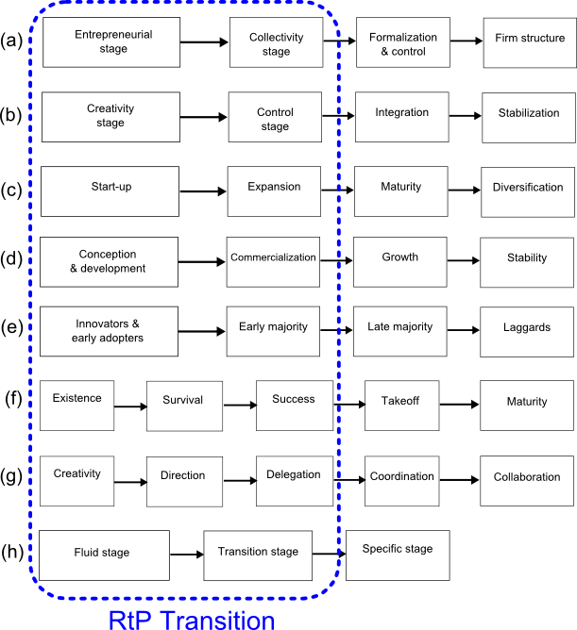

Figure 1 (a)–(h) - Different models showing lifecycle stages in NTBF’s and the RtP transition

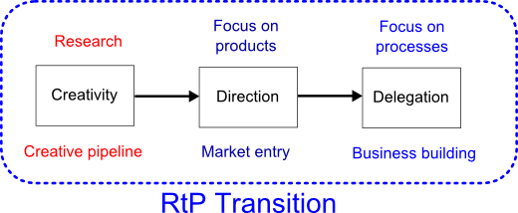

Fig.2 - Single model for the RtP transition

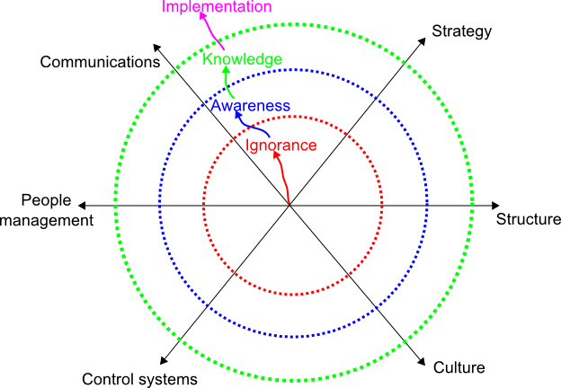

Figure 3 - Modified version of Phelps’ Tipping-point model [Phelps, 2007]

Management Theory
A number of models from management theory were selected for analysing the RtP transition, based on: (a) Personal experience during 6 years at a new technology-based firm in the telecommunications sector, “NTBF A”. It was formed by a group of 10 scientists and engineers in January 2000, and had grown to more than 100 employees by January 2007. (b) “NTBF B”, case study in [Kohtamaki, 2004]. (c) “NTBF C”, case study in [Macpherson, 2004].

During the transition period, there is a transfer of effort from research to product development and then to process development. To visualise this shift, the models of Abernathy & Utterback [Abernathy, 1978] and [Oakey, 2007] were altered slightly to include an initial research stage, see Fig.4, where initial R&D is followed by product innovation and then manufacturing process development (process innovation). One sign of this shift is the transfer of staff and resources from R&D to manufacturing, operations and customer service, as the company grows. E.g., NTBF A employed 25 staff in 2001, of whom 20 were in R&D. In May 2007 there were 96 staff, with 40 in R&D. The boundary between product innovation and process innovation in Fig.4 is “fuzzy”: instead of a definite, sharp cut-off of research, there is instead a continuous transition from research through product innovation to process innovation, with all 3 stages overlapping.

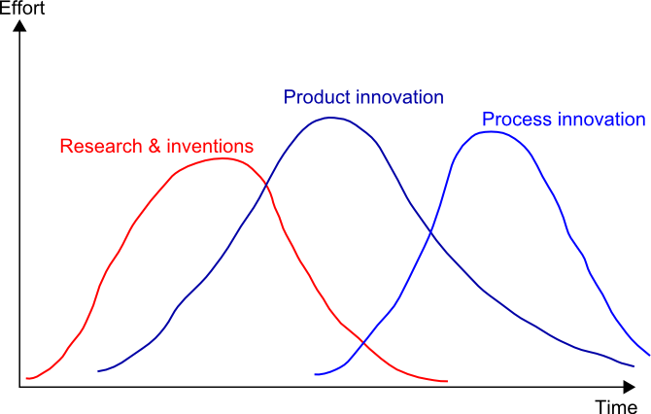

Figure 4 - Innovation cycles showing how research is followed by product & process innovation

The technology continuum shows the role of technology in the firm, Fig.5. When the role of technology is very strong, it will drive business strategy from the top-down [T846, 2005: Block 1], which may be expected in NTBF’s. As the firm moves away from research focus, so the influence of technology on business strategy may decrease.

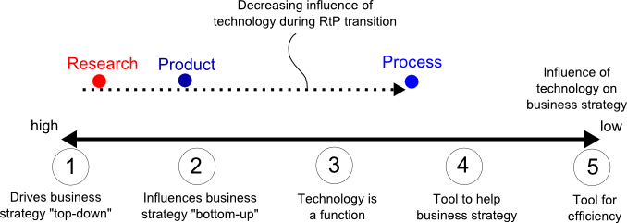

Figure 5 - Role of technology in NTBF’s

When a NTBF is started, the structure may be very informal, with few layers of management, and little horizontal differentiation [B713, 2004: Block 1.5]. It needs little management intervention, encourages frequent communication between employees, and allows creativity to flourish. The founders may disdain management activities since all their energies are taken-up in developing new ideas and inventions [Greiner, 1998]. A number of individuals may perform a wide variety of roles and responsibilities simultaneously [Flamholtz, 2000, chp.8]. Culture includes the basic values, ideologies and assumptions which guide individual and business behaviour [B713, 2004: Block 1.5], and is the social glue which holds the company together. Handy’s 4 culture types may be used to analyse the company [Handy, 1976]. In the creativity stage, the culture is visionary and entrepreneurial [Kampas, 2004]. E.g., at NTBF B, the lack of organisational structure at the beginning was compensated by employees’ trust in the founders [Kohtamaki, 2004].

As the firm moves from the creativity to the direction stage (product focus), so more levels of management are introduced. A functional organizational structure is introduced to separate R&D from manufacturing and sales & marketing. Company culture also changes, moving more towards a power culture [B713, 2004: Block 1.5], with some elements of task culture. For example, NTBF A had only a single engineering manager in 2001, with a single department for R&D. In May 2007, NTBF A had multiple levels of project managers, and a number of divisions within R&D. At NTBF C, the founders could no longer cope with the daily management and administrative tasks as the firm grew, and so recruited 3 more managers.

The next stage (process focus) requires a more decentralized structure, with more levels of management, where authority and responsibility is delegated. For example at NTBF B, founders began to entrust responsibility to more junior team members and so became distanced from the day-to-day running of the firm [Kohtamaki, 2004], thus causing the culture type to move towards a task culture.

In the creative stage, controls may be more organic and based on trust, [Kohtamaki, 2004]. Founders are able to monitor performance in an ad-hoc fashion. Objectives, measurement and feedback systems are lightly-used, and may only be partially followed-through. Goals are shared by the small group of staff, who may share common backgrounds, experience and attitudes. Performance appraisals may not be consistent, (or not used at all). As the company progresses into the direction stage, so the founders are no longer able to monitor performance of the growing number of staff [Flamholtz, 2000: chp.10]. Goals become less clear, and a formal system is needed for ensuring that employees’ goals are aligned with those of the company. Mechanistic controls are often introduced at this point [Davila, 2005], which may bring conflicts with founders and researchers who fear loss of freedom, and regard meetings and procedures as a waste of time.

HR management includes recruitment, training and retention. In the creativity stage, staff are only recruited in small numbers, sometimes based on word-of-mouth and personal referrals [Baron, 2002]. High importance may be put on social inclusion in the founders’ inner circle. Induction and training is mostly avoided, since resources and structures for training are not present, and new staff are chosen for their prior experience [Andries, 2006]. Motivation and staff retention is based on intrinsic pride in the job, and the promise of a part-share in the future business. For example during the first year after NTBF A was founded, new employees were identified from among the network of university colleagues, and share options were offered as an incentive to join the company (since salaries were slightly lower than the industry average). Similarly, at NTBF B, the first group of employees were all former work colleagues of the founder members [Kohtamaki, 2004], and they contributed money to the start-up capital in return for share options.

As the company moves into the direction stage, so recruitment becomes a larger task, and founding members may have less influence over it. Some staff training is required since new members may have less prior experience. Motivation is based on salary and share options. It was only as NTBF A grew beyond 50 staff that more formal recruitment procedures were introduced.

In the delegation phase, recruitment is often a separate function, and responsibility no longer lies with the founders. Researchers may sometimes begrudge the time and effort needed to recruit larger numbers of lower-skilled staff. Formal staff training is required to train new employees about the technology, the business, and company procedures. Motivation is based on salary and individual bonuses, and to a lesser extent on share options [Greiner, 1998]. For example at NTBF A, more staff were needed for customer service, operations and assembly tasks by May 2007: this required staff with less advanced skills who needed a formal training programme.

In the creativity stage, teams will be small and informal, but as more staff join, so team boundaries become more distinct, and stricter procedures introduced. Technical specialists may be required to work with new team members who have skills in management, quality or finance, so creating conflicts. This may be because fanatical belief in the product may become fanatical resistance to change [Kampas, 2004], [Leonard, 1992]. Managing the social dynamics of a team may be as important as managing the task, and the RtP transition may aggravate the problems. For example, at NTBF A, teams were small units where all members were technical specialists in 2001. By May 2007, the teams were larger, and always included a project manager (not usually a technical expert in the field).

Communications between staff within the company are extremely important. In the creativity stage, there may be only a small number of employees, with few levels of hierarchy. This allows rapid, informal communication, and ideas easily spread from bottom-up as well as top-down. Leadership is often benevolently autocratic [Flamholtz, 2000: chp.11], with founders able to share information with the staff.

In the direction stage, management is more top-down and directive. Larger staff numbers require more formal communication means such as company emails and web-pages. In the delegation stage, management is decentralized, and specific procedures are required to ensure that all departments in the company receive information, in a timely, uniform manner. An example of this may be monthly staff meetings, attended by staff across all departments. For example at NTBF A in 2001 there were no formal requirements documents or schedules and no regular company meetings. By May 2007, all projects were controlled with requirements documents and Gantt charts, and staff meetings were held monthly.

Fig.6 shows Tannenbaum & Schmidt’s communication styles, with possible positions for the RtP stages overlaid.
Freedom for subordinates
Authority of manager
Tells
Sells
Tests
Suggests
Consults
Joins
Delegates
Research
Product
Process
Continuum of mgmt. communication styles
Figure 6 - Tannenbaum & Schmidt’s management styles [B713, 2004: Block 1.5]

Another aspect is the degree to which the communication climate is open or closed. In the creativity stage, the climate may be more open: descriptive, solution-oriented, inclusive, forgiving and supportive [B713, 2004: Block 1.5]. As the company moves into the direction stage, the climate may become more closed: more judgmental, controlling, defensive and restrictive of information flow.

Methodology
Longitudinal surveys across different firms are useful to map the characteristics of NTBF growth, and to ensure that results are not unique to a single organization. Due to project time constraints, opportunistic sampling was used to perform retrospective longitudinal surveys on a number of technology-based firms, using a detailed questionnaire. The questionnaire asked respondents to answer all questions as they applied to the firm at 2 time instants, T1 (usually when the employee joined the firm) and T2 (current time, or time when employee left the firm). It is clear that different respondents will report different times T1 and T2, from firms which are at different stages of the RtP transition, see Fig.7.

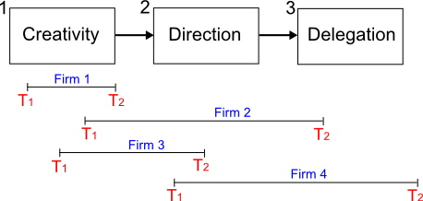
Figure 7 - Different respondents report different times T₁ and T₂ for firms at different stages

Due to the limited time and resources available, opportunity sampling has been used: respondents have been chosen because they are known to the author (or referred by colleagues), and the time-frame is simply chosen to be the period in which the respondent worked at the firm (regardless of the stages the firm went through during this period).

Cardinal et al. [Cardinal, 1997] make the following recommendations to improve the validity and reliability of retrospective surveys:
- Allow free responses (respondents may leave a question blank if they cannot remember).
- Use multiple respondents for each firm, and cross-check answers.
- Ask about simple, concrete facts rather than opinions or beliefs.
- Do not ask about the distant past (more than 10 years).
- Motivate respondents: explain usefulness of research and minimize the number of questions.

Weaknesses of the methodology:
- In hindsight, respondents tend to impose more structure on the situation than was actually present at the time [Cardinal, 1997].
- Specific details of procedures and events in the distant past are difficult and unreliable to recall.
- A significant number of respondents were only at junior levels, and so may not have had access to complete information about the firm.

The questionnaire was sent to 48 technology-based firms. To date, 41 firms have completed the questionnaire and of these, 31 responses have shown a significant transition from research to products.

The questionnaire replies were filtered using the criteria that firms must: (a) have less than 150 employees at time T1, (b) expand in staff numbers, and (c) show either signs of “growing pains” or a partial RtP transition. These criteria excluded large or well-established companies which were neither growing nor moving from research to products, which is reasonable in order to keep the project focused on “new technology-based firms”. This reduced the number of suitable firms from 41 down to 31. The average time-frame from time T1 to T2 was 55 months (between 4 and 5 years), which is a reasonably-long time-frame over which to note changes. Time-frames had a lower limit of 6 months and an upper limit of 10 years to ensure that they were long enough to show significant changes, but not so long that respondents could not remember details. The time difference between the survey date and time T1 was 82 months on average (between 6 and 7 years).

Results

1. Distribution and Size of firms
The firms were distributed between telecomms, software, semiconductors, consumer electronics, industrial and IT, see Fig.8. The mean number of employees increased from 38 employees at time T1 to 143 at time T2.
Figure 8 - Distribution of companies by industry sector

2. Management focus & Growth stages
Firms were mapped onto lifecyle-stages using the intersection of 3 different measures: (1) shift in application of research, (2) shift in design emphasis from technology to market, and (3) shift in customer segment, see Figs.9(a) – 9(c). Results show a progression in lifecycle-stage from creativity to delegation as the firms grow, Fig.9(d).

Figure 9(a) - Change in research focus

Figure 9(b) - Shift in design emphasis

Figure 9(c) - Shift in customer segment

These 3 measures allow classification into one of Greiner’s 3 early growth stages: Creativity, Direction and Delegation, see Fig.9(d).

We present the hypothesis that companies at time T1 are more likely to be in Stage 1 (Creativity stage) and at time T2 are more likely to be in Stage 2 (Direction stage): the null hypothesis says that there is no relationship between the point in time and the lifecycle-stage. A chi-square test gave a value of chi-square = 6.78 which is above the minimum level of 6.0 needed to be significant at the 5% level for 2 degrees of freedom [Howitt, 2005: chp.14]. Thus we can accept the hypothesis that there is a definite shift in lifecycle-stage from creativity to direction during time-frame T1 to T2, and supports the validity of Greiner’s lifecycle-stage model.

Figure 9(d) - Results showing shift in lifecycle stage from time T1 to T2

At time T1, in the early stages of a NTBF, the firm is guided by what its technology can achieve, and this is seen in the results of Fig.10: there is an apparent shift in technology role away from driving business strategy, more towards influencing it, then becoming a separate function and finally a mere tool for improving efficiency. The hypothesis gave a chi-square value of 7.0, making it statistically significant.

Figure 10 - Changing role of technology in business strategy

3. Structure & Culture
Only 14 firms (45%) showed a change in management structure, moving away from ad-hoc management towards a more formal functional or matrix structure. Only 10 firms (32%) showed an increase in job mechanisation or specialisation, while 16 firms (52%) showed a shift away from a friendly and informal atmosphere to one which was more formal, stressful and demanding. In order to measure the effect, responses to questions on structure and culture were weighted, the scores were added, and the difference in scores between time T1 and T2 taken. A t-test on the difference in scores gave a value of t = 3.81, which is higher than the required value of 2.04 at the 5% level and so the hypothesis of a shift towards a more formal structure and restrictive culture can be accepted.

4. Management control systems & HR
Fig.11 shows a general increase in management control systems, which is a natural consequence of expansion, and fits in with Fig.7, Section 1.4.3.1. It seems to be a common characteristic of technology-based firms that employees are trusted to perform their duties, and timesheets are not often used, even after expansion. Nearly all the firms surveyed had introduced employee appraisals by time T2. Of the 31 respondents at NTBF’s, 5 respondents (16%) moved from an R&D or engineering role into management.

Figure 11 – Increase in management control systems

Fig.12 shows the shift in employee feelings over time, as the firm moves between growth stages. The 2 largest increases from time T1 to T2 are feelings of being overburdened with rules, and being under pressure to produce results. As the firm becomes bigger, so more mechanistic controls are needed, and more rules introduced. In many technology-based firms, some of the early employees come from an academic or research background where there are few formal controls, and they may find it difficult when more formal controls are introduced. As the focus changes, products become higher priority than open-ended research, and so the pressure to produce tangible results increases. These employee feelings may be a source of conflict and tension. For example at NTBF A, joint research projects with the university were started in 2001, but in 2006 these projects were cancelled, and all funding withdrawn, which produced feelings of insecurity amongst some of the employees who had come from academia.

Figure 12 - Shift in employee feelings
Figure 13 - HR problems experienced at T₁ and T₂

Fig.13 shows the shift in HR problems experienced. Technology-based firms seem to have problems recruiting skilled staff at all phases of development. As the firm grows, it appears that staff become demotivated, are poorly coordinated, and feel less involved in the company. These are all symptoms of firms which grow rapidly, and undergo structural and cultural changes.

5. Communications
Tannenbaum & Schmidt’s communication styles do not fit the results of Fig.14, which show that the stages of “Suggests” and “Joins” are actually used more in the early stages of technology-based firms, and so the order of communication style should perhaps be changed to: “Join” -> “Suggest” -> “Tell” -> “Persuade” -> “Delegate”. For example, when NTBF A was formed in 2001, the founders had a strong technical involvement, and joined-in with colleagues to solve problems. By 2005, as staff numbers increased to nearly 100 and more layers of management were added, so the founders become more distanced from technical details, and middle-managers with less in-depth technical knowledge took over leadership of teams and projects.

Figure 14 - Shift in team leader communication style does not fit Tannenbaum & Schmidt well

Fig.15 illustrates the change in communications between departments at the firm. There appears to be a small shift towards less open and inclusive communications from time T1 to T2.

Figure 15 - Communications between departments at time T1 and T2

6. Mapping results onto the Tipping-point model
The aggregated results from all sections were mapped onto the Tipping-point model, using the procedure mentioned in [Phelps, 2007]. In order to allow them to be plotted on a single figure, a weighting scale was used, based on the relative contribution of each item to the dimension being measured. The overall aggregate results of all 31 NTBF’s combined, after weighting are shown in Table 1, and super-imposed on the modified Tipping-point model in Fig.16.

Table 1 - Results after aggregating the weighted values for each of the 6 dimensions

Time  Dimension | T1 | T2 | Improvement
Strategy | 24.4 | 40.5 | Better
Structure | 24.5 | 56.3 | Better
Culture | 61.5 | 51.6 | Worse
Control systems | 54.8 | 12.9 | Worse
People management | 48.4 | 8.4 | Worse
Communications | 51.8 | 63.5 | Better

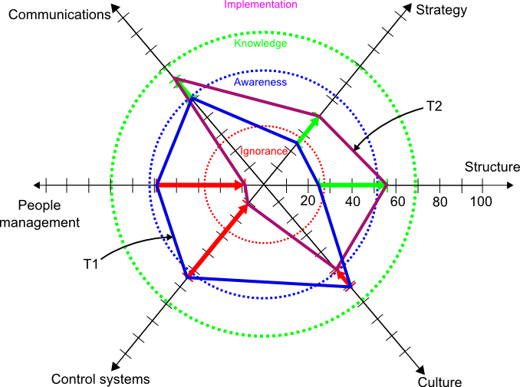

Figure 16 - Mapping aggregate changes onto the modified Phelps model

It is seen that the scores along the Strategy, Structure and Communications dimensions improved from time T1 to T2, whilst the scores for Culture, Control systems and People management dropped. The positions for the circular boundaries of “ignorance”, “awareness”, “knowledge” and “implementation” are arbitrary, since the source article [Phelps, 2007] does not give any indication as to how to position them.

7. Summary questions
A Likert scale was used to assess how respondents felt about the RtP transition at the firm, see Table 2.

Table 2 - Summary question Q6.1 and number who answered positively on a Likert scale

Q6.1 “Thinking about the firm as it changed from time T1 to T2,  do you agree / disagree with the following ?” | % respondents  who agree /  agree strongly
The firm experienced “growing pains” | 87.1 %
Priorities in allocating resources changed greatly | 93.5 %
Organizational structure changed greatly | 83.9 %
Culture changed greatly | 64.5 %
Changes were stressful to staff | 74.2 %
The firm needed to change to survive | 83.9 %
Managers handled the changes well | 16.1 %
“Transition from research to product-focus” gives  a fairly good description of the changes that took place in the firm | 90.3 %
The firm was successful in making the transition from research to products | 74.2 %
.
More than 80% of respondents felt that the firm did experience growing pains, that priorities in resource allocation did change greatly, organizational structure did change greatly, the firm did need to change and that the concept of a research to product transition does describe the changes quite well. To a lesser extent, most respondents felt that the changes were stressful to staff and that the firm was successful in making the transition to focus on products. Change in company culture was considered to be less significant. In only 16% of cases (that is, 5 firms out of 30), were managers considered to have handled the changes well.

Question Q6.2 “What was the biggest management hurdle ?”
Commonly-listed management hurdles were:
- Change from academic mindset to a commercial perspective.
- Communication between development teams, especially when geographically separated.
- Recruitment and training to obtain skilled staff.
- Unclear corporate strategy.
- Semiconductor firms have big challenges in choosing when to stop testing and freeze a design.

Question Q6.3 Comments on the extent of RtP transition at the firm
A broad consensus of opinion was:
- Some form of research to product transition did take place between time T1 and T2.
- The transition was gradual, and only partially complete by time T2.
- Sudden step changes occur due to external events and new technologies.
- Changes are inevitable in all companies, especially in high-tech industries.
- Entrenched attitudes of the founders can obstruct company progress.

Discussion
The majority of companies surveyed were small technology-based firms (wireless, software, IT, electronics and semiconductor) located in the U.K., and so the findings are skewed towards similar firms. Since there was only a single respondent at each firm, the results may be biased towards the viewpoint of that particular individual, and so conclusions that can be drawn from them are limited.

The lifecycle-stage analysis assumes that a firm will substantially complete a particular phase before moving on to the next one [Andries, 2006], but there may be significant iterations within each phase, and these are not captured by the questionnaire which used only 2 points in time T1 and T2. Ideally, a rigorous survey should involve continuous monitoring of each firm at intervals of no longer than a month, over a period of several years: this would allow multiple transitions between stages and also iterations within a stage, to be captured.

Results showed that there was a significant shift in lifecycle-stage from the “Creativity” stage at time T1 to the “Direction” stage at time T2. This suggests that Greiner’s lifecycle-stage model is representative of at least the first 2 stages of growth in a NTBF.

The role of technology in company strategy changed from driving business strategy to becoming a separate function as the firms grew. This finding is intuitive because as a NTBF expands and hires staff who are more commercially-oriented than academic, so the influence of technology on decision-making will diminish.

As staff numbers increase, management approach becomes more formal and hierarchical, and culture changes towards a stronger work ethic and a more stressful and demanding atmosphere. Founders and early-stage employees prefer to work on developing new ideas and inventions, and dislike the added management burden [Baron, 2002]. Results show that employees suffer from poor motivation as the firm grows: stricter control systems are introduced, and mutual trust between management and employees begins to suffer [Kohtamaki, 2004]. This is supported by the results showing that employees feel more under pressure to produce results, and more afraid of blame for failure. It is somewhat compensated for by an improvement in feelings of being supported and valued. People management problems of poor motivation, lack of involvement and poor coordination all show a large increase as the firm grows, and point to a need for better management [Greiner, 1998].

Tannenbaum & Schmidt’s communication model [B713, 2004: Block 1.5] did not seem to fit the growth trajectory of the NTBF’s surveyed, and needed changing to move the “suggest” and “join” styles into the initial “Creativity” lifecycle-stage. Although communications were expected to become less free and open as the firm became larger, only a mild trend was seen.

The modified Tipping-point model [Phelps, 2007] was found to be useful for visualising changes: it enables an individual firm’s progress along different dimensions to be plotted on a single diagram, and compared to other NTBF’s. However, it was not clear what relative scales should be used for the different dimensions, and what weighting values should be used to arrive at the scores.

Conclusions

The lifecycle-stage model is useful for examining the progress of a NTBF as it grows. The lifecycle-stages of “Creativity”, “Direction” and “Delegation” seem to fit the surveyed firms reasonably well. Categorizing a particular firm into one of these stages helps to understand the current and future challenges which it may have to overcome.

A modified version of Phelps’ Tipping-point model is useful for visualising the progress of a NTBF along multiple different dimensions, and enables comparison with other NTBF’s. The problem of ad-hoc scaling and weighting values means that care must be taken when making comparisons.

As the role of technology in corporate strategy changes, so the structure, culture and control systems all change accordingly. Employees experience increasing feelings of being overburdened with rules, lack of trust, pressure to produce results, and fear of blame.

Founders and early employees may feel these pressures most, as some are stuck in an academic mindset, and are unprepared for changes as the firm progresses from research to product-focus.

Future work
The survey is not yet complete, and has some limitations due to having only a single respondent for each company, and relying on retrospective data gathering from only 2 measurement points in time. Nevertheless, it lays the ground-work for a more in-depth survey, which should:

- Gather data from more than 1 employee at each firm, and compare findings.
- Record data at intervals of no more than 3 months over a period of several years.
- Record data in real-time (not retrospectively).
- Gather data from a larger group of firms across other sectors, e.g. biotech / pharmaceuticals / logistics firms.
- Include semi-structured interviews with senior managers.
- Include data about external events, e.g. entry of new competitors, substitute products.
- Gather more information about specific problem areas (e.g. HR problems) which have been highlighted.

References

[Abernathy, 1978] W. Abernathy, J. Utterback, “Patterns of industrial innovation”, Technology
Review, 1978, Vol.7, pp.40 – 47

[Andries, 2006] P. Andries, K. Debackere, “Adaptation in new technology-based ventures”, Int. J.
Management Reviews, 2006, Vol.8, No.2, pp.91 – 112

[B713, 2004] B713 Course notes, “Fundamentals of Senior Management”, Open University, 2004

[Baron, 2002] J.N. Baron, M.T. Hannan, “Organizational Blueprints for Success in High-Tech Start-ups”,
California Mgmt. Review, Vol.44, No.3, Spring 2002, pp.8 - 36

[Brah, 2000] S.A. Brah, J.L. Hunsucker, “R&D to operations transition management”, Int. J.
Operations & Production Management, Vol.20, no.1, 2000, pp.31-49

[Cardinal, 1997] C.C. Miller, L.B. Cardinal, W.H. Glick, “Retrospective reports in organizational
research”, Academy of Mgmt. J., 1997, Vol.40, No.1, pp.198-204

[Choi, 2004] W.K. Choi, J.Y. Choung, “Establishing major successful factors of new
technology based firms”, Int. Eng. Mgmt Conf. 2004, IEEE, pp.348 - 352

[Churchill, 1983] N.C. Churchill, V.L. Lewis, “The five stages of small business growth”, Harvard
Business Review, May – June 1983, pp.30 – 50

[Collis, 2003] J. Collis, R. Hussey, “Business Research”, Palgrave Macmillan, 2003

[Davila, 2005] T. Davila, “An exploratory study on the emergence of management control
systems”, Accounting, Organizations and Society, 2005, Vol.30, pp.223 - 248

[Flamholtz, 2000] E.G. Flamholtz, Y. Randle, “Growing pains. Transitioning from an
entrepreneurship to a professionally-managed firm”, Jossey-Bass, 2000

[Garnsey, 2005] E. Garnsey, P. Heffernan, “Growth setbacks in new firms”, Futures Journal, Vol.37, 2005, pp.675 – 697

[Garnsey, 2006] E. Garnsey, E. Stam, P. Heffernan, “New firm growth”, Industry & Innovation, Vol.13, No.1, March 2006, pp.1 - 20

[Greiner, 1998] L.E. Greiner, “Evolution and revolution as organizations grow”, Harvard Business
Review, May – June 1998, pp.55 – 67

[Handy, 1976] C. Handy, “Understanding organizations”, Penguin, 1976

[Hanks, 1993] S.H. Hanks, C.J. Watson, E. Jansen, G.N. Chandler, “Tightening the Life-Cycle Construct: A taxonomic study of growth stage configurations in high-technology organizations”, Entrepreneurship Theory & Practice, Winter 1993, pp.5 – 28

[Howitt, 2005] D. Howitt, D. Cramer, “Introduction to statistics in psychology”, 3rd ed., Pearson / Prentice-Hall, 2005

[Kampas, 2004] P.J. Kampas, “Shifting cultural gears in technology-driven industries”, IEEE Engineering Mgmt. Review, Vol.32, No.1, 2004, pp.3 - 11

[Kazanjian, 1989] R.K. Kazanjian, R. Drazin, “An empirical test of a stage of growth progression
model”, Management Science, Vol.35, No.12, December 1989, pp.1489-1503

[Kohtamaki, 2004] M. Kohtamaki, T. Kekale, R. Viitala, “Trust and Innovation: from Spin-Off Idea
to Stock Exchange”, Creativity & Innovation Mgmt., 2004, Vol.13, No.2, June pp.75 – 88

[Leonard, 1992] D. Leonard-Barton, “Core capabilities and core rigidities”, Strategic Management
Journal, Vol.13, 1992, pp.111-125

[MacMillan, 2004] I.C. MacMillan, R.G. McGrath, “Nine new roles for technology managers”,
Research Technology Management, May-June 2004, pp.16-26

[Macpherson, 2004] A. Macpherson, O. Jones, M. Zhang, “Evolution or revolution? Dynamic capabilities in a
knowledge-dependent firm”, R&D Management, Vol.34, No.2, 2004, pp.161 - 177

[Moore, 1999] G.A. Moore, “Crossing the chasm”, 1999, Harper Business, New York

[Oakey, 1991] R. Oakey, “Innovation and the Management of Marketing in High Technology
Small Firms”, J. of Marketing Management, Vol.7, 1991, pp.343 - 356

[Oakey, 2007] R. Oakey, “Clustering and the R&D management of high-technology small firms”, R&D Management, Vol.37, No.3, 2007, pp.237 - 248

[Phelps, 2007] R. Phelps, R. Adams, J. Bessant, “Life cycles of growing organizations”, Int. J. of Management Reviews, Vol.9, No.1, 2007, pp.1 - 30

[Quinn, 1983] J.B. Quinn, “Managing strategic change”, in C. Mabey, “Managing Change”, 2nd
Ed., Paul Chapman Pub., U.K.

[Rutherford, 2003] M.W. Rutherford, P.F. Buller, P.R. McMullen, “Human resource management
problems over the life cycle of small to medium-sized firms”, Human Resource
Management, Winter 2003, Vol.42, No.4, pp.321-325

[Saunders, 2007] M. Saunders, P. Lewis, A. Thornhill, “Research Methods for Business Students”, FT /
Prentice-Hall, 2007, 4th ed.

[T840, 2004] T840 Course notes, “Technology management: an integrative approach”, Open University, 2004

[T842, 2006] T842 Course notes, “The Technology Management Project”, Open University, 2006

[T846, 2005] T846 Course notes, “Technology strategy”, Open University, 2005

[Van de Ven, 1999] A.H. Van de Ven, D.E. Polley, R. Garud, S. Venkataraman, “The Innovation Journey”,
Oxford University Press, 1999

