Assessment in enterprise education: practice and potential practice

Dr. Luke Pittaway, Director, Enterprise and Regional Development Unit,
University of Sheffield Management School,
9 Mappin Street, Sheffield, S1 4DT
Tel: +44 (0)114 222 3486; e-mail: luke.pittaway@shef.ac.uk

Prof. Paul Hannon, Director of Research and Education,
National Council for Graduate Entrepreneurship

Prof. Allan Gibb, Professor Emeritus
University of Durham

Prof. John Thompson, Roger M Bale Professor of Entrepreneurship
Huddersfield University Business School
Abstract
This paper introduces current debates on assessment practice in Higher Education and explores educational research on assessment. It progresses by exploring a number of outcomes and highlights their role in helping understand the potential reasons for engaging in enterprise education. The paper then applies this outcomes framework to assessment practice. It does so by reporting a series of focus groups undertaken at the International Small Business and Entrepreneurship (ISBE) conference 2005. The focus groups engaged over 40 entrepreneurship and small business academics in a brainstorming exercise which explored forms of assessment that could be used to meet particular outcomes in enterprise education. These results are presented according to different potential entrepreneurial outcomes. The concluding part of the paper categorises these practices to develop and present the views of the participants and it provides a detailed analysis of assessment practice in enterprise education.

Assessment Practice Enterprise Education Entrepreneurial Outcomes Learning Outcomes

Introduction
In a recent systematic literature review (SLR) of enterprise education Pittaway and Cope (2007a) identified through citation coding some of the key research themes in enterprise education. In the review themes that appear to dominate research in the subject included: factors affecting the propensity of students to become entrepreneurs; changes in student efficacy as a result of education; pedagogy; and, institutional policies (Pittaway and Cope, 2007a). Surprisingly one of the many gaps in the field identified in the SLR was assessment practice. No papers in the review directly addressed the issue of assessment practice and coded citation data developed inductively from abstracts did not highlight the subject as of major concern to the research community. Research on pedagogy in enterprise education appears to focus mainly on programme design and implementation than on the efficacy of assessment practice. When exploring the National Council for Graduate Entrepreneurship’s (NCGE) research bibliography a similar conclusion can be drawn. Despite a database of over 700 citations, including recent working papers, there are only three papers listed that have a specific interest in assessment practice. Askham (1997) who examines two-way feedback in a portfolio of assessment but from the point of view of general education; Bilen et al. (2005) who’s main focus is on the programme design of Penn State’s engineering entrepreneurship programme where the secondary focus is assessment practice; and, Reid and Petocz (2004) who examine different assessment techniques designed for assessing creativity. While recognising the limitations of both the SLR and the NCGE’s bibliographical database it does seem that there is a paucity of work specifically addressing assessment practice in enterprise education published in entrepreneurship journals.
If correct such an oversight would seem unfortunate. Assessment is an important part of academic practice as illustrated by the views of the Centre for Study in Higher Education in Australia:

“Assessment is a central element in the overall quality of teaching and learning in higher education. Well designed assessment sets clear expectations, establishes a reasonable workload and provides opportunities for students to self-monitor, rehearse, practise and receive feedback. Assessment is an integral component of a coherent educational experience”. CSHE

Many government agencies tasked with quality in education like the Higher Education Academy (HEA) and Quality Assurance Agency (QAA) in the UK focus on assessment practice. They do so both as a means to ensure effective evaluation, and the protection of ‘educational standards’ (summative assessment), and as a method of learning and student feedback (formative assessment). Assessment practice is seen in educational research to be an important part of academic practice and this can be illustrated through the existence of a journal dedicated to the subject and the prevailing view is highlighted by Winter (2003) when he argues:

“Assessment of students’ learning is clearly at the very centre of universities’ ‘core business’. It is the function universities carryout on behalf of society; it is, as it were, the product we sell. Students attend our courses leave us with an officially documented judgement on their work, which constitutes both and individualized evaluation and also a public qualification”. (Winter, 2003: 112).

So it seems assessment practice is important and has perhaps been neglected as a subject in enterprise education. This paper seeks to begin the process of addressing this oversight. It does so by introducing different views and arguments in the research on assessment practices. The paper then presents some established entrepreneurial outcomes in enterprise education developed by the National Council for Graduate Entrepreneurship (NCGE). It reports on a series of focus groups in a workshop that engaged over forty entrepreneurship and small business academics in a brainstorming exercise using these entrepreneurial learning outcomes to think about potential assessment practices. Finally, the paper concludes by drawing together some categories of assessment practice and illustrates how these might be used to enhance enterprise education.

Assessment Practice: Debates and Discussions
In a recent book Banta (2002) argues that there is a scholarship of assessment and this can been defined as ‘…sophisticated thinking about assessment’ (Banta, 2002; 242). Assessment as a subject is broad including many forms of assessment practice in Higher Education including: institutional assessment; teacher assessment and student assessment (Banta, 1999). Student assessment, which is the focus of this paper, has become a subject of concern partly because of increased pressure from accrediting agencies and governments seeking to influence and measure institutional performance. Never-the-less assessment practice can be considered to be integral to educational practice and is viewed as important in gauging the link between desired educational outcomes and actual student achievement (Banta, 1999). Inevitably, the link between educational outcomes and assessment is close; as the assessment system used can drive the behaviour of students and ultimately the learning they experience (Schwartz and Webb, 2002).
Debate in educational theory, therefore, revolves around both educational and political concerns. For example one educational concern focuses on how assessment itself impacts on learning seeking to understand the extent to which assessment can help learning occur. A connected political concern focuses on the increasing role of external accreditation systems driving outcome-based; credit-based and modular forms of education when formative and diagnostic approaches are seen to be potentially more useful and more supportive of educational processes (Ecclestone and Swann, 1999). Despite some of the philosophical issues that can arise when considering the questions above much of the literature on assessment practice focuses on technical considerations (Dunne, Bennett and Carré, 1997) and the main issues are summarised by Ecclestone and Swann (1999) as: formative versus summative feedback; the coherence of assessment policy across departments and institutions; the role of second marking; the role and design of assessment criteria; the productivity of assessment strategies; and, the impact of formative feedback on future student behaviour. In addition one can add such concerns as: the role of student self and peer assessment (Falchikov and Goldfinch, 2000); the challenges of assessing newer learning designs, such as, problem based learning (Gijbels et al., 2005); the tension in assessment between selective norm-referenced assessment and criterion-referenced assessment (Broadfoot, 1996; Ecclestone, 1996); and, the challenges of linking assessment to the requirements of accreditation agencies (Hindi and Miller, 2000).
Even in technical areas, however, lecturers were found to be challenged by the philosophical tensions that arise from the simultaneous existence of different philosophies of assessment practice (Ecclestone and Swann, 1999), which is illustrated by the following quotation:

“The competing demands for improved assessment practice create confusion and insecurity for experienced and novice assessors alike. The phenomenon has been observed by other researchers (in the US) and such tensions became evident as our project progressed” (Ecclestone and Swann, 1999: 382)

These tensions have been commonly viewed through the lens of dichotomous relationships (Neil, Wadley and Phinn, 1999). These dichotomies and philosophical tensions in assessment practice have led to considerable variation in forms of assessment in Higher Education. For example surveys of assessment practice illustrate considerable diversification in what is assessed, how it is assessed, when and where it is assessed and who was doing the assessing, although trends such as increased use of formative assessment and the involvement of peers and other stakeholders in assessment practice have been noted as recent developments (Topping et al., 2000).
These tensions, philosophical differences and diversity in forms of assessment set against the important role assessment plays in converting learning into credentials has led to some uneasiness over the state of assessment practice in Higher Education (Winter, 2003). These concerns are highlighted by some key contributors to the subject who have argued that poor assessment practice is endemic in Higher Education (Boud, 1995; Ramsden, 1992; Brown, 1999; Race, 2003). The view is best illustrated by Brown who argues that:

“The conventional ways by which we choose how to assess our students are just not good enough to achieve what we want.” (Brown, 1999: 4)

The problems identified by these researchers are far reaching. For example, some argue that the alignment between clear learning outcomes, appropriate assessment tasks and learning opportunities are not as carefully thought through as they should be (Rust, 2002). Others point out that many of our assessment processes encourage surface learning directing students to ‘play the system’ rather than encouraging deep learning (Winter, 2003) and that our systems for managing assessment activity vary in quality (Yorke, 1998). Further arguments suggest that assessment needs to be valid, reliable and transparent and that it is neither because educators: fail to measure what we should be measuring; have to apply personal judgement which is unreliable; and, fail to be transparent about our expectations with students (Race, 2003).
These criticisms of current assessment practice point to some important considerations for assessment in enterprise education that educators should be cognisant of and which assist the development of effective practice. These are worth highlighting before exploring the forms of assessment identified during the workshop/focus groups (see Table 1).

Table 1: Key Considerations for the Development of Effective Assessment Practice

Principles of Effective Assessment Practice

Assessment should be valid, reliable and consistent
The purpose of assessment should be clearly explained
The amount should be appropriate
The criteria should be understandable, explicit and transparent
Assessment should be based on understanding of how students learn
It should accommodate individual differences in students
Assessment procedures should allow students to receive feedback on their learning
Assessment should provide staff and students with opportunities to reflect on their practice and their learning
Assessment should be an integral component of course design

The principles identified in Table 1 provide a good foundation on which to start a discussion about assessment in enterprise education. Many of the points highlighted are not particularly controversial but a number of challenges do arise from this discussion. Firstly, assessment should be based on understanding of how students learn. When applied to enterprise education this implies; that that educators know what it is that students are supposed to learn and they know how students learn it. Neither assumption can be accepted as being unproblematic. As educators in the area are aware, there are difficulties in definitions and much diversity in interpretation of the words ‘enterprise’ and ‘entrepreneurship’ when applied to education and the two words imply different things (Gibb, 2002; Pittaway and Cope, 2007a). There are also many debates about how to learn, whatever ‘it’ is and only limited knowledge about how ‘entrepreneurs’ or ‘enterprising people’ themselves learn (Pittaway and Cope, 2007b). So educators cannot assume we know what is that we want students to learn nor assume that we know how students learn it.
Secondly, Brown (1999) makes the point that the ‘conventional ways’ that are used to assess students are not as effective as educators would like. This is a consideration for enterprise educators because it illustrates that the practices that are generally accepted in Higher Education may not in fact be appropriate for testing what educators wish students to learn. It demonstrates that enterprise educators may need to be innovative when thinking about new methods of assessment, especially where the aims of the educational activity differ from the norm. Finally, the discussion above illustrates that researchers in assessment practice have concluded that there needs to be alignment between learning outcomes, assessment tasks and the learning opportunities created. One of the problems in enterprise education has been ambiguity and considerable disagreement over the learning outcomes desired (Gibb, 2002). It does seem important then that enterprise educators need to have clear learning outcomes in mind when developing courses in enterprise and entrepreneurship; and assessment practice should be designed to effectively assess whether these learning outcomes have been achieved. In the next part of the paper we discuss entrepreneurial outcomes and introduce those outcomes that were used to guide the workshop on assessment practice in enterprise education.

Entrepreneurial Learning Outcomes
The subject of entrepreneurial learning has become a focus for inquiry in entrepreneurship research (Gibb, 1997; Deakins and Freel, 1998; Cope and Watts, 2000; Rae, 2000). It offers two interesting developments in terms of education. Firstly, if educators can start to understand how ‘entrepreneurs’ or ‘enterprising people’ learn then they can start to make judgements about the forms of education activity that can promote such learning (Pittaway and Cope, 2007b). Secondly, research on entrepreneurial learning enables educators to begin to identify the learning outcomes they wish to embed in educational activities (Gibb, 2002). Current research on entrepreneurial learning has made a number of conclusions about how entrepreneurs learn that offer important insights for educational practice. Features of entrepreneurial learning include that: it is action-orientated (Dalley and Hamilton, 2000); entrepreneurs learn through experience (Rae 2000; Rae and Carswell, 2000); they learn through doing and reflection (Deakins and Freel, 1998; Cope and Watts, 2000); they learn through copying, experimenting, problem solving, opportunity taking and making mistakes (Gibb, 1997). Much of the literature highlights these elements of doing and experiencing. The literature also highlights the role of reflection and the role of mistakes, showing that critical learning events and major setbacks enable transformative learning to occur during entrepreneurial activity (Reuber and Fischer, 1993; Cope, 2003; 2005).
From this empirical base and from the empirical base of other areas in entrepreneurship research it is possible to begin to draw together entrepreneurial learning outcomes and this is something that Gibb has recently done for the NCGE. These entrepreneurial learning outcomes are highlighted in Table 2. The entrepreneurial outcomes framework presented in Table 2 and available at the NCGE website provides clarity with regard to potential entrepreneurial learning outcomes. While the outcomes themselves can provide a foundation for debate and their use will differ between courses and programmes they highlight eight areas where educators might seek to impact on students’ learning. The eight areas as presented reflect changes in behaviours, empathy, values, motivations, awareness, competencies, venture creation knowledge, and ability to manage relationships. In doing so the framework shows the potential complexity of enterprise education: that it can be about awareness and understanding or the life-world of entrepreneurs; that it can be directed at changing student intentions to pursue entrepreneurship as a career, that it can be directed at developing wider ‘enterprising skills’ and that it can aim to provide specific assistance with the development of actual ventures by students. These eight areas of entrepreneurial learning outcomes provided the foundation for the workshop to be discussed next.

Table 2: The NCGE’s Entrepreneurial Learning Outcomes Framework
A - Entrepreneurial behaviour, attitude and skill development
Key entrepreneurial behaviours, skills and attitudes have been developed. | To what degree does a programme have activities that seek clearly to develop: for example, opportunity seeking; initiative taking; ownership of a development.

B - Creating empathy with the entrepreneurial life world
Students clearly empathise with, understand and 'feel' the life-world of the entrepreneur | To what degree does the programme help students to 'feel' the world of: living with uncertainty and complexity: for example, having to do everything under pressure; coping with loneliness; holistic management.

C - Key entrepreneurial values
Key entrepreneurial values have been inculcated. | To what degree does the programme seek to inculcate and create empathy with key entrepreneurial values: for example, strong sense of independence; distrust of bureaucracy and its values; strong sense of ownership.

D - Motivation to entrepreneurship career
Motivation towards a career in entrepreneurship has been built and students clearly understand the comparative benefits | To what degree does the programme help students to: understand the benefits from en entrepreneurship career?; compare with employee career; have some entrepreneurial 'hero's' as friends acquaintances; and, have images of entrepreneurial people 'just like them'.

E - Understanding of processes of business entry and tasks
Students understand the process (stages) of setting up an organisation, the associated tasks and learning needs | To what degree does the programme take students through: the total process of setting up an organisation from idea to survival and provide understanding of what challenges will arise at each stage; and, helping students how to handle them.

F - Generic entrepreneurship competencies
Students have the key generic competencies associated with entrepreneurship (generic 'how to's') | To what degree does the programme build capacity, for example, to find an idea; appraise an idea; see problems as opportunities; identify the key people to be influenced in any development.

G - Key minimum business how to's
Students have a grasp of key business how to's associated with the start up process | To what degree does the programme help students to develop knowledge about how to start businesses: for example, see products and services as combinations of benefits; develop a total service package; price a product service; identify and approach good customers.

H - Managing relationships
Students understand the nature of the relationships they need to develop with key stakeholders and are familiarised with them | How does the programme help students learn how to manage relationships: for example, identify all key stakeholders impacting upon any venture; understand the needs of all key stakeholders at the start -up and survival stage; know how to educate stakeholders.

Workshop Design
The workshop was designed to explore the forms of assessment strategies, regardless of constraint, that entrepreneurship educators thought were appropriate given some specific entrepreneurial learning outcomes. It occurred at the International Small Business and Entrepreneurship (ISBE) conference held at Blackpool on 1st of November 2005 in a special interest seminar focused on entrepreneurship education organised by the authors of this paper. The aim of the wider workshop was to develop an informal forum of entrepreneurship educators to share experience and discuss issues relevant to practice. The workshop sessions were designed to: disseminate practices and developments in enterprise education; review previous and present policies supporting enterprise education; and, enable barriers to be identified. There were three sessions: what do we mean be entrepreneurial education; how best to approach entrepreneurial education; and, how do educators evaluate outcomes from entrepreneurial education. The final session of the three focused on assessment practice and it is the output from this session that this paper reports on. The workshop had just over 40 participants who were mostly educators but from a range of countries and the session included some policy-makers from the UK. Unfortunately data on the exact make-up of the cohort was not collected at the time.
There were several steps in the session through which a ‘brainstorming exercise’ on assessment practice in enterprise education was carried out. Firstly, the group was split into seven smaller groups, which we are describing here as focus groups because they included a scribe and a co-ordinator. Each focus group was given a particular area of the entrepreneurial learning outcomes framework on which to focus their discussions and there were around six people in each group. Once the groups were organised a brainstorming exercise was carried out to encourage participants to think about all of the ways in which they might assess their particular entrepreneurial learning outcomes. The brainstorming exercise applied specific rules to ensure the focus groups worked effectively, these rules were: no judging; encourage ‘freewheeling’; go for quantity; and, encourage ‘piggybacking’. This took the focus groups approximately 20 minutes and each individual assessment type was recorded on post-it notes. Following on from the brainstorming exercise focus groups categorised their assessment types into themes that made thematic sense to them. Once this had been completed they were asked to draw diagrams representing the assessment types, the themes and the potential links between these themes. The output from this session is reported in the following part of the paper.
Before progressing it is worthwhile considering whether this can be considered a valid method for a research paper. There are some obvious limitations. These were self-managed focus groups and although structured similarly there will have been differences between the management of each group. The data from these discussions was not collected via a traditional method, it was not recorded and transcribed nor were there observers taking notes. Consequently, the researchers have been unable to code and thematically analyse data in any systematic form and the data in this paper only focuses on the output of the brainstorming and categorisation exercises. Another limitation is clear when one observes the output from the focus groups. It possible to see that contributors sometimes slipped between assessment practice and teaching method. Despite these limitations the results were such that the authors felt they were worth publishing. There are a number of reasons supporting this view. Firstly, as demonstrated previously, little has been written about assessment practice in enterprise education and this workshop represents a valuable source of information on educators ‘unrestricted’ views on how assessment practice could be developed to measure entrepreneurial learning outcomes. Secondly, the opportunity to draw from the experience of over 40 enterprise educators on assessment practice is not common and one must recognise that even at an average of 5 years experience for each educator, the workshop represents over 200 years experience in enterprise education. Finally, the nature of the brainstorming exercise itself forced the educators to apply their experience in a hypothetical situation. This was valuable because participants were seeking to identify all the ways in which certain outcomes ‘could’ be assessed rather than how they ‘were’ being assessed. Drawing on the combined experience of these educators to think creatively about assessment practice did highlight a number of potential innovations and novel techniques that may be valuable and that have not necessarily been used widely before. In the next part of the paper we introduce the output from the focus groups.

Results from Focus Groups
There were seven groups focusing on seven of the eight areas of the entrepreneurial learning outcomes framework (see Table II). One area of outcomes was omitted due to the number of participants, the preferred size of the focus groups and the self-selecting nature of the workshop design. The first group explored assessment strategies for understanding whether a course or programme had developed entrepreneurial behaviours, attitudes and skills. They were given a series of examples which included many of the commonly expected entrepreneurial behaviours, such as, opportunity seeking, initiative taking, and alertness to opportunity (Gibb, 2002). The output from their discussions is presented in Figure 1.

Figure 1: Focus Group Output on Entrepreneurial Behaviours, Skills and Attitudes

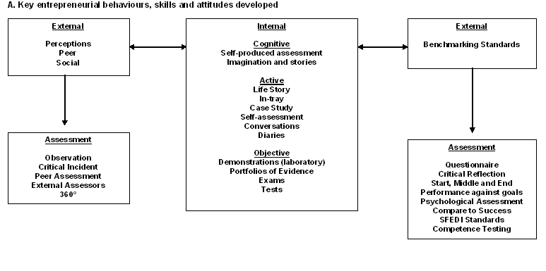
When looking at behaviours and skills the enterprise educators split it into two forms of external assessment and one form of internal assessment. The external forms were broadly ‘subjective’ led by peers or stakeholders or ‘objective’ led through reference to established standards (e.g. personality tests). The internal forms of assessment, which seem to be mainly focused on individual self-reflection, were broken down into three types cognitive examining attitudes; active examining reflections on personal behaviour; and, objective via actual experience through tests or exercises. There are a fair number of assessment techniques put forward in each but what is interesting is the centrality of the ‘self’ in the model designed by the group. The model implies that the focus group believe that to assess behaviour, attitude and skills there is a need for a significant component of self-assessment, something which is not particularly common in everyday assessment practice in Higher Education (Schwartz and Webb, 2002). It is also worth considering the place of ‘traditional’ assessment techniques in this area of entrepreneurial learning outcomes. The implication from the output seems to be that methods based on writing that are commonly used in Higher Education, such as: essays, exams, and reports, do not have much of a role when the learning outcomes are behavioural or attitudinal.
The next focus group explored how entrepreneurial education designed to create empathy with the life-world of entrepreneurs could be assessed. The entrepreneurial learning outcome is both tactile and emotional, in the sense of allowing students to ‘feel’, ‘experience’ or ‘get close to’ entrepreneurial activities, experiences and emotions. Figure 2 presents the output of this group.

Figure 2: Focus Group Output on Creating Empathy with the Entrepreneurial Life-world
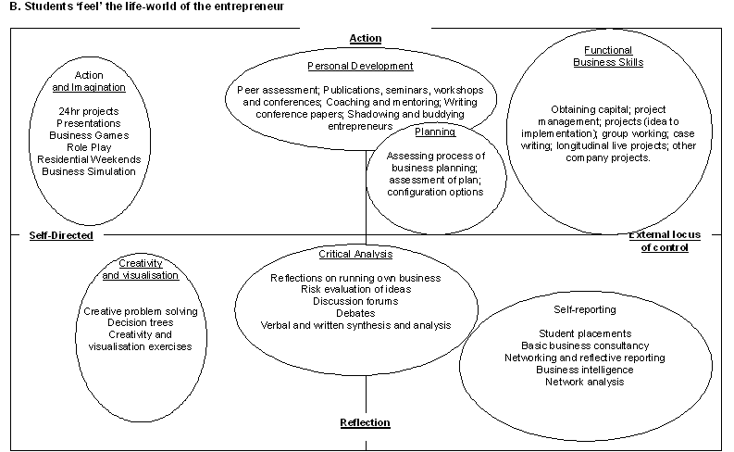

The categorisation of assessment techniques by this focus group is again quite illustrative of the challenges of assessment practice in Higher Education. There are two dichotomies used to organise the assessment themes. The first dichotomy shows a distinction between ‘reflective assessment practice’ and ‘active assessment practice’, or methods used to enable reflection on experience and methods used to assess students during the formation of experience. The second dichotomy presented makes a distinction between ‘self-directed’ and ‘external locus of control’. The meaning here is based on the location of assessment practices and the dichotomy seems to imply for self-directed ‘assessment based on experience gained through the course of ones own practice’ while for external locus of control it seems to imply ‘assessment based on experience gained through engagement with others practice’. In this model there are also many forms of potentially innovative assessment practice and little evidence of the common forms currently used in Higher Education.
The third focus group explored enterprise education that inculcates key entrepreneurial values, for example, strong sense of independence and distrust of bureaucracy. Figure 3 highlights the output of this focus group.

Figure 3: Focus Group Output on Inculcating Key Entrepreneurial Values
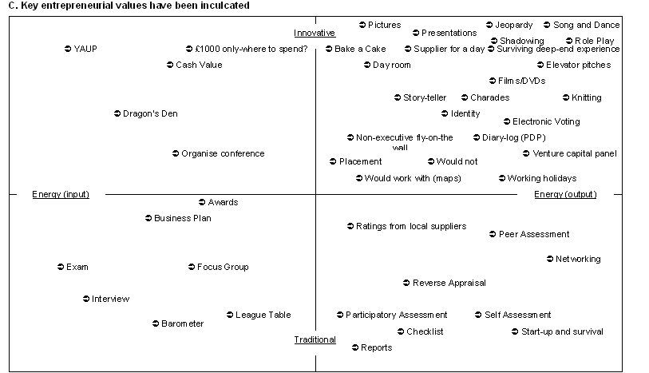

This group again use dichotomous relationships to categorise the different forms of assessment identified. They make a distinction between ‘traditional’ and ‘innovative’ forms of assessment and created a dimension based on ‘energy’. The group conceived this to mean but examining the assessment techniques categorised ‘energy input’ seems to imply effort expended to produce an output before it is produced while ‘energy output’ seems to imply effort expended on the output during its production. In this focus group it is evident that the brainstorming exercise encouraged the identification of many assessment techniques that are innovative and outside the ‘traditional’ practice of higher education. Although it is difficult to speculate it seems likely that this occurred due to the focus on inculcating values, which clearly requires some innovative assessment methods.
The fourth focus group explored assessment practices that could assess changes in motivations for a career in entrepreneurship or enterprise. The results from this focus group are presented in Figure 4.

Figure 4: Focus Group Output on Motivation for a Career in Entrepreneurship
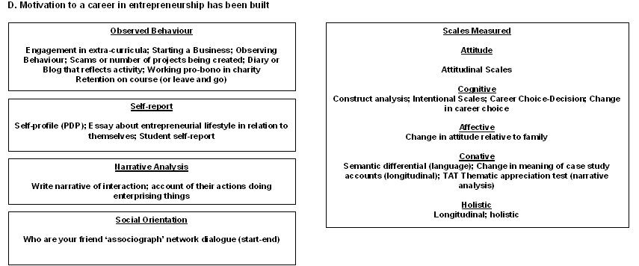

This group categorised assessment practices into themes based on a major distinction between measurement scales designed to assess motivational attitudes objectively and observation of actual behaviour using more subjective techniques. Observed behaviour was considered to be open to assessment at a number of levels; direct observation by assessor; self-assessment; personal reflective assessment; and, peer assessment. Objective motivational scales were categorised according to form, including: attitudinal; cognitive; affective; conative; and, holistic. The evidence from this group again shows a dichotomous relationship between subjective measures and objective ones. The group also highlights, along with other groups, the important role of self and peer assessment when seeking to understand motivational changes.
The fifth group explored practical aspects of enterprise education and were asked to examine knowledge; that students understood key information about ‘how to’ start up businesses. The output from this group is presented in Figure 5.

Figure 5: Focus Group Output on the Process (Stages) of Going into Business
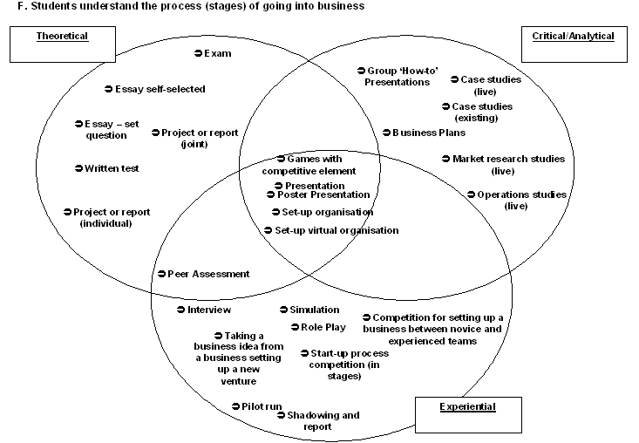
This group creates three intersecting forms of assessment practice based on ‘theory’; ‘analysis/critique’; and, ‘experience’. These forms also have ‘integrative’ assessment practices, which are considered to include; actual start-ups; venture simulations; and, poster presentations. What is interesting about this group’s output is that it demonstrates assessment based on three different forms of enterprise education: about; for and through (Gibb, 2002) but does not consider these to be mutually exclusive. The existence of the integrative techniques demonstrates that this group sees links between the different forms based on theory, analysis and practice.
The next group also explored the practical aspects of enterprise education but were more focused on the practicalities of start-up rather than the practicalities associated with going into business and with stages of growth. The output from this focus group is presented in Figure 6.

Figure 6: Focus Group Output on How to Start-up Businesses
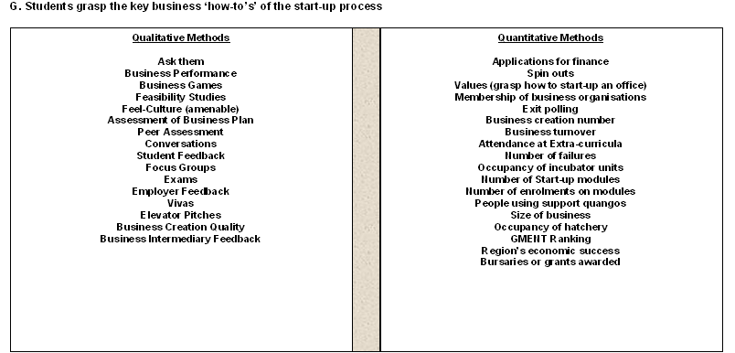

The group again chooses a dichotomous relationship to describe the differences between assessment practices. They highlight ‘quantitative’ and ‘qualitative’ methods. The qualitative methods are what would be considered normal assessment practice in Higher Education. These are methods focused on understanding whether students have gained knowledge, skills or experience effectively. The quantitative methods focus on the actual impact of enterprise education on start-up activity. They include, for example, applications for finance, start-up rates; occupancy in incubators; and, exit polling. It is possible that the output from this group was influenced by its composition (perhaps it had more policy makers than other groups) but it is valuable that assessment here provides a broader focus on whether enterprise education is impacting on wider economic factors.
The final group explored assessment practices that test whether students understand the relationships they need to develop with key stakeholders. Figure 7 presents the output from this group.
The focus group examining relationships identified a number of themes within which they categorised assessment practices. They made the focal point the ‘student entrepreneur’ showing that there were aspects of assessment practice which enabled students to think carefully about their stakeholders and the role they play in potential ventures. The assessment practices surrounding those focused on the student-entrepreneur can be categorised as ‘competence-based’; ‘skills-based’; ‘community-based’; ‘experience-based’; and, ‘risk-based’. This focus group identified that in order to assess relationships with stakeholders an educator would first need to build communication and interaction skills and competencies amongst students. Secondly, an educator would need to provide practice and experience for the student. Finally, the educator would need to test performance via community feedback and stakeholder assessment.

Figure 7: Focus Group Output on Understanding the Relationships with Key Stakeholders
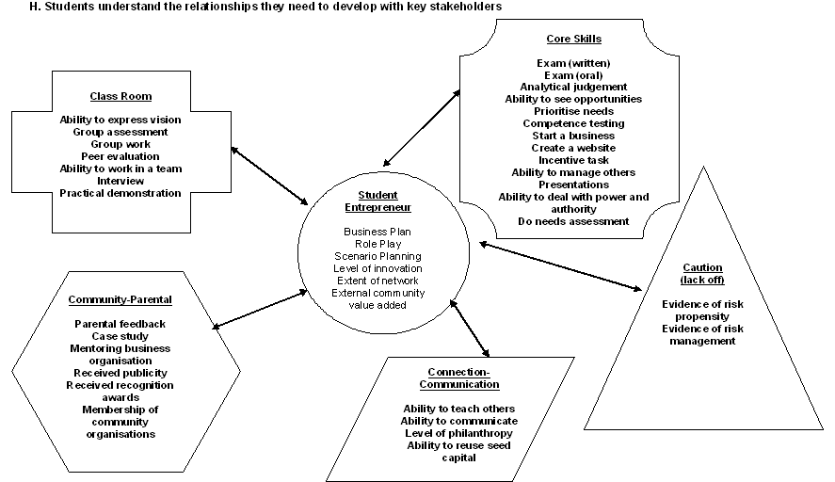
Discussion
There are many aspects of the research that require comment. Initially, what should strike the reader first from the focus groups’ output presented is the shear complexity and diversity of potential assessment practice identified by the enterprise educators. This is especially relevant when considering that the brainstorming exercise enabled educators to think freely about what assessment practices would be appropriate for particular learning outcomes, rather than considering, what they would, could or do use. There are a number of observations that can be made.
Given the potential complexity and diversity of assessment practice in enterprise education the subject clearly requires more consideration both from a research and a practice perspective. Assessment is identified as being an important part of educational practice and as educators we need to think carefully about this aspect of our practice (Banta, 2002). It is important to note from our previous discussions that this complexity and confusion about the role of assessment is not unique to enterprise education as it permeates most disciplines (Ecclestone and Swann, 1999). Thinking more carefully about the issues associated with assessment, considering more carefully the intended entrepreneurial learning outcomes desired and linking these together in effective educational designs is recognised as good practice (Rust, 2002). Clearly, effective enterprise educators will do this but it is perhaps not as simple as the argument would make it seem.
The diversity demonstrated in the focus groups highlights another issue, which is the prevailing assumptions about ‘effective assessment practice’ (Neil et al., 1999). It has been argued by many contributors to the subject that conventional approaches to assessment are not good enough to achieve what educators want (Ramesden, 1992; Boud, 1995; Brown, 1999; Race, 2003). Although this is not directly demonstrated in this study it would be interesting to observe how many of the more innovative forms of assessment identified in the brainstorming exercise are used in practice. It also necessary to point out that ‘conventional’ and ‘innovative’ can also be applied to methods of delivery. There can, for example, be innovative delivery and conventional assessment to fit in with University regulations and requirements. Lack of innovative assessment does not necessarily imply lack of innovative delivery. These issues are certainly interesting in terms of the relationship between assessment and teaching practice and they could be a focus for future research. Regardless of actual practice the focus groups presented in this paper demonstrate opportunities for more innovative practice but the various categories of potential alternatives for enterprise educators may make the options bewildering regardless of whether they could be implemented.
The options are perhaps bewildering for a number of reasons. Firstly, the study explores all the potential entrepreneurial learning outcomes and inevitably individual modules and programmes will pursue only one or a few of these. Secondly, there is considerable philosophical diversity about the role of assessment practice demonstrated in both the literature and the output from enterprise educators. There are a number of common themes, which are typically presented as dichotomies. From the literature there are a number of considerations. Should assessment be ‘formative’, helping students identify weaknesses and improve learning, or ‘summative’ being used to assess where they are in terms of performance (Ecclestone and Swann, 1999). There is some tension between these views with educational researchers identifying more with diagnostic forms and external accreditation systems driving more summative methods. These tensions are effectively illustrated in the focus groups between more subjective forms of assessment being categorised differently from objective forms. Despite these tensions a mix of formative and summative methods is the common solution.
Further philosophical tensions seem to exist in the distinction between ‘cold-observer’ and ‘social’ assessment. In recent years there has been a growth of self and peer assessment (Falchikov and Goldfinch, 2000) in Higher Education recognising that those engaged in learning can also assess the learning that has taken place. This tension is also demonstrated in the categorisations created by the focus groups. Many of the groups when forced to think creatively about assessment for entrepreneurial learning outcomes recognised that a significant component of self; peer and stakeholder assessment would be required. Despite this the extent to which these forms permeate actual practice is possibly more limited. It was also evident that these methods were counter-balanced with more observational forms showing that enterprise educators desire both forms simultaneously.
The final area of consideration was the challenges of assessing more innovative forms of learning (Gijbels et al., 2005). In terms of innovative forms of learning the entrepreneurial learning outcomes used in the focus groups encouraged educators to think carefully about assessment where learning designs might be innovative. This was evident in a few of the groups where experiential learning, action learning and simulations were the focus of assessment practice. Obviously, this area presents a major challenge for enterprise educators. Enterprise education, one could argue, should be one of the more innovative forms of learning in Higher Education. It consequently requires assessment practices that capture and assess learning effectively and by definition these practices may need to be innovative. The fact that limited consideration has been given to assessment despite significant research on pedagogy (Pittaway and Cope, 2007a) should, therefore, be a concern. It is important to develop innovative assessment practice to support innovative educational designs and careful thought needs to given to the linkage between these aspects of the educational process.

Conclusions
To conclude this paper has examined the research on assessment practice in enterprise education and has concluded that there is insufficient research focusing on the subject. The paper argues that this is an error because assessment is an important element of teaching and learning in Higher Education. It then reviews the subject of assessment practice in Higher Education showing that there are many concerns in educational research about the role of assessment. For example, there are tensions between assessment practice and the contrasting demands of different stakeholders in the educational system. The paper highlights many areas of tension including: summative versus formative and norm-referenced versus criterion-referenced. It progresses by introducing entrepreneurial learning outcomes and argues that learning outcomes, learning designs and assessment need to be carefully aligned. It introduces the workshop and the focus groups that were carried out and explores the output from the focus groups examining the brainstorming exercise with over 40 international enterprise educators. The discussion highlights the major issues for consideration based on these focus groups.
This study’s main contribution is to show that research on assessment practice in enterprise education is important and has perhaps been neglected. It provides some valuable insights into some of the challenges that educators need to consider when designing assessment and highlights that for enterprise education assessment practices may well need to be innovative and that educators may not be able to depend on traditional assessment techniques. The output of the focus groups also provides a range of ideas about possible assessment techniques, which are organised according to particular entrepreneurial learning outcomes. These examples and brainstorming amongst the participants can be valuable to educators, helping them to think about possible alternatives for particular educational activities.
The study also provides a basis for future research. One of the major questions arising from the work has been: if educators consider these assessment techniques as potential practices how do these compare with actual practice? Also while researchers view assessment practice in dichotomous relationships; educators consider these dichotomies to co-exist, to provide support for each other in a portfolio of assessment. A research question that arises from this point is: what are the effective portfolios for particular forms of pedagogy and how do educators create and identify the appropriate balance between different forms of assessment and what are the drivers behind these decisions (Young, 1999)? Another question that arises from this study is: how do enterprise educators begin to introduce more innovative forms of assessment within a system that is recognised to have competing assessment demands and where current assessment practice is considered to be failing (Brown, 1999; Race, 2003)? These are a few of the questions that arise from this study which require further research and may be the focus of future studies by the authors.

References
Askham, P. (1997). An instrumental response to the instrumental student: assessment for learning, Studies in Educational Evaluation, 23(4), 299-317.
Banta, T. W. (1999). Assessment essentials: planning, implementing and improving assessment in Higher Education, San Francisco, CA: Jossey-Bass.
Banta, T. W. (Ed) (2002). Building a scholarship of assessment, San Francisco, CA: Jossey-Bass/John Wiley & Sons.
Bilen, S., Kisenwether, E., Rzasa, S. and Wise, J. (2005). Developing and assessing students’ entrepreneurial skills and mind-set, Journal of Engineering Education, 94(2), 233-243.
Boud, D. (1995). Assessment and learning: contradictory or complementary? In Knight, P. (Ed) Assessment for learning in Higher Education, London, Kogan Page.
Broadfoot, P. (1996). Education, assessment and society: a sociological analysis, Buckingham, Open University Press.
Brown, G., Bull, J. and Pendlebury, M. (1997). Assessing student learning, London, Routledge.
Cope, J. (2003) ‘Entrepreneurial learning and critical reflection: discontinuous events as triggers for ‘higher-level’ learning, Management Learning 34(4): 429-50.
Cope, J. (2005) ‘Toward a dynamic learning perspective of entrepreneurship, Entrepreneurship: Theory and Practice, 29(3), 373-398.
Cope, J. and Watts, G. (2000) ‘Learning by doing: an exploration of experience, critical incidents and reflection in entrepreneurial learning’, International Journal of Entrepreneurial Behaviour and Research 6(3): 104-124.
Dalley, J. and Hamilton, B. (2000) ‘Knowledge, Context and learning in the small business’, International Small Business Journal, 18(3): 51-59.
Deakins, D. and Freel, M. (1998) ‘Entrepreneurial learning and the growth process in SMEs’, The Learning Organization 5 (3): 144-55.
Dunne, E., Bennett, N., and Carré, C. (1997). Higher education: core skills in a learning society, Journal of Education Policy, 12(6), 511-525.
Ecclestone, K. (1996). How to assess the vocational curriculum, London, Kogan Page.
Ecclestone, K. and Swann, J. (1999). Litigation and learning: tensions in improving university lecturers’ assessment practice, Assessment in Education, 6(3), 377-389.
Falchikov, N. and Goldfinch, J., (2000). Student peer assessment in Higher Education: a meta-analysis comparing peer and teacher marks, Review of Educational Research, 70(3), 287-322.
Gibb, A. A. (1997) ‘Small firms’ training and competitiveness: building on the small business as a learning organisation, International Small Business Journal 15(3): 13-29.
Gibb, A., (2002), In pursuit of a new enterprise and entrepreneurship paradigm for learning: creative destruction, new values, new ways of doing things and new combinations of knowledge, International Journal of Management Reviews, 4(3), 213-232.
Gijbels, D., Dochy, F., Van de Bossche, P. and Segers, M., (2005). Effects of problem-based learning: a meta-analysis from the angle of assessment, Review of Educational Research, 75(1), 27-61.
Hindi, N. and Miller, D., (2000). A survey of assessment practices in accounting departments of colleges and universities, Journal of Education for Business, 75(5), 286-290.
Neil, D. T., Wadley, D. A. and Phinn, S. R. (1999). A generic framework for criterion-referenced assessment of undergraduate essays, Journal of Geography in Higher Education, 23(3), 303-325.
Pittaway, L. and Cope, J., (2007a). Entrepreneurship education – a systematic review of the evidence, International Small Business Journal, forthcoming.
Pittaway, L. and Cope, J., (2007b), Simulating entrepreneurial learning: integrating experiential and collaborative approaches to learning, Management Learning, 38(2), forthcoming.
Race, P. (2003). Why do we need to ‘repair’ our assessment processes? A discussion paper, Journal of Science Education, 4(2), 73-76.
Ramsden, P. (1992). Learning to teach in Higher Education, London, Routledge.
Rae, D. (2000) ‘Understanding entrepreneurial learning: a question of how?’, International Journal of Entrepreneurial Behaviour and Research, 6(3): 145-159.
Rae, D. and Carswell, M. (2000) ‘Using a life-story approach in researching entrepreneurial learning: the development of a conceptual model and its implications in the design of learning experiences’, Education and Training 42 (4/5): 220-7.
Reid, A. and Petocz, P. (2004). Learning domains and the process of creativity, Australian Educational Researcher, 31(2), 45-62.
Reuber, A. R., and Fischer, E. M. (1993) ‘The learning experiences of entrepreneurs’, in Frontiers of Entrepreneurship Research, N. C. Churchill et al., eds., Wellesby, Mass.: Babson Centre for Entrepreneurial Studies.
Rust, C. (2002). The impact of assessment on student learning, Active Learning in Higher Education, 3(2), 145-158.
Schwartz, P. and Webb, G. (2002). Assessment: case studies, experience and practice from Higher Education, Kogan Page, London.
Topping, K. J., Smith, E. F., Swanson, I. and Elliot, A. (2000). Formative peer assessment of academic writing between postgraduate students, Assessment and Evaluation in Higher Education, 25(2), 149-166.
Yorke, M. (1998). The management of assessment in Higher Education, Assessment and Evaluation in Higher Education, 23(2), 101-114.
Young, G. (1999). Using portfolios for assessment in teacher preparation and health sciences. In Brown S. and Glasner, A. (eds), Assessment matters in Higher Education, Buckingham, Open University Press, 122-131.

See http://www.cshe.unimelb.edu.au/assessinglearning/05/ for more information.
Assessment and Evaluation in Higher Education
http://ncge.com/communities/education/content/get/7
Covering seven of the eight entrepreneurial learning outcomes
Although the distinction between the two is not absolute
By unrestricted we mean that educators were asked to think about methods for assessing entrepreneurial learning outcomes regardless of whether they would be practical within the usual restrictions placed on academics in Universities.

