The Strategy of Business Reorientation in a Typical Croatian Cruising

Prof. Tihomir Lukovic
University of Dubrovnik
Branitelja Dubrovnika 29
20000 Dubrovnik

Tel: 0038598343899 Email: tihomir.lukovic@unidu.hr
Website: www.tlukovic.de

Dr. sci Zvonko Grzetic

Hydrografic Institute, Split

Objectives:
Subject is cruising in the Mediterranean which is made as single or multiple day cruising on typical traditional vessels, particularly adapted. Development of Croatian cruising fleet is especially interesting, as it developed as a result of support and cooperation with tourist agencies from emitting tourist market.

Prior work:
Paper is part of a comprehensive and continuous decennial research of nautical tourism in Croatia and in the Mediterranean. Authors based their research on the researches performed by TOMAS nautica, TOMAS cruising, TOTUS and on the cooperation with other European projects in nautical tourism.

Approach:
Besides analysing research projects systematically conducted in Croatia and in the Mediterranean, authors conduct their own field researches every 2 or 3 years, conducting surveys in cca. 400 marinas in Italy, France and Spain (comprising about 12,000 km of coast). Current status and data from Croatia and Greece are added. Development of typical Croatian cruising is particularly discussed.

Results:
Croatian cruising fleet is developing as family business following the development model of small entrepreneurship. Development is the result of close connection and form of partnership with the emitting market which requires from cruisers very strict quality requirements and control of the services. It's a good example of connecting receiving & emitting markets of nautical-tourism and of developing partnership. Through tourist-agencies the emitting market found its interest of creating a development partnership to mutual interest. The paper will present current data, and the film will present Croatian cruising.

Implications:
We conducted the research on development of national cruising in Croatia and in the Mediterranean and supported it with the example. The development progresses as a result of a cooperation and partnership between tourist agencies of emitting markets and national entrepreneurs. It may be concluded that business interests in tourism are developed through intensive cooperation between emitting-and receiving markets. Such a cooperation supports regionalisation and new forms of cooperation and business-linking.

ABSTRACT:

Nautical tourism in the Mediterranean is very dynamic and creates new tourist selective categories and new products. The theory of strategic management has strictly selected all known strategic forms, analysed separately its parts and phases, identified the patterns of their trends and shaped them. However, nothing is final, and in the course of the theory development new strategic development forms created in tourism may be observed. Interdependence of theory and practice is becoming more intensive, and nautical tourism is a phenomenon within which very dynamic and not sufficiently explained changes occur. Cruising, as one of the major international businesses in the Mediterranean, is assuming new development forms. Besides the major world cruising and specialised ports for acceptance of large cruisers organised in reputable associations like «Cruise Europe» situated in Rome, there are also new forms of cruising. They develop in the form suited to the indented Mediterranean coast, available to local entrepreneurs and their capital, traditionally acceptable, and are categorised as small and medium entrepreneurship in cruising (SMS). One of the interesting examples of special kind of cruising appeared in the Adriatic in the 70s as a specific development form of SMS and as a result of successful cooperation of European market of demand and Croatian market of offer. Traditional Croatian old-timer «trabakul» has in a short time gone through business transformation which resulted in a new fleet of typical Croatian cruisers suited to complex market conditions in the Mediterranean. Operating in the conditions of seasonality and various forms of diversification, Croatian cruising went through several development stages on the route to quality, organised and market oriented new Mediterranean fleet of cruisers – old-timers. In the process various strategies are combined and new strategic development models are formed, designed for nautical tourism market. Starting from the period of communism and dictated and controlled development and arriving to the development in free market conditions, this fleet has gone through a hard development process. Tourist agencies of European market of demand have recognised significant development possibilities of the new type of cruising and initiated its development. Good cooperation between tourist agencies which required the quality of the service and controlled it and visionary abilities of the owners of the fleet resulted in a very successful family business. We will analyse the process, both theoretically, from the position of strategic management, and also from the position of small and middle entrepreneurship in practice. To illustrate the results we will present a short documentary.

Contents:

- Introduction
- Typical regional Mediterranean cruising
- Position and role of local cruising in the development of small entrepreneurship
- Cooperation and partnership of emitting and receiving market – factor of development of local cruising
- The strategy of business reorientation and the beginning of the cruising fleet in the Adriatic
- Conclusion

1. Introduction

Nautical tourism in all Mediterranean countries shows not only high growth rates, which are above the known growth rates, but also the development has been continuous for several decades.
Each country in the Mediterranean is developing its own development concept of nautical tourism which depends on a series of factors, but primarily on the level of economic development and the beauty of the coast and the saturation of tourist amenities. The differences of their development among Mediterranean countries are great, and deserve investigation aimed at providing scientific contribution to the development of this phenomenon. Some of the countries base their development on marinas and charter (France and Spain), while other develop world cruising, like Italy. However, a typical local cruising is present in all Mediterranean countries. Being one of the three main forms of nautical tourism (nautical tourism, cruising and charter), cruising is a significant activity. Besides multi-continental corporative cruising, which attracts large industries of ancillary supporting and complementary activities, local cruising is being developed as an example of successful family business.
The subject of this paper is the research of the development of Mediterranean local cruising, its description and characteristics.
The emergence of local cruising is different for each country, and its special development models all have one common characteristic. They are an example of successful family business and belong to the sphere of small entrepreneurship, giving incentive to the development of other small entrepreneurship activities. Developing primarily on the basis of the beauty of the coast, they support its sustainable development and preservation of the local culture and traditional crafts, all aimed at extending their offer.
Developing as a counter-balance of the large world cruising which is gradually losing its elite aspect and assuming characteristics of mass tourism, Mediterranean cruising, with its smaller traditional old-timers, gradually assumes the role of elite cruising. Under the strict control of tourist agencies of the emitting market, local cruising improves its services each year and occupies larger and more fixed position in the cruise market. Close connection and cooperation with the emitting market, which include even partnership model, is an example of new relationships in tourism which require scientific analysis and explanation.

2. Typical regional Mediterranean cruising

2.1 Large and small cruising, main characteristics

By definition, cruising is entertainment sailing, or sports and recreational tourism. Tourist dictionaries and Internet dictionaries contain very simple explanation, for instance, at the site http://www.answers.com/topic/cruise there are several interpretations of tourism, among which: «To sail or travel about, as for pleasure or reconnaissance. » It seems that cruising is a very clear idea, but it has a more complex structure in the system of nautical tourism. Therefore it has to be observed as a part of nautical and tourist structure which can be presented through the basic model of classifying nautical tourism.

Figure 1 Classification of nautical tourism
NAUTICAL TOURISM
Nautical tourism ports

Charter

Cruising
Anchorages
Berths
Dry marinas
Marinas:
Category I
Category II
Category III
Cruisers
Ports for cruisers
Motor yachts
Sailing yachts
National old-timers:
a) for single day cruising
b) for several days cruising
Ports for big cruisers:
a) Specialised ports («Cruise Europe» members)
b) Non-specialised ports

Ports for national old-timers
Big world cruisers

Source: Classification by the author T.L.

Functionally modelled, cruising consists of two main subgroups; ports for accepting cruisers and cruisers. The predominating form of cruisers are large world cruisers, to which an increasing number of Mediterranean ports are being adapted and suited. If we know that maxi voyagers which can take up to 5,000 tourists sail along the Mediterranean, it is not difficult to conclude about their nautical and tourist domination. Those are large sailing hotels, which are categorised like hotels, and which take a special place in national legislations which support the development of cruising.
The segment which we are to research in this paper are small cruisers, that is, Mediterranean regional and national fleet of old-timers, which are becoming increasingly important in nautical tourist offer. What is the significance of the fleet?
Development of luxurious and ample offer, which is strategically suited to the large world cruiser, with the aim that a tourist satisfies all their needs in the cruiser, almost made the tourist not to leave the cruiser at all. The comprehensiveness of the offer made the tourist lose the contact with the nature and the possibility to know it better in a particular locality. It is exactly what small Mediterranean cruisers will provide, and their offer is developing and shaping in harmony with the natural beauties of the Mediterranean. Small regional and national oldt-timers create a completely different offer and satisfy tourists’ needs relating to the impressions of the landscape and cultural destinations in the navigational route along the national sea.

  - Mediterranean cruisers – old-timers, a product of Mediterranean maritime culture

Europe is a continent whose development is closely connected to the sea, the Mediterranean and the surrounding oceans. Starting from ancient Greece and Rome, followed by Mediaeval Spain, France and Italy, and all other Mediterranean countries, they all link their development to the sea. The sea has always been a factor of development. Shipbuilding has developed along: in ancient times large and small wooden ships were built, and each locality had its specific constructions which have been preserved to present days, either as ship models or ships in navigation. Such ships are now the basis of development of regional and national old-timers – local cruisers. They are the product of the time when they were built, but they are also a link between a man and the sea. It seems that their construction is balancing between their artistic beauty and the power of the sea which is different at each locality. Ships are therefore different in appearance and construction, but Mediterranean characteristic is present in each of them
The development of world cruising is accompanied by local cruising at each Mediterranean locality. Depending on a number of factors, the local cruising has been designed into a specific local and national nautical tourist offer. It may be classified as:

  - Vessels/cruisers for single day sailing, and
  - Vessels/cruisers for several-days sailing.

The above classification has its legislation basis; in fact, this is how the national legislature treats the local cruising. The law also requires the categorisation similar to the categorisation of hotels, with 3-5 stars, and standards for acquiring a category. In this way, old-timers have become a demanded nautical tourist product in the market. In the clash with large world cruisers, old-timers are increasingly designing their offer market. While the offer of large cruisers consists of complete equipment of cruisers, the offer of old-timers is based on natural beauties and cultural heritage of the area. They are the connection of the Mediterranean cultural heritage and human need to experience the nature, and they fit very well into the globalisation of the market, shaping their portion of global market.

- Place and role of local cruiser in the development of small entrepreneurship

Local cruising links numerous complementary activities which could be grouped according to the level of their dependence:

- Activities which are very closely connected to local cruising:

  - Traditional shipbuilding of wooden ships,
  - Construction of private ports for winter accommodation of vessels,
  - Servicing of vessels.

- Activities which are significantly connected to local cruising:

  - Farming,
  - Fishing,

- Activities which are not significantly related to local cruising:

  - Wholesale,
  - Traffic,

What is particularly important for the development of cruising is preserving old crafts, souvenir production, healthy food production, quality fish supply, and the like. All these activities belong to the sphere of small entrepreneurship and family business that are developing on the Mediterranean coast and islands. Thus cruising does not only achieve significant financial and development results, but also contributes to the preservation of Mediterranean cultural heritage. However, local cruising has another characteristic. Its distribution in the Mediterranean is not uniform, nor is it the manner of its emergence. Most often, local family communities have for hundreds of years settled the area making their living on the sea and maritime activities. Such communities are very close and are often relatively isolated from the surrounding large cities. The concentration of cruisers is clearly noticed, which forms the local model of economic development in which everything is related to cruising. In such localities cruising is also an economic and political development factor, which will be particularly explained afterwards. All this contributes to economic development regionalisation which is becoming European model of economic development.
Besides, the fact that products of local cruising are based on natural beauties and cultural heritage of the coast adds to its contribution to the sustainable development of tourism.
The third characteristic of local cruising is its contribution to the development of local small town ports. Mediterranean coast is rich in cultural heritage which have developed and grown for thousands of years, leaving visible traces and unique invaluable cultural wealth. The remains of such cultural sights have become tourist attractions upon which the development of tourist products of cruising are based. Large and small ports have developed in those localities. The majority of small, attractive ports cannot accommodate large cruisers, and those historical sights remain inaccessible to their passengers, but not to the passengers of old-timers. In addition, while, in the course of their development, large cruising changes large city ports, local cruising changes the profile of equally important, small ports. Large world cruisers develop at annual rates between 15 and 25%, and old-timers cruisers follow with similar rates. The development of large cruising is a typical example of corporation development which does not have development feedback with the destinations. On the contrary, local cruising is closely connected to the locality and strongly supports local economy and develops together with the community. Small, attractive ports follow the development, adapting to the changes and becoming significant features of local cruisers. The dynamics of those changes depends on financial effects of the business relation, which is proved by strong market activities.
The question that requires an answer is the following: What caused the rapid development of local cruising – a tourist phenomenon and which marketing basis is it based on?

- Cooperation and partnership of emitting and receiving market – a factor of development of local cruising

4.1 Main market and interest relations of the competent subjects of old-timers cruising

According to standard tourism theories, it is known that the demand market is variable and the offer demand is inflexible. Influenced by the motives and the needs, the demand market forms the needs and transmits them to the offer market, which then reacts by a formed offer and tourist products. Professor Luiz Moutinho designed the process of articulating the demand, through various stages, from first stimulating motives to final decision.

Diagram 1 Presentation of the system of personal decision-making about the voyage

Stimuli to travel:
- advertisements
- brochures about excursions
- reports from excursions
- recommendations by tourist agents
Social and personal behaviour determinants relating to travelling:
- Socio-economic status
- Personal characteristics
- Social influence and aspirations
- Beliefs and values
Motivation
Desires/needs
Expectations
Searching information
Estimation of the voyage
Desire to travel
Decision about the voyage/demand

Thinking about destinations:
- The relation of costs and values
- Attractions/benefits
- Occasion for travel
- Tourist arrangement
- Quality/quantity of tourist information
External variables
- Confidence in tourist agent
- Idea about the destination/service
- earlier travel experience; time consumption
- estimation of the risk (objective/subjective)

Source: L. Moutinho: « Strategic Management in Tourism », May 2000

The offer reacts to the shaped demand by articulating the suitable offer of its range of products. Prof. Philip Kotler has well distinguished the characteristics of the services, including tourist services as well, and gives their four main characteristics:

  - Impalpability,
  - inseparability,
  - variability, and
  - transience.

In order to transform the demand in nautical tourism into consumption, four main characteristics of tourist demand need to be satisfied:

  - articulated needs,
  - price affordability to tourists,
  - promptness to buy, and
  - free time of the subject of the needs - tourists.

During the realisation of this process through which nautical tourist consumption is reached, it is necessary to ensure good communication in its broadest sense. Communication in nautical tourism has a special importance. On the basis of strong motives of the emitting and the receiving markets, which are not equal, but complement each other, both oriented to consumption, a model of the relation between emitting and receiving market is created. Starting from interlinked motives of offer and demand, a partnership model is gradually created, aimed at maximising the quality of the product of nautical tourist offer, so that the category «value for money», which in nautical tourism is an important factor of successful business, is brought to its maximum. In the market competition for consumption the category «value for money» is one of the most important categories in the subjective model of objective decision for consumption. The money a tourist spent at a cruiser or in a nautical tourism port will lead to the idea that he/she «had spent the planned amount, or even more, but he/she is satisfied! », which is essential and is one of the factors of successful business. In order to obtain a positive answer, interest and competent subjects are engaged, and thus become business partners. In the demand market of nautical tourism, and especially in old-timer cruising, it is the tourist agencies. On the other side there are cruisers (owners) and their offer. The target competent subject of that relationship, to whom all activities of the agencies and cruiser owners are directed, is a tourist – passenger on the cruiser. The proposal for the model is presented in the Diagram 2:

Diagram 2 The model of interest relationships

Target subject
Interest subjects – partners
Tourist/
passenger on a cruiser
Tourist agency
Owner of the cruiser – old-timer
Joint interests of tourist agencies and owners of the cruisers:
- To know the needs of tourist – potential passengers of the cruisers,
- To evaluate «value for money»,
- To design the offer and products aimed at satisfying «value for money»
Interest of tourists:
- To realise their needs,
- To satisfy their needs relating to the «value for money»,

Source: authors

As it is evident from the model, a tourist agency in the emitting market becomes a business and an interest partner to the owner of the cruiser. Their activities are jointly directed towards satisfying subjective category «value for money», which is the main factor of consumption and a condition for the consumption to realise. They are connected by the same interest – to satisfy the needs of a tourist/passenger on the cruiser and to instil the sense of satisfaction. The sense of satisfaction has to be permanent, so that the category «value for money» is truly realised. That happens at a particular time and space; what are the characteristics of the time and space and what is their role in cruising?

4.2. Seasonality and its effects in old-timer cruising

One of the main characteristics of tourism is its seasonal characteristic. From business aspect, seasonality is undoubtedly negative. Its characteristics like dead season, excess of employees, fixed costs and no earnings, are common problems for the management of any company doing business in tourism or nautical tourism. The only solution to this problem is to prolong the season. This is the common problem for all companies dealing in nautical tourism: ports, charter and cruising. How could the negative effects of seasonal aspect of nautical tourism business be reduced, i.e. how can the tourist season be prolonged? The problem is very often a strategic problem to be solved at the micro level of development decision-making. The question to be answered is: is the seasonality in nautical tourism to be eliminated and how?
The season in the Mediterranean is related to the summer. All countries of the emitting and receiving European markets are influenced by the Mediterranean and its summer peak season in tourism. Full season is in the second part of June, July and August. For most of the tourists, a car is the main transportation medium to their destination, and especially for boaters and passengers on cruiser old-timer. About 80% of boaters and passengers on cruiser old-timer, and of other kinds of nautical tourists use their own vehicle to reach their starting destination. There are three main European car routes which lead to tourist destinations. Seasonal migrations of tourist flows in summer months are presented in Figure 1.

Figure 1 Main European tourist and passenger summer routes

Source: authors

As it is obvious, all routes run through Germany, and then continue to three main routes which then branch to their destinations on the coast. Seasonal aspect in nautical tourism is clearly noticeable. Apart from French Cote d Azure, seasonality in nautical tourism may be described as follows:

- With nautical tourism ports in the Mediterranean, the season lasts about 22 weeks. Preparations for the season start in March/April, and dead season is in December and January, when most of nautical tourism ports close down their business.
- Smaller charter companies have the same destiny, while larger charter companies like «Moorings», «Private Yachting», «Bavaria Yachts», «Sun Charter» etc. transfer their charter fleets to the markets where the season is longer.
- With cruising, seasonality is manifested in accordance to the type of the subject. This analysis may be further researched and explained in view of the main subjects in cruising:

c1) ports for cruisers

Ports for cruisers in most part of the Mediterranean experience the negative influence of the low season, when the arrival of large cruisers in winter is 5-10 times lower. Smaller ports for cruisers old-timers have completely dead season, without a single arrival of local cruisers in winter, as cruising in such ships depend on the weather and the temperature.

c2) cruisers

Large world cruisers are not much affected by seasonality, as they have well established routes in all parts of the world, and the stay there resist unfavourable winter weather conditions. Local cruisers old-timers, being closely connected to local characteristics and weather, have a distinctive seasonality, and winter is used for communicating with tourist agencies and preparation of the cruisers for the next season.

As it can be concluded, seasonality is not equal in all types of nautical tourism and cruising.
What does seasonality depend on?
Negative effects of seasonality depend on the mobility of the subject. Additional factor is the size of the company, but the main factor is the objective of each type, i.e. of each company. Nautical tourism ports are immovable and are most affected by the negative influences of seasonality. Because of their mobility, charter and cruising have an opportunity to search active markets where the season lasts longer. This particularly refers to large world cruisers. Local old-timers are practically immovable, as they are linked to the locality/market where they operate, and have strong seasonality aspect of their business. It rarely happens that they leave to other areas beyond their fixed cruising routes. Additional reason is the profit they make during the season which is sufficient to cover all costs, pay annuities of investment loans of the owner/investor and still live comfortably.
However, negative effects of seasonality in nautical tourism business is a fact which each segment of nautical tourism tries to mitigate by applying a special model. Generally, two basic models of affecting/reducing negative effects of seasonality are mostly used:

  - Diversification – used by «immobile» types and companies of nautical tourism: nautical tourism ports, ports for accommodation of all types cruisers and local cruisers old-timers.
  - Model of business relocation, used by large cruisers and large charter companies.
  - Model of business expansion, a specific model of development of small and medium entrepreneurship in local Mediterranean cruising.

In the model of diversification, nautical tourism ports which do not stop operating during winter, use their capacities for other activities. This primarily refers to good quality marinas which at the time organise conferences, sports competitions, fairs, wedding receptions and other gatherings, covering thus fixed costs and maintaining the basic crew/employees of the port, who cannot be easily found in the labour market.
Charter and cruising companies choose business relocation to transfer their fleet/vessels to other markets and in this way cover the basic operating costs. Local cruising, organised as local, family business, develops a model of business expansion, in such way that they build good family hotels, motels, restaurants, shops, production halls, etc. in immediate vicinity of their family houses. High profit earned in cruising is directed into new investment and family business is expanding. This expansion usually remains within the family land, port of the cruiser and family house. Thus, the question still remains «Is seasonality absolutely negative and should it be opposed by aggressive tourist offer and by saturating the coast which will ensure consumption and reduce seasonality? »
In all recent analyses the problem of seasonality has been increasingly discussed. The question is should it be opposed and how. Recognising the significance of sustainable development in tourism and nautical tourism, it becomes obvious that seasonality is a necessity and a factor of sustainable development of tourism. Local old-timers, closely connected in their offer to the locality of the Mediterranean, adapt their business and development to the seasonal aspect of nautical tourism. Despite business and financial effects of seasonality, we think that seasonality is one of the preconditions of tourism, nautical tourism and local cruising.

- The strategy of business reorientation and the emergence of the cruising fleet in the Adriatic

5.1. Croatian cruisers old-timers – their emergence and development

Long ago, inhabitants of Omiš were famous mariners, and notorious for their piracy. Venetian, Ottoman and other fleets used to pay them a lot of money for sailing along their part of the Adriatic. More recently, in Yugoslavia, the community was relatively isolated and a little rebellious. This affected the development of a fleet of wooden ships called trabakul which families used to dredge sand in the river Cetina estuary. The sand is of high quality sand and is used for fine final works in construction. The sand was sold along the coast, from Rijeka to Dubrovnik, and in the whole Yugoslavia. The activity ensured a relative independence and some political influence of this small community in the local policy and economy of the town of Omiš.

Model 1 Model of Development cruise family business with old-timer on the Adriatic coast, before civil war

Touristic sesonal demand
from the emmitive European Market

Disadvantageous political behaviour
Not supported by laws

Receptive
local market
Cruiser’s offer

Source: authors

Croatian old-timer fleet now has 164 registered old-timers (2006) in the Association of Croatian old-timer cruisers situated in Split. Their organisation is transparent and it has a web page at the address www.jedrenjak.hr . As many as 110 cruisers at the location between Split and Omiš, Krilo Jesenice in particular, is registered for single-day and several-days cruising. It is an example of family business in a typical Mediterranean cruising operating in the Adriatic. In general, one family has one cruiser, and recently, some families purchase another, along with investment into other objects.

Figure 2 Space arrangement of a family business

ERCEGOVIĆ, 5 cruisers
ORKAN, CICERO, KNEŽA, Sv. VID
PASAT

NARANČA, 2 cruisers
TUNA, NARANČA

RAKULJIĆ, 3 cruisers and 2 for excursions: KAPETAN JURE, MAJA
ALOHA, MONVI, KUPINOVA

TOMAŠ, 2 cruisers
ADRIATIC QUEEN, BURA

NOVAKOVIĆ, 3 cruisers
DALMATINAC, SRETAN
PRAVEDAN

VUKOVIĆ, 4 cruisers
SAGENA, TOMA, SILVA
ŽDRELAC

TOMIĆ, 3 Katamaran
KRILO JET. KRILO, MALA LARA

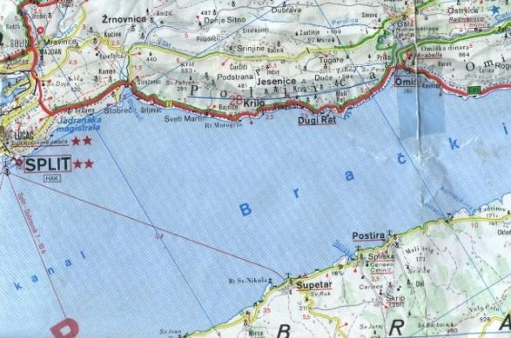

Source: authors

Other amenities are also developing along with the family cruising business, but it would be interesting to observe what led to that development.
The development of tourism in the Adriatic initiated seasonal tourist cruising business. Cruising which started in the 60s was organised in the manner that in June the owners would mount a berth on their trabakul and engage in cruising, and in September the berth would be dismantled and the ship would again be used in sand business. Tourist agencies of the German emitting market noticed the development potentials for such type of cruising and towards the end of the 70s they engaged in negotiating about possible new tourist offer in the European market. The financial market in Yugoslavia was at the time characterised by high interest to investment loans, and a very complex procedure for the realisation of the loan. Tourist agencies offered not only cooperation in booking for three to four months of cruising, but also very favourable long-term loans, and partnership. However, agencies also dictated their conditions relating to the quality of the offer, for instance:

- The ships Trabakul had to stop dredging for sand,
- The ships had to be reconstructed for cruising, mostly for several-days excursions, 1-2 weeks per group, or route,
- Berths and all other facilities in the old-timer had to be reconstructed in accordance to national and European highest quality standards,
- Quality control of the cruiser crew,
- Controls had to be performed regularly, especially during the season.

At the same time cruisers were given guarantees for the paid allotment during the whole season – 3-4 months a year.
The help of tourist agencies led not only to the contacts between emitting and receiving markets, but the cooperation has been upgraded to a form of partnership. Very often agencies and families, cruiser owners, jointly invest into development and new products. One of the results of such cooperation is the construction of 3 fast hydrofoils suitable for single-day excursions to attractive destinations on nearby islands.

Figure 3 One of three fast katamaran-cruisiers «KRILO JET» in ownership of family Tomić, for one-day excursion Split-Hvar-Korčula (www.krilo.hr)

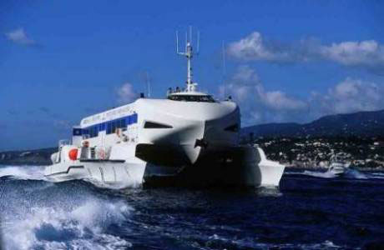

Photo by the authors

Model 2 Model of development and support of a family cruise business and entrepreneurship on the Croatian Adriatic coast after civil ware (after 2000)

Demand from global tourist emittive market

Intensive communication and research of touristic market

European tourist agencies which are situated on emittive market

Advantageous political and business behaviour
Law system which support development
of nautical tourism

Receptive touristic market
complementar effect
Cruiser’s offer
Greatest touristic offer
Two multi-regional group offers

Banks with bank’s products
Country government
Local and regional government
Researches of touristic institutes
Shipbuilding industry
SUPPORT SUBJECTS

Source: authors
As a result of good cooperation with tourist agencies, all families in the area between Split and Omiš extended their business and developed new tourist and catering facilities. In the area of less than 20 km new facilities have been built in recent years: 20 new family hotels, 50 catering capacities, 40 shops, 70 production premises, etc.
In this way, business reorientation from sand dredging to cruising yielded very good results. Business reorientation and economic and capital strengthening of the families from the area brought a number of advantages:

- The association Association of private shipowners participates in the communal government of Omiš and is very influential,
- The municipality covers 2% of the interest for each investment loan, with the aim to develop and build new cruisers,
- Zagrebačka banka, the major bank in Croatia and eastern Europe, made a long-term contract about cooperation with the association Association of private shipowners aimed at developing new banking products needed to cruisers,
- A minimum of one member of each family from the area is attending a university studies of tourism and economy, aimed at increasing the quality of family tourism,
- Government administration noticed the benefits which this cruiser old-timer business achieves, and participates in developing the infrastructure of that Adriatic area and completing the highway for better traffic connection,
- Traditional crafts are being maintained and developed, and became a part of tourist offer, as in other countries.

Business reorientation which was organised in the described manner stimulated business expansion which resulted in surprising benefits and good results. This is one of good examples of connecting emitting and receiving markets. Linking which was done by tourist agencies grew into profit-oriented investments aimed at developing the offer for satisfying the needs which the agencies observe working directly in the emitting European countries.

Diagram 3 The scheme of the reorientation strategy of Croatian cruisers old-timers

Business in close local community

Business in large European market and implementation of globalisation in business
Sand dredging for construction
European tourist agencies
Cruising on old-timers
From 1960 to 1980

From 1980 to the present

Source: Authors

Business reorientation from sand dredgers to cruising and tourism was not only an important turning point, but also brought significant changes in the way of living. Ancient pirates have become successful businessmen in small entrepreneurship, subjects of globalisation and promoters of regional development.

  - Cruising in Mediterranean and European old-timers

Cruising n old-timers is not present only in Croatian cruising, but also in the whole Mediterranean and Europe. Such aspect of nautical tourism can be found in Italy, Mediterranean islands, Greece, France and Spain, but also in the North Sea and Eastern Sea in the north of Europe.

Figure 4 Small cruisers in Warnemünde, the North Sea and Croatian Cruiser old-timer

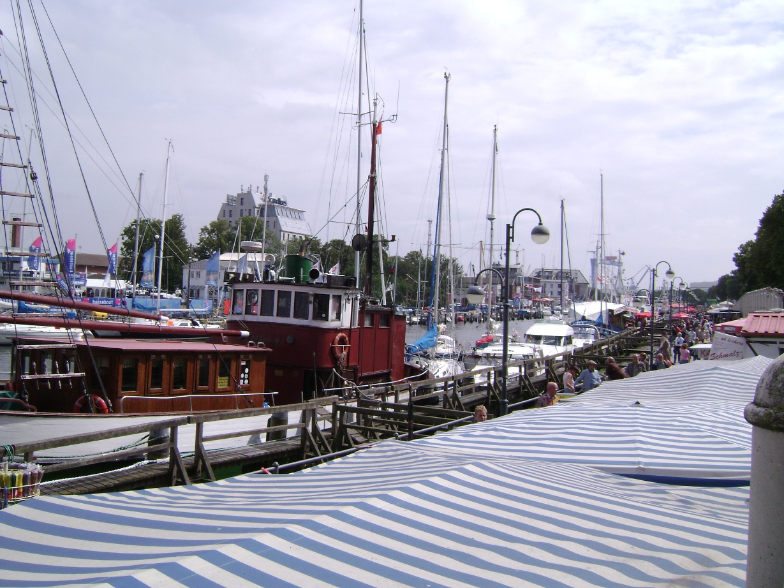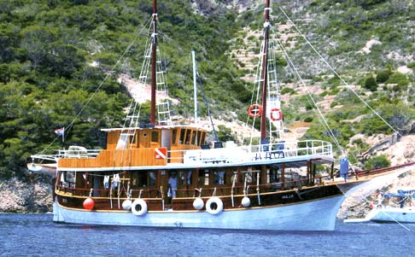

Source: Photos by the Authors

The development of cruising on old-timer cruisers occurs in all European and world coasts. The main characteristic of such cruising is intensive linking with the locality and the nature. Each type of vessel is the result of adaptation to local natural surrounding. It became part of the local and national tradition and culture and is an important form of local cruising.
The researches conducted in Germany, a significantly emitting nautical tourism market, indicate the importance of local cruising.
That type of cruising is not competitive to the standard large cruising, since the differences in motives and the type of offer are outstanding. The countries with developed river, lake and channel nautical tourism (Germany, the Netherlands, Denmark etc.) have well developed cruising in old-timers which is an important segment of tourist offer. The research, which was conducted in Germany and ordered by the German government, is interesting for our analysis. Contrary to the Mediterranean countries, other tourist emitting countries, including Germany, regard nautical tourism as part of aquatic tourism. It distinguishes base and additional types of aquatic tourism. The scheme below illustrates the idea.

Scheme 6 Defining and classifying of aquatic tourism in Germany.
Aquatic tourism in Germany

Segments connected with aquatic
tourism
Aquatic tourism
(close meaning)
Shipping
Oriented to water tourism
(exact)

- Canoe tourism
- Sailing,
motorboats
- Charter boat
tourism
- Surfing,
waterskiing
- Diving
- Fishing
- Trendsports
(rafting,
canyoning
ect.)
- Passenger
Shipping
- River cruising
- Sea cruising
- Ferries
- Traditional
shipping

- Beach/bath
tourism
events
- Camping
tourism on
sea
- Rudder boat
lent during
holidays
- Winter-
Aqua sports
- Ect.

- Maritime
events
- Maritime
industry
tourism
(p.e.
taxations)
- Sea/Ship
Museums
- Ect.

Object of the study

Source: dwif/BTE 2002

As it can be seen, traditional cruising is one of the five types of «shipping» of marine tourist traffic. Such form of marine tourist traffic in traditional vessels occurs in lakes, rivers and channels, where nautical tourism is organised besides freshwater aquatic tourism, traditional cruisers are also present in the sea, the North Sea and the Eastern Sea.
Financial meaning of cruising is not important to local old-timers, but is an important segment of the entire German tourist offer and aquatic tourism offer.

Table 1 Number of realised days of tourist traffic in aquatic tourism in Germany in 2002 (estimated figures).

Water tourism | days of stay
Boat tourism and water-sports (sailing,- motor, houseboat, canoe, surfing, diving) (look table up) | 2.880.000
Ferry passenger shipping | 2.700.000
Maritime events | 2.000.000
Shipping for tourists | 1.200.000
Excursion and several day shipping (traditional shipping) | 60.000
Sea-and river cruising | 54.000
Sum | 8.894.000

Source: Economics ministry of Mecklenburg-Vorpommern (2002) p.59; 104

It can be observed that shorter excursions in traditional ships realised 60,000 days. Such type of aquatic tourism participates with only less then 1% in total tourist activities, which is relatively low, bit in some localities such type is very much represented. Aquatic tourism of emitting European markets is a segment of total tourist offer and cannot be observed separately. Therefore comparisons with Mediterranean nautical tourism cannot be easily done.
Contrary to the Mediterranean, and to less saturated areas, nautical tourism in traditional ships in the European emitting market is developing along with the entire tourist development. Cruising on traditional old-timers in the Mediterranean has been intensified; it represents the development framework, and is the local development leader. In the Mediterranean, it is developing through the development of family small enterprise and is locally dominating as shown in the example of Croatian cruising.

Research of this old-timer cruising market in Croatia show, that it enter in competition with traditional cruising. But, when we talk about little parts of sea, like Adriatic Sea, Black Sea, Ionian Sea, Aegean Sea, this great cruisers can not enter in harbours of many historical towns. That is reason why this great cruiser companies and new founded companies need to start to built cruisers for not more than 200 persons but on high quality and standard. This new fleet will be great competition to old-timer-cruising and these families, which have now this business, need to invest and take care of ecology and nature and with this new model of daily cruising, event-cruising and another will be ok.
In Croatia now this cruiser-companies are supported by government and in development plan of tourism nautical-tourism with old-timers is contained. Investors are mostly private but they have nice conditions for investigations.

6. Conclusion

Nautical tourism in each Mediterranean country develops in accordance with a number of national specific aspects. The development is primarily influenced by local tradition. A part of nautical tourism offer is cruising organised on traditional ships typical for a locality or a region. In this time of high industrialisation, the offer of cruisers old-timers is well accepted, as it is closely related to natural beauties and traditional culture of the locality.
The development of cruising on old-timers may be realised either as a single-day cruising or several-days cruising. With the help of tourist agencies cruising on old-timers in the Adriatic developed into a well organised and high quality offer, recognisable in European and world demand markets. The emergence of Croatian old-timer cruise fleet is specific, both in terms of how it was created and how it developed and changed its business reorientation. Switching business from sand dredging to cruising yielded very good economic results, all within family business. It was also followed by cooperation and partnership with tourist agencies which are experts in needs of the demand market. This resulted in an interesting, capital linking of subjects of the emitting and receiving markets, all aimed at satisfying dynamic demand.
The example of the development of Croatian cruising is an example of development changes of cruising not only in the Mediterranean but in the whole Europe. Old-timer cruising illustrates the relative aspect of the standard division of a market to emitting and receiving markets. In terms of old-timer cruising the absolute emitting market does not exist, because under the influence of the globalisation process and new business relations it becomes a receiving market as well. Rivers, lakes and channels have always been navigational routes, and cruisers use old-timer ships and enlarge the local and regional tourist offer of traditionally emitting markets.
Mediterranean old-timer cruising is a segment of very dynamic development of small entrepreneurship and cruising which develops its offer on the natural potential of the coast. Old-timer cruising is the main factor of regional and local development in certain Mediterranean areas which have preserved the tradition. It is the basis for the development of other activities the volume of which depends on the size of the family. Under the influence of globalisation new models of cooperation and partnership are developed, which directly connect emitting and receiving tourist markets, whose aim is to satisfy the needs of tourists/consumers. Such models are market oriented, and the centre of attention is a tourist as the end user. A particular value of such type of development is the dependence on the nature, which contributes to sustainable development and environment protection. In relation to market trends and the factors of such trends, it is reasonable to expect high development rates of cruising and the results at local and regional level.

Reverences:

- Ross K. Dowling, «Cruise Ship Tourism», Cowan University, Faculty of Business and Law, School of Marketing, Tourism and Leisure Joondalup WA 6027 Australia, 2006
- Kotler, Philip: « Marketing management », 1999 Schäffer-Poeschel
- Luković T. & Gržetić Z. «Nautičko turističko tržište u teoriji i praksi Hrvatske i europskog dijela Mediterana», Hrvatski hidrografski institut Split, Split/Dubrovnik 2007
- Luković T. & Šamanović J. «Management i ekonomika nautičkog turizma»,
Hrvatski hidrografski institut Split, Split, 2007
- Luković T. & Strasburger J. «Yachting on the european part of the Mediterranean»
pro literatur Verlag, Nürnberg Germany 2005
- Moutinho L., « Strategic Management in Tourism », May 2000

In Croatia it is the „Ordinance on categorising and classifying nautical tourism vessels“, Official Gazette ….
Kotler, Philip: « Marketing management », 1999 Schäffer-Poeschel
A very strong interest of demand in all kinds of nautical tourism is to satisfy the needs of tourists and boaters, which is followed by the interest of the offer to design capacities of nautical tourist offer and their full employment.

