Contradictions in Social Enterprise:
Do they draw in straight lines or circles?

Pam Seanor, Researcher
Huddersfield University Business School
University of Huddersfield
HD1 3DH, West Yorkshire
Email: p.seanor@hud.ac.uk

Mike Bull, Research Fellow,
Manchester Metropolitan University
Dr Rory Ridley-Duff, Senior Lecturer,
Sheffield Hallam University

ABSTRACT
This paper provides a critical perspective on the discourse surrounding the concept of social enterprise. The paper shifts the lens away from numbers to consider how actors see themselves as social enterprises. The authors make sense of the foundations upon which the concept of social enterprise and entrepreneurship is ‘drawn’ – quite literally – by considering linear models and diagrams that analyse social enterprise on a continuum between non-profit (mission) and profit (market) orientation.
A great deal has been made of the success and growth of social enterprise. The imagery in the literature reflects an emphasis on growth resulting from ‘the rising tide of commercialisation of non-profit organisations’ (Dees, 1998) with the result that the CBI now includes over 50,000 organisations in a social enterprise sector (SBS, 2005). Despite reports of rapid growth, there is awareness that ‘take-up of social enterprise model … is patchy and fails to reflect the enthusiasm with which it is discussed’ (Stevenson in Westall & Chalkley 2007). We ask why?
A methodological approach involving visual drawings by actors reveals stories and sensemaking experiences of social enterprises. Open conversations enabled the researchers to gain deep insights that would not have been as insightful through a quantitative approach.
The key findings suggest: Firstly, participants report tensions when pursuing social and economic goals simultaneously. Secondly, whilst some welcome opportunities that are emerging, others perceive substantive threats to the third sector. Thirdly, Social enterprise emerges as a diverse and heterogeneous movement located at the boundaries of public, private and voluntary sectors. At each boundary, different constitutional forms and practices are seen.
In conclusion, it is argued that the linear perspective itself gives the impression that there is a ‘patchy’ take up of social enterprise. A heterogeneous perspective reveals that theory and policy development is patchy, rather than social enterprise practices.
The unique contribution this research paper offers is within the depth of enquiry and insight into the actual practices provided from those within the field. The critical perspective is taken from the literature and discussed in the settings of the actors in the field which provides practitioners, business support agencies and academics with a different level of empirical investigation that captures an originality and narrative that has barely been explored before.

Keywords: Social Enterprise, Empirical Research, Visual Data, Theoretical Models, Drawings, Sensemaking.

Introduction
A great deal has been made of the success and growth of social enterprise. Imagery in the literature reflects an emphasis upon growth; Dees (1998) describes social enterprise as ‘the rising tide of commercialization of non-profit organisations’ (as cited in Emerson & Bonini, 2004:36). Some empirical evidence supports this image: the Government's Annual Small Business Survey 2005 mapped 55,000 social enterprises in the United Kingdom (SBS 2005) up tenfold on previous counts.
However, these numbers may not accurately represent organisations in the field (Haigh 2005; Lincoln 2006). At best, data provides a partial view indicating either a dynamic, growing sector or a confusing picture hidden from view. This is reflected in debates within the literature on the confused identity of social enterprise (Borzaga & Solari 2001; Curtis 2006; Defourny 2001; Ridley-Duff 2007a). Recently, a different perspective on social enterprise has been articulated:
‘Despite a genuine recognition of their strong record in delivering services, the take-up of the social enterprise model across local and national government is patchy and fails to reflect the enthusiasm with which it is discussed’
(Stevenson in Westall & Chalkley 2007)
This paper shifts the lens away from numbers. The authors make sense of the foundations upon which the concept of social enterprise is ‘drawn’ – quite literally. Attention is given to the models and diagrams that are used to conceptualise social enterprise. We focus on how actors make sense of these models through qualitative research using the drawings made by actors. Visual data is a relatively unused methodology (Meyer 1991), yet provides the researcher with alternative data collection methods to frame complex situations. Actors drew lines, circles and squiggles onto models and diagrams to illustrate their contexts. By drawing upon this data, we gain a richer picture and understanding of social enterprise.
Three main findings are focused on. Firstly, participants report tensions when pursuing social and economic goals simultaneously. Secondly, whilst some welcome opportunities that are emerging, others perceive substantive threats to the third sector. Thirdly, Social enterprise emerges as a diverse and heterogeneous movement located at the boundaries of public, private and voluntary sectors. At each boundary, different constitutional forms and practices are seen.
In conclusion, it is argued that the linear perspective itself gives the impression that there is a ‘patchy’ take up of social enterprise. A heterogeneous perspective reveals that theory and policy development is patchy, rather than social enterprise practices.

The Language and contradictions within Social Enterprise
Much of the discourse voices concern regarding the definition of social enterprise. Some call for narrowing of the concept (Pearce 2003), whilst others seek to broaden discussion (Light 2006; Ridley-Duff 2008). Amongst this variety some common characteristics are distinctive. Social enterprises are socially driven organisations with specific social, environmental and economic objectives. Seen as part of the social economy, they utilize business-like skills to create profits that are re-invested into their social missions (Bull 2006). Is it that simple?
The UK Government promotes social enterprise as delivering ‘business solutions for public good’ (OTS 2007). Others focus on innovation in addressing societal failures (Evers 2001; Nicholls 2006). This underlies different perspectives between social enterprise and social entrepreneurship. As Westall and Chalkley (2007:27) point out, social enterprise is a process rather than a product; it is ‘not just about goods and services, but also about political and social co-ordination’. Slow take up of social enterprise models may serve to highlight that practices at community and local authority levels may not yet be firmly accepted.
There are several conceptualisations of social enterprise and social entrepreneurship (for fuller discussions see Alter 2004; Defourny 2006; Mair & Marti 2004; Nicholls 2006; Pearce 2003; Ridley-Duff 2007a). The paper focuses upon three of these conceptual theoretical models. Firstly, the social enterprise spectrum, that is rooted in the concept of a double-bottom line (Dees 1998; Dees and Anderson 2006). The spectrum is a linear depiction of a continuum of options and opportunities. These organisations are seen as ‘hybrids’ choosing from a range of options utilizing various business-models. At one end of the spectrum are ‘purely philanthropic’ goals opposed to those that are ‘purely commercial’.
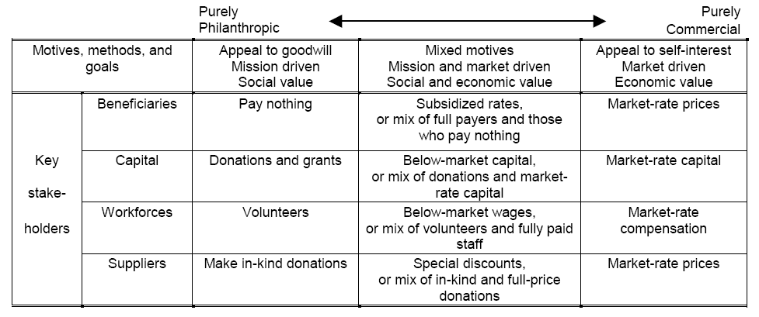
Figure 1: Social enterprise hybrid spectrum (Dees, 1998)
Of importance to the discussion within this paper, Dees and Anderson (2006:54) suggest that there is no dichotomy in meeting these two opposing goals but rather that ‘reality is more like a continuum with many shades of grey’. Others have built on the continuum model. Figure 2 is an adaptation that views social and economic goals as held in equilibrium (Alter 2004).
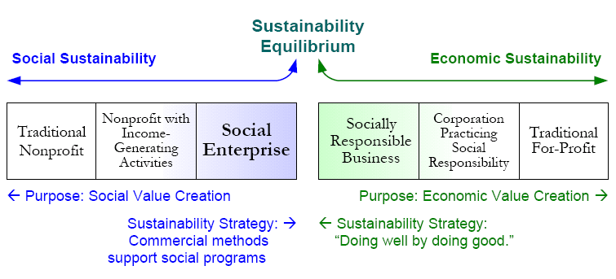
Figure 2: Sustainability Spectrum (Alter 2004:8)
Alter (2004) proposes dual value creation (‘blended value’ – Emerson 2004) as a more holistic notion than the double (or triple) bottom line. The classification, however, is similar: traditional non-profit and traditional for-profit organisations represent the boundaries of Alter’s framework. Both non-profit organisations with income generating activities and social enterprises are situated on the side of social sustainability. Alter makes a conceptual distinction but in practice it is difficult to clearly differentiate (Westall & Chalkley 2007).
An alternative typology is found in conceptual cross-sectoral models that accommodate the public sector. As a result, some authors argue that social enterprise is not a distinct sector: Figure 3 illustrates one view of this landscape whereby the conceptual location of social enterprise activity is seen at the overlaps of three sectors. Pharoah, Scott and Fisher (2004) identify the overlapping areas as the locus of social enterprises, whereas Leadbeater (1997) views the overlaps as the breeding ground for social entrepreneurs. Seanor and Meaton (2008) support Pharoah et al. and trace the intellectual heritage back to Billis’s (1993) ambiguity model. This has been evolved into a typology based on the characteristics of each hybrid (Ridley-Duff 2008). Whereas Ridley-Duff argues that each hybrid can be regarded as a different form of social enterprise (with an ideal type at the cross-over point of all three sectors) Nicholls (2006) limits ‘social enterprise’ to the point where all three sectors overlap.

Social enterprise activity
Voluntary Sector
Private sector
Social enterprise activity
Social enterprise activity
Public Sector

Figure 3: A cross-sectoral view of social enterprise
The advantage of placing social enterprise within a ‘lumpy’ landscape (Aiken 2006) is an appreciation of ambiguity in the practices, origins and ethos of social enterprises. Cross-sectoral models can account for the concurrent emergence of both ‘heroic’ social entrepreneurial models and multi-stakeholder approaches to provide clarity regarding the ‘blurring’ between the non-profit and profit sectors (Dart, 2004).
To add further complexity, Kerlin (2006:249) notes that the term social enterprise means different things in different national contexts, namely the European ‘concept of a social economy is not used in the United States and non-profit social enterprises are often discussed as operating in the market economy.’ In the US, an emphasis is placed upon social enterprise goals being linked to the social entrepreneur’s individual characteristics rather than the effects of a collective identity (Bull 2008; Spear 2007; Westall & Chalkley 2007). This has resulted in two disparate discourses with academics and practitioners failing to acknowledge or refer to one another’s work (Nyssens 2006b). ‘Blurring’ is thus dependant on national, global and contextual issues. This, in part, explains why models and diagrams appear confusing and unrepresentative to parties locked inside one idiosyncratic perspective.
Somewhat surprisingly, much of the dialogue of those seeking social change is seen to comfortably fit within the linear spectrum typology (Bornstein 2004; Drayton 2005; Emerson 2004). Dart (2004:414), however, comments that those ‘in the social enterprise movement, and particularly those who self-identify as social entrepreneurs, commonly focus on a more narrow operational definition of social enterprise that is framed more specifically in business and revenue generation terms.’ He therefore questions the innovation in these approaches. Dart’s comment reflects the focus on financial frameworks and income generation to serve a social purpose. However, this viewpoint is being challenged by those who argue that the models used for social enterprise development are all too often underpinned by a strategic and ‘rational’ emphasis that subordinates social objectives to financial imperatives and business-like approaches (Arthur et al. 2006; Curtis 2006; Light 2006; Pharoah et al. 2004). Arthur et al. (2006:1) states:
‘Ten or so years ago it would have seemed like an oxymoron to amalgamate the terms social and enterprise. Since that time the concept has rapidly passed from obscurity to the status of orthodoxy.’
This divide is historically influenced by the origins of social enterprise. There are ethical and political divides as well as a political ‘softening’ that merges the economic and social (Bull 2006). Arthur et al. (2006:2) continue to outline the hazards of legitimising a narrative that assumes business success will lead to social aims taking care of themselves. This leap of faith is problematic. It characterises social enterprise as a way of ‘doing’ business much the same as private businesses. Efficiency over effectiveness is being queried. By emphasizing business over social there are concerns that the various aims of social enterprises may not be attended to and social missions may ‘drift’ (Anheier 2000; Evers 2001; Foster & Bradach 2005; Georke 2003; Mendel 2003). More than this, radical social change may be lost from the political landscape altogether! We explore these issues drawing on empirical research grounded in the views of actors within the field of social enterprise.

Research Design
This paper seeks to make sense of complex situations, not count or measure by numbers. As such, it is methodologically interpretive and draws its data from three pieces of qualitative research. In refuting that social reality is objective, the authors ground their work in ‘truth’ as a socially accepted construction (Berger & Luckman 1966). Seanor's study involved interviews with mature organisations within the Voluntary and Community Sector (VCS) evolving into social enterprises. Evidence from this study is supported by, and compared to data captured during an ESF funded research project developing diagnostic tools for management practice (Bull 2006) and finally findings from an 18-month critical ethnography (Ridley-Duff 2005), grounded in the self-perceptions of social entrepreneurs pursuing employee-ownership in Spain and the UK.
By considering how actors visually construct and reflect upon their experiences, Stiles (2004:128) claims we can tap ‘embedded phenomena’ that are ‘integral to understanding organisations’. Meyer (1991) suggests that visual data offers a rich data source whereby encoding and interpretation is undertaken by both actor and researcher to achieve mutual understanding. The use of non-text-based data is not a clearly established methodology (Mason 1996). Nevertheless, Stiles (2004:127) proposes that it has value because ‘…images can be as valuable as words or numbers in exploring organisational constructs’. Meyer (1991:220) also urges researchers to exploit graphics and drawings by arguing that informants ‘possess more copious and meaningful information than they can communicate verbally.’
The findings are a product of meetings and correspondence over the course of a 9-month period in which the authors helped each other to interpret the visual data. Key questions included: Do theoretical models assist with the practical problems organisations face? How do actors frame social enterprise? Do practitioners think about their organisational development processes inductively or deductively? Do they draw in straight lines or circles? Most actors found visual models of use. Some, however, refused to pick up a pencil to mark or draw a model. These actors preferred using words.

Findings – Do they draw in straight lines or circles?
In this section, the authors trace how three emergent findings are grounded empirically in the drawings of research participants.

Finding 1: There are tensions in meeting both social and economic goals
As was discussed in the literature there is a disjuncture between those that suggest that no tension exists (Evers 2001, Emerson 2004) and others who question the perfect mix between social and economic aims (e.g. Arthur et al. 2006; Curtis 2006; Pearce 2003; Pharoah et al. 2004). The first drawings were made during Bull’s (2006) study. Actors were asked to indicate where they saw their organisations on a continuum from ‘social’ at one end to the ‘enterprise’ at the other. Seanor’s initial study began similarly, with mission (social) and market (enterprise). The continuum itself provoked much discussion in both investigations. However, across the two studies differences were noted in the responses of actors.
Social Enterprise
In Bull’s study (Drawing 1) there was a mix of engagement from an immediate large ‘X’ at either end (more often than not at the enterprise end) to quite hostile and aggressive responses where actors refused to pick up the pencil. Bull noted that the size of the ‘X’ depended on actors’ positive commitment to (or confidence in) their position along the continuum. There was an embarrassment from some as to their position. One actor was content to picture themselves as a smiling face at the social end of the spectrum. In other cases, it was unclear whether participants felt they were not enterprising enough for themselves, not enterprising enough for their funders, or simply admitting there was a mismatch between their private and public aspirations.
In Seanor’s study, actors were asked if they had seen the linear model. They were also asked how useful the models were as a way of discussing the ethos of their organisations, and the knowledge and skills needed to operationalise them. Perhaps not surprisingly, the majority of actors had never seen the conceptual model. In contrast to Bull’s research, Seanor’s study when asked to locate their organisation on the continuum, many positioned themselves nearer the social end. Only one actor in clearly marked their organisation as located in the economic half of the spectrum.
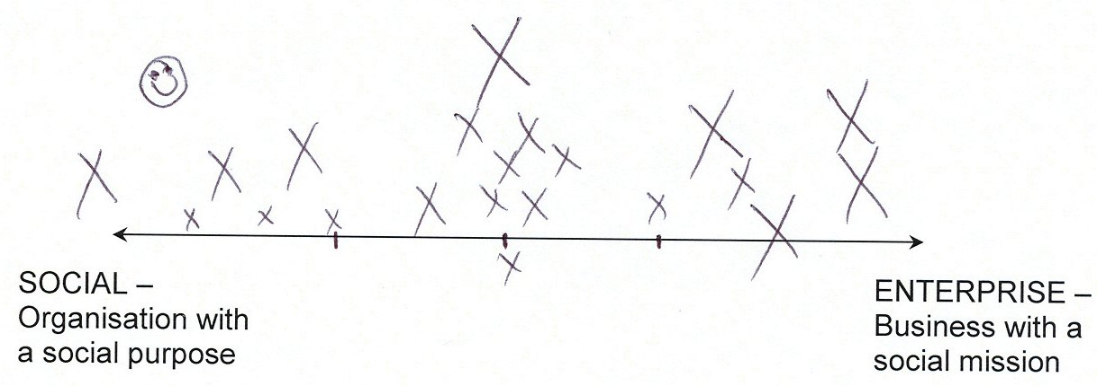
Drawing 1: Range of social enterprise hybrids between social and enterprise purposes
Although the continuum allowed many to indicate their current situations, actors felt that they needed to provide more of an explanation. In Bull’s study they added arrows to show their direction and future path. This was overwhelmingly towards the ‘enterprise’ end of the spectrum. One actor, however, indicated a move towards the social end – a lone arrow against the stream.
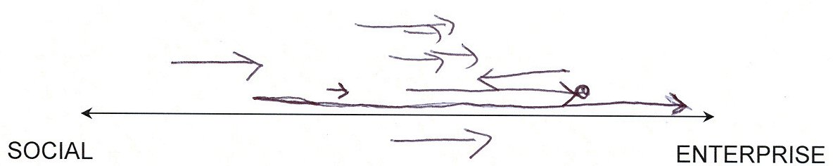
Drawing 2: Perceived direction of change within each social enterprise
In Drawing 3, from Bull’s study we see an actor explaining the ‘hats’ they wear: alternative personae for different stakeholders. They adopt an ‘enterprise’ persona when meeting with people outside the organisation. Within the organisation, they adopt a ‘social’ persona.

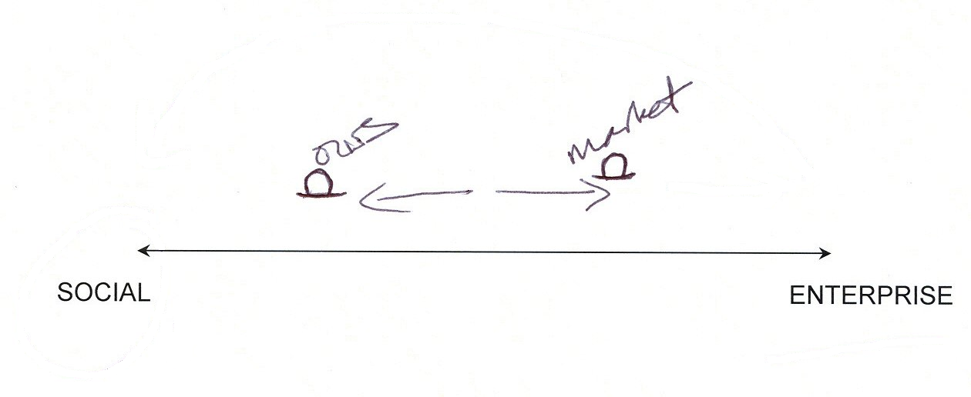

Drawing 3: Different hats for different personas.
In Seanor’s study there was no overwhelming ‘x marks the spot’ for social enterprises. Instead, actors identified a range of positions that they move between. Light (2006) suggests that organisation members may experience an ‘ebb and flow’ between ‘market’ and ‘mission’. He states that time and environmental influences change the quality of social enterprise characteristics. In contrast to the ‘tide of social entrepreneurs…changing the face of England’s voluntary and community sector’ (Boschee, 2006: 359; Dees, 1998), a metaphor more suggestive of a dynamic relationship is adopted. For Light, there is a tide coming ‘in and out’. Drawing 4 correlates well with Bull’s hats drawing and supports Light’s (2006) notion of an ebb and flow: an actor illustrates their fluctuating experiences.
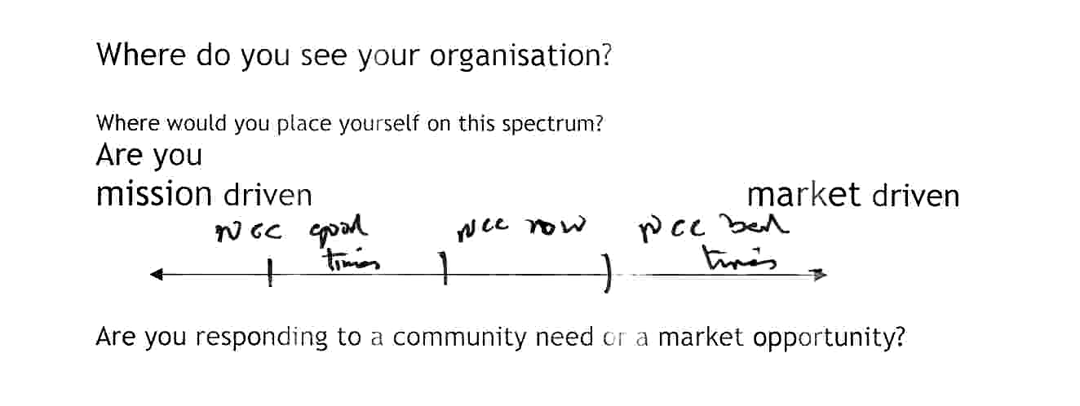
Drawing 4: Social enterprise spectrum ebb and flow
This actor describes ‘good times’ as periods of secure funding, able to actively pursue their social aims. Counter-intuitive to the literature, in ‘bad times’ they concentrate upon economic goals, pull back from networking activities and the promotion of social aims. This ‘ebb and flow’ is also reflected in Drawing 5.


Drawing 5: back and forth movement between goals
The actors aim to move beyond the mid-point to become more financially secure but do not depict this as a linear movement. Instead, they illustrate a series of backward and forward movements between their social (s) and economic (£) goals.
In the social enterprise literature, there is a presumption that organisations desire to become more efficient. Organisations are seen as moving in a ‘McDonaldization’ production-like process toward the commercial end of the spectrum (Dart 2005; Dees et al. 2001; Hardy 2004). The data, however, support Alter’s (2004) alternative voice: non-profits and social enterprise are focussed on their social missions. As a consequence, ‘organizations rarely evolve or transform…along the full spectrum’ (2004:7). Drawing 6 illustrates Alter’s model further: two actors in Seanor’s study drew the following:
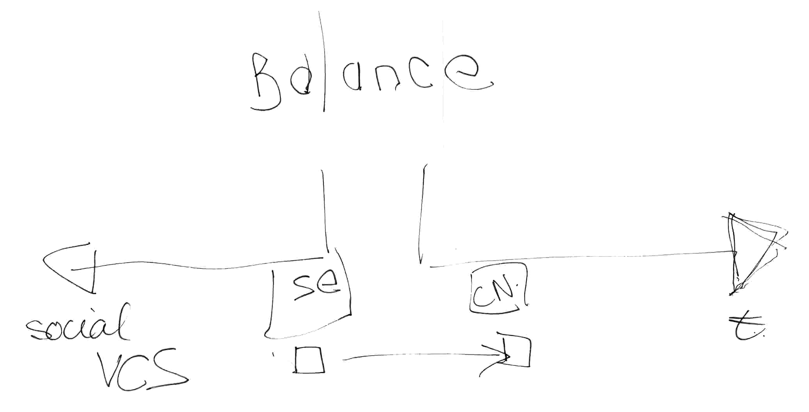
Drawing 6: Balance in a social enterprise
They acknowledged a need to become more financially secure but stressed that they had no intention of moving to the economic end of the spectrum. They felt the Balance model better represented their plans.
In Bull’s research one actor, without prompt, chose to deviate from the continuum (Drawing 7).

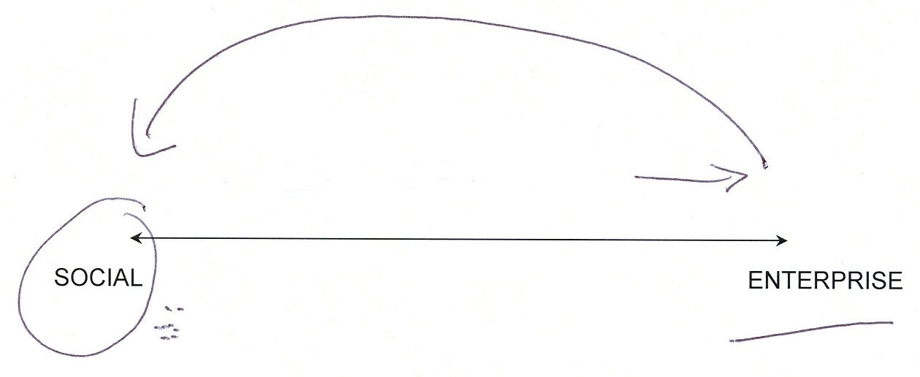

Drawing 7: Recursively linking the enterprise back to the social.
The actor (with some venom) drew an arrow to the enterprise, underscored the enterprise and then the arrow back to the social in haste that the necessity to move to the enterprise was purely a strategic drive that, for them, was the best way of achieving the social – the dots and the circle came as the actor insisted that the social was their only concern – not the enterprise per se. Actors did not want to prioritise ‘enterprise’ and resented their values being eroded. They were cautious of managerialism and the shifting sands of government policy. ‘Enterprise’ was perceived as undermining the trust, morality and social nature of the services they were providing.
Drawing 8 (from Seanor’s study) illustrates a complete rejection of linear thinking. In this case, the actor refused to place a mark upon the line and drew two circles showing an overlap between social and economic worlds.
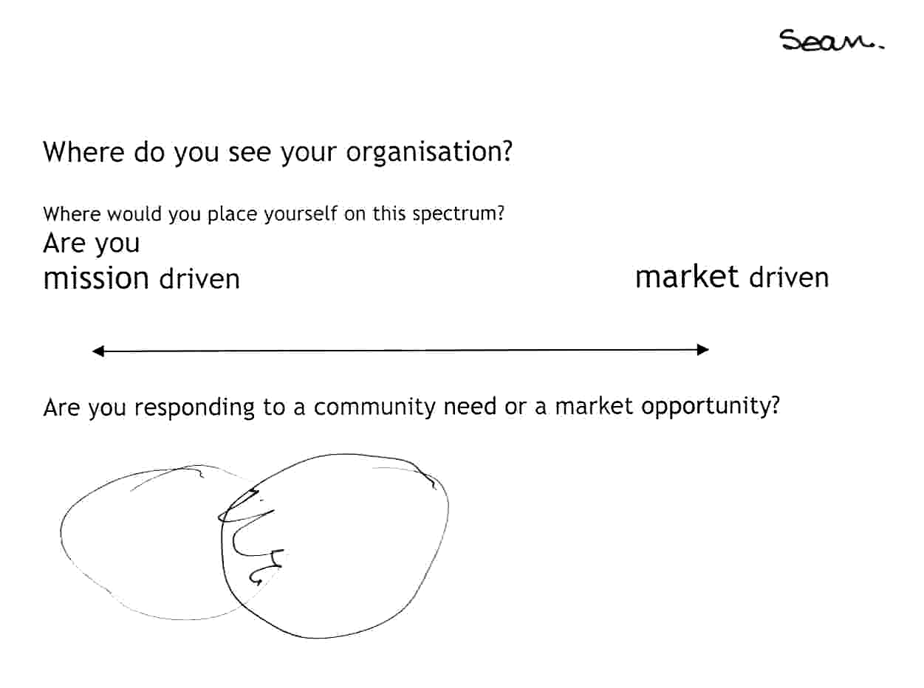
Drawing 8: A circular alternative to the social enterprise spectrum
This drawing was unexpected and changed the nature of Seanor’s future interviews. The blending of two worlds invited a return to the literature, and this uncovered Billis’s (1993) ambiguity model. Later cross-sectoral models (Leadbeater 1997; Pharoah et al. 2004) were discovered. In subsequent interviews, cross-sectoral models were introduced and discussed.
Finding 2: There are perceived opportunities, threats and resistance associated with social enterprise models
From Seanor’s study, the majority of the respondents had not seen a cross-sectoral model. However when shown, many actors found this model to be of more value. It was perceived as more relevant as a way of conceiving current and future options. Many actors emphasised that their focus for social enterprise activity was located at the overlap between the public and voluntary sectors. Some emphasised movement across the overlap of private and voluntary sectors.
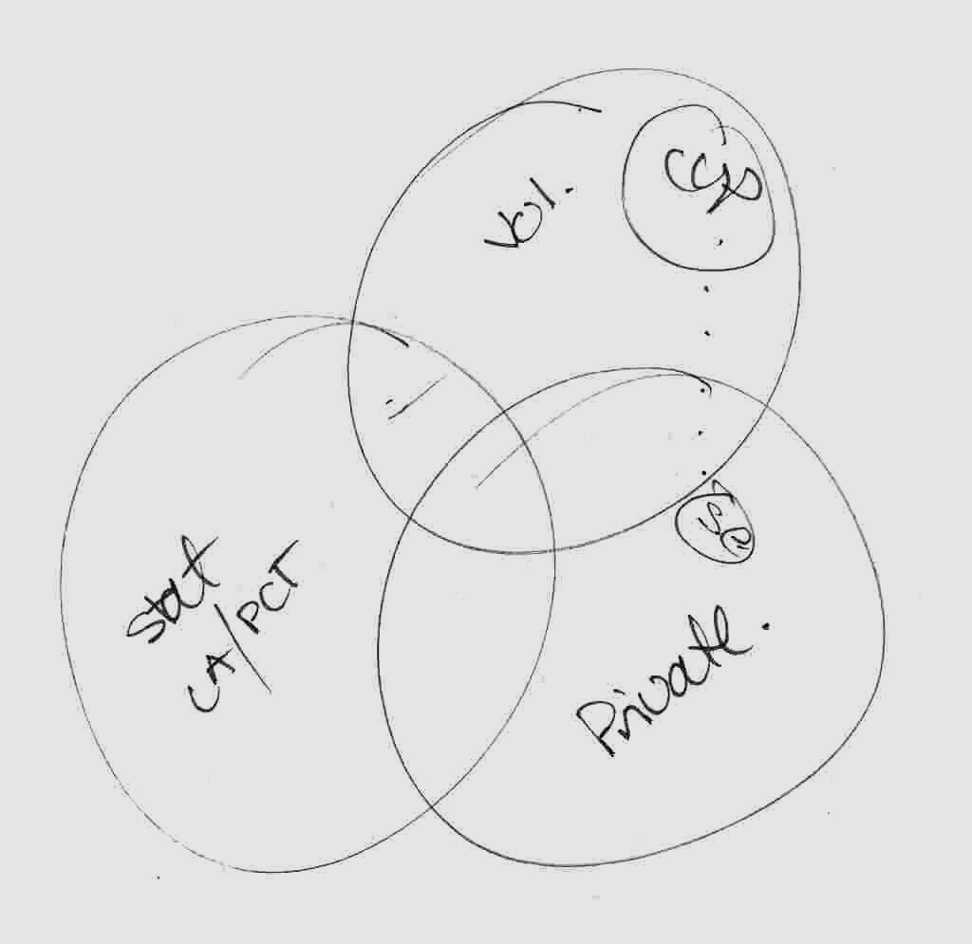
Drawing 7: viewing a social enterprise opportunity
Drawing 7 illustrates this. Two actors in a registered charity contracted to provide social services for statutory providers drew their organisation firmly in the voluntary sector. Surprisingly, they saw the future of social enterprise not as the contracting they currently undertook, but a training and support programme they intended to sell to the private sector.
An actor from another organisation (Drawing 8) drew the three worlds model to emphasise the perceived threat from the private sector. She identified the location of social enterprise as contracting between the VCS and local authorities (compare Westall & Chalkley 2007).

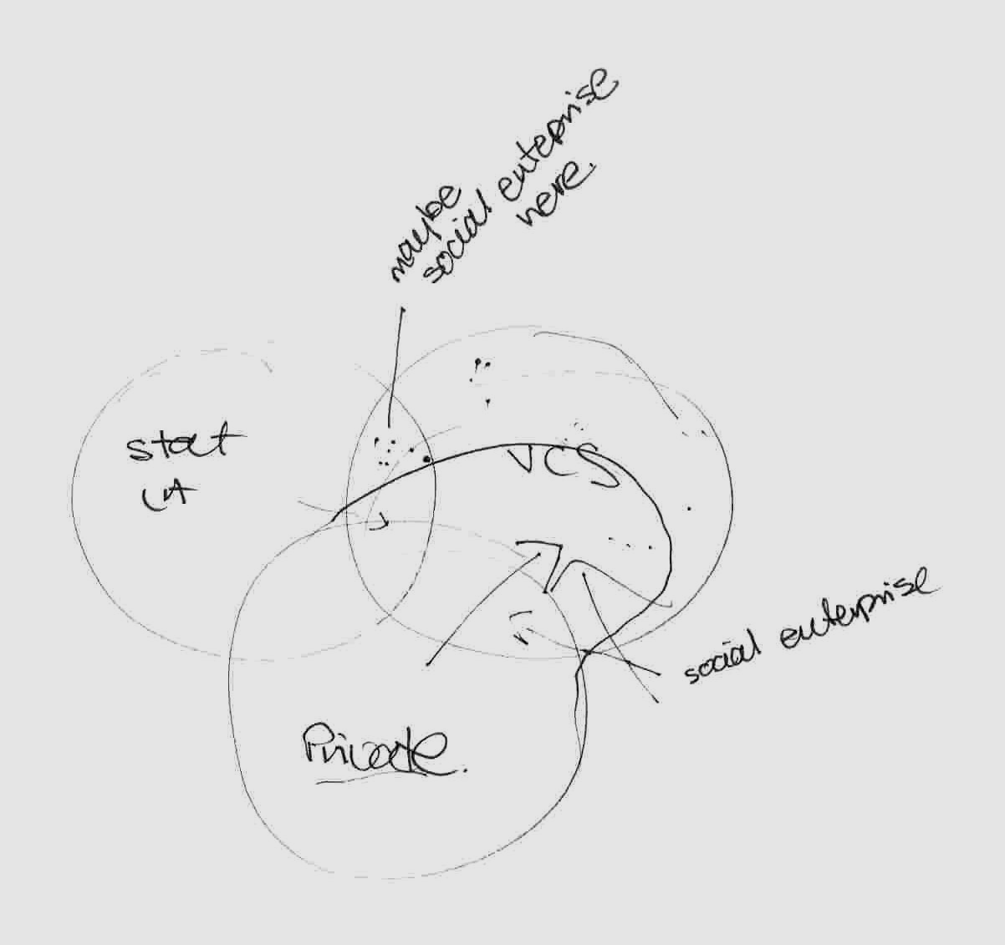
Drawing 8: viewing social enterprise as a private sector threat
Their view was that social enterprise was encroaching the VCS. The drawing looks like a battlefield advance or an amoeba engulfing another cell, representing the huge threat. Their response was to defend the third sector’s ability to deliver contracts. This drawing echoes the comments of other actors who discussed ‘resistance’ and ‘defending’ their social aims from both the private sector and the social enterprise movement.
The impression given to the researchers throughout was that even if social enterprise is a ‘way of thinking’, some participants intended to move ‘chameleon-like’ between sectors rather than adopt an unambiguous ‘business-like’ identity.

Finding 3: There is debate about individual versus collective entrepreneurship
Drawing 9 from Seanor's study shows another drawing made by an actor who rejected the Dees’ continuum. They link governance practices to different enterprise models to reveal diversity in social entrepreneurial perspectives.
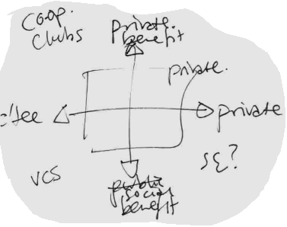
Drawing 9: Grid representation showing governance
as lacking in social enterprise spectrum
First she drew a grid to represent where she felt social enterprise was located. The Y-axis denotes ‘private’ and ‘social’ benefit. The X-axis depicts ‘committee’ versus ‘private’ control. Of particular note is the positioning of co-operatives and clubs, voluntary community sector (VCS) and social enterprise (SE) in different quadrants. Although seen to have a social benefit, she questions whether social enterprise differs from the VCS on account of private rather than community control. This stands in sharp contrast to a literature that often emphasises democratic control in social enterprises (see Borzaga and Defourny, 2001; Pearce, 2003).
This actor elaborated their thinking in a second drawing (Drawing 10). The sectoral model is used to locate health authorities and social enterprise activity in the overlapping areas between sectors.
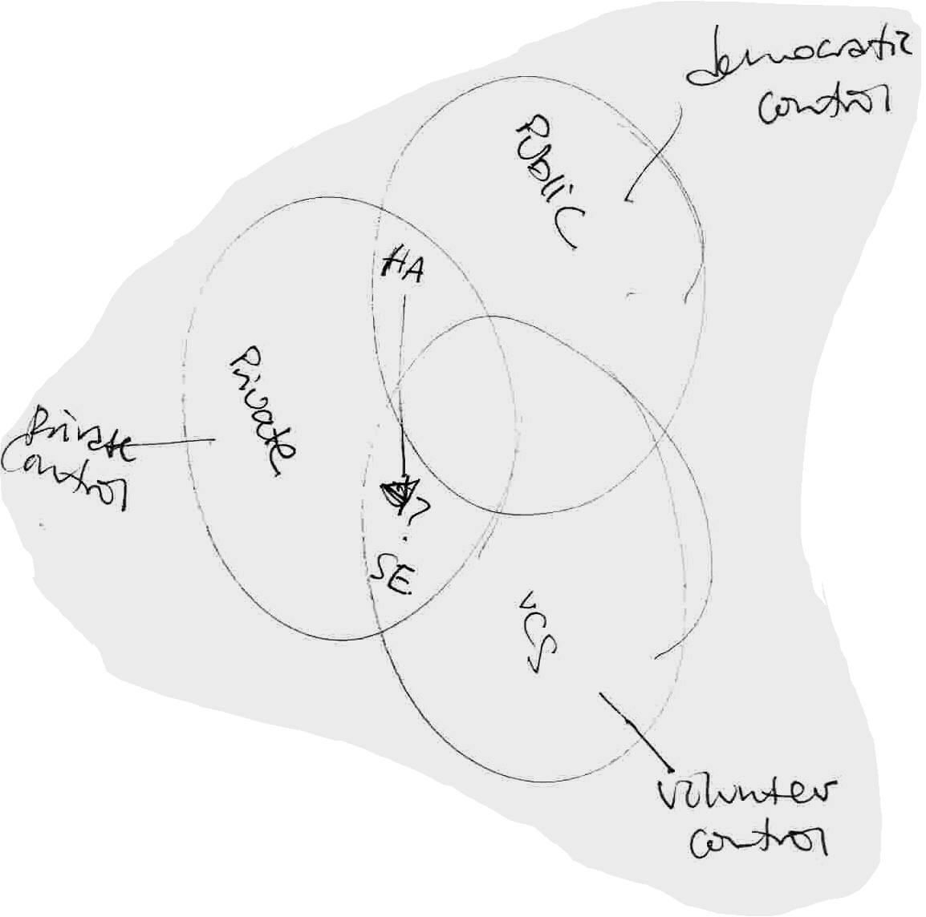
Drawing 10: Sectoral drawing showing importance of governance in UK
It is the mode of governance (tension between private and member/community control) rather than a business model that underlies her perspective on social enterprise.
Taken together, these understandings echo the sophistication of the governance models found by Turnbull (1994, 1995) in the co-operative networks of Spain. As social enterprises mature, they not only embrace the tension between private and community control, they also start to replace linear thinking with circular, holistic and recursive thinking. The three worlds are incorporated within the governance structure to bridge stakeholder groups.
Drawing on Ridley-Duff’s research in 2003, field visits were undertaken to the Spanish Mondragon co-operatives to assist a UK business introducing member-ownership and control (see Ridley-Duff, 2005). Practitioners in Mondragon gave talks to UK academics and practitioners on the governance models used in commercial and social economy organisations. Interestingly, the same governance model – albeit with varying stakeholders – was adopted regardless of sector. In this case, the researcher (as ethnographer) transcribes drawings made by actors during talks and seminars.
Drawing 11 shows the generic governance model. In industrial settings, a General Assembly of all members (i.e. workers) constitutes a sovereign body. In retail and banking, the General Assembly comprises workers and customers. In educational settings, the General Assembly comprised students (in higher education)/parents (in pre-university education), workers (support and academic staff) and ‘supporting organisations’ (local government and businesses). Stakeholders varied but the governance model was consistent with the exception of organisations small enough for members to have personal relationships with each other.

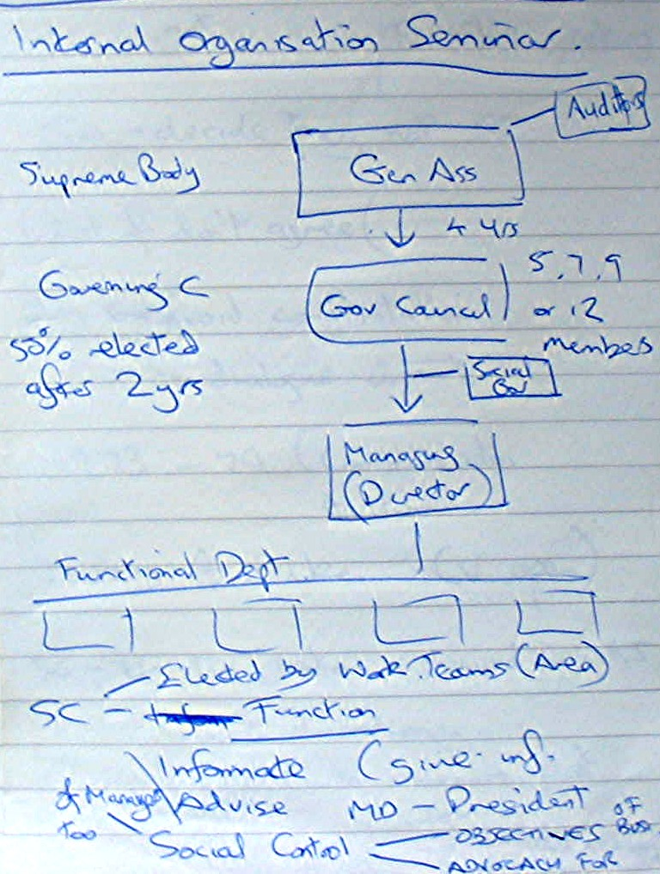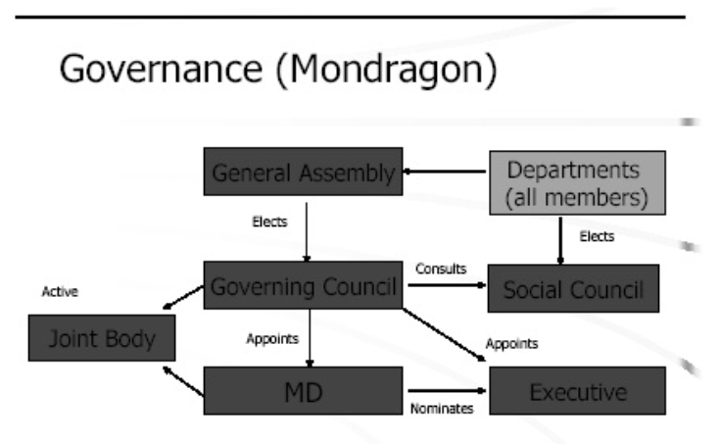

Drawing 11: Representation of Mondragon Governance to UK Academics / Practitioners

In Spain, the General Assembly (Gen Ass) appears at the top of the model (Drawing 11). It is perceived as a body controlling the Governing Council (Gov Council) and Executive. A Social Council (Social Gov) appears between the governing and executive groups. In notes at the bottom, the function/role of the Social Council (SC) is elaborated. Elected by ‘Work Teams’, it ‘informates’ and ‘advises’ the Managing Director and President and retains social control rights. In seminars it was clarified that Social Councils are empowered to challenge the behaviour of managers who are ‘too authoritarian’ (see Ridley-Duff 2007b: 124). This concurs with other research concluding that the culture is more egalitarian than the norm in business and characterised by discursive debate to resolve low-level conflicts (Whyte & Whyte 1991; Cheney 1999).
The nature of the model, therefore, owes less to linear thinking that may first be apparent. As the right hand diagram shows, members in General Assembly elect and participate in the Governing Council (for enterprise governance). Members in their operational roles elect Social Council representatives (for social governance). These interact and monitor the activities of members, including executives. In terms of Alter’s sustainability model (Alter 2004), this is a constitutional settlement that manages economic and social management by accommodating the tension between them.
Back in the UK (see Ridley-Duff 2004), the model was reconceptualised. This is clearly evident in the visual representations presented at UK board meetings (later used to educate middle-managers and employee groups). Drawing 12 shows the model presented by a company director to company managers in December 2003. This was then presented more formally (by the same director) to employees at a company-wide consultation (on the right).

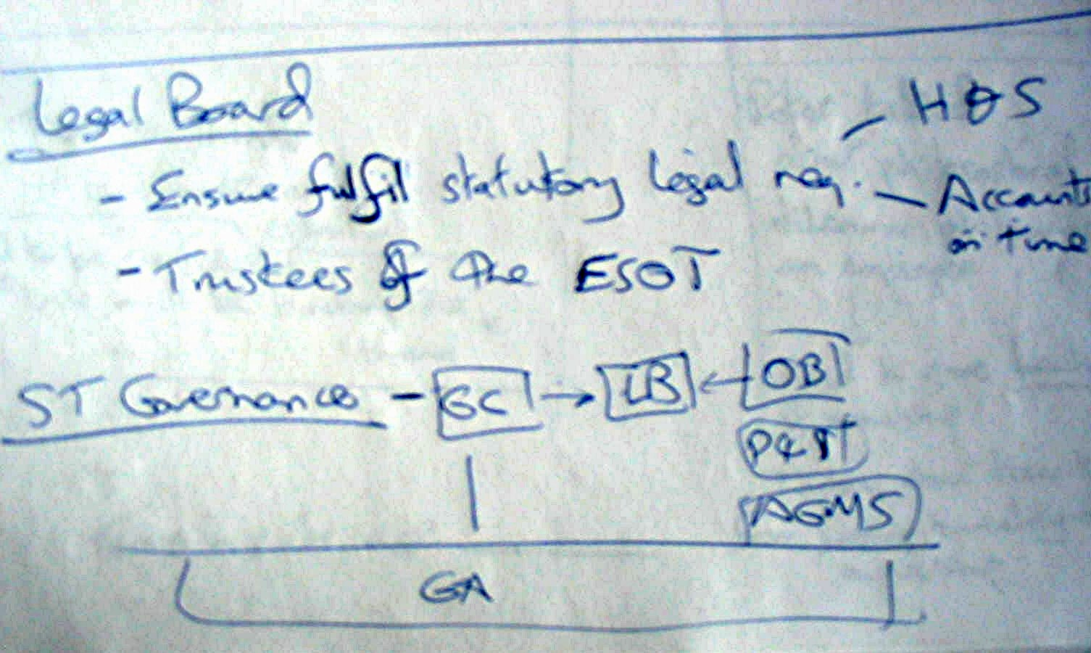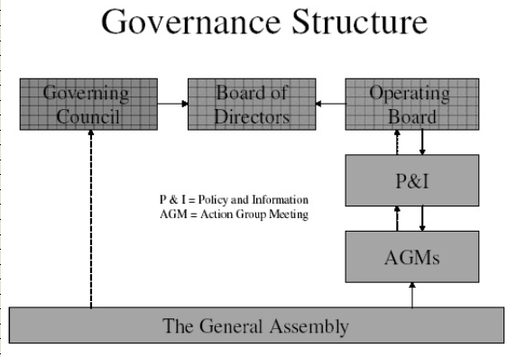
Drawing 12: Representation of Governance to UK Managers/Employees (Custom Products)

The General Assembly (GA) moves from the top to the bottom of the diagram. The recursive tensions between Social and Governing Councils - part of Mondragon’s tri-partite power structure (Turnbull 1994) – is replaced by linear relationships. Information no longer moves ‘around’ centres of power – instead it moves ‘up and down’ a traditional hierarchy to an Operating Board. The Policy and Information group is comprised of managers appointed by directors/executives. Unlike Mondragon’s Social Council, power-relations between individuals developing social policy are inseparable from operational line management. At Mondragon, departmental members elect the Social Council: power-relations are based on peer-group dynamics, with a chair that is independently elected (Whyte and Whyte, 1991).
The UK directors perceive their General Assembly as a democratic advance. However, subsuming Policy & Information into a line management relationship with operational managers reveals the continued dominance of rationalist (linear-hierarchical-bureaucratic) thinking (Friedman, 1962; Rawls 1999). The recursive models with dual economic and social governance (favoured in Mondragon) draw on grassroots democratic organisation (see Morrison 1991; Oakeshott 1990; Turnbull 1994). In applying the model within the UK, Mondragon’s collectivist approach is supplanted by neo-managerialist thought (Terry 1998). The question remains, therefore, whether the outer appearance of similarity (on paper both organisations are similar) now obscures differences in social philosophy.
The visual data makes these differences clear. They convey which sub-groups are ‘on top’. At Mondragon, ‘social governance’ is embedded in the system both separate and equal to ‘enterprise governance’, recursively linked to operational management. Managers there supervise workers in operational relationships. Workers, in turn, supervise managers through both the governing and social councils. The UK company directors, however, discard the idea that social management has equal status to operational (economic) management. Visually, social policy is presented as subordinate to operations, and pluralism is supplanted by the unitary control of operational managers. This can be obscured in verbal representation (for example, by talking up the ‘social responsibilities’ of the Governing Council). In visual data, intended practices are harder to obscure.

Implications
What this paper concludes is that continuum models inadequately represent the complexity of practitioners’ intentions and actions. Location, ethos and opportunities cannot be expressed as ‘x’ on a line. A more useful model considers three competing worlds of social organisation (public service, private enterprise and voluntary action) that compete and co-operate with each other to achieve specific ends.
Practitioners largely ignore concepts and models presented in academic/policy papers. When used, they do stimulate fruitful debate because participants start to articulate their own understandings using different visual representations. Using drawings and diagrams elicited responses that broke through barriers surrounding the concepts of social enterprise.
There were three key findings. Firstly, in the minds of practitioners tensions exist between the social and economic domains and goals. Many will only entertain dominant economic thinking where it supports social goals, overcomes barriers to funding, or enables survival. There are multiple attitudes ranging from: enthusiasm and acceptance of business-like behaviour; acceptance of an ebb and flow between social and economic; a radical view of enterprise as the ‘dark side’ to be raided on a smash and grab basis, or avoided all together. Not all practitioners perceive a need to pursue a business model (even to obtain necessary funding) as numerous income streams (grant aid, contracts and partnerships) remain.
Secondly, cross-sectoral models of social enterprise help practitioners perceive and articulate opportunities and threats. These revealed various levels of concern (and resistance) to the development of a social enterprise movement. Their concerns were broader and more complex than potential contracting and procurement strategies, and extended to issues of identity, values and threats to the delivery of social services. In some cases, the social enterprise model is perceived as a way of raising funds through market trading that will fund social service/social action. The flip side, however, is a perception that ‘social enterprise’ offers a private sector model to compete against community organisations. In this guise, it is perceived as a hostile movement capable of eroding the influence of the third sector.
Thirdly, practitioners in well-established social enterprises understand the link between democratic governance and the sustainability of social action and economic benefits. Where liberal economic thinking influences debate, this is seen as eroding democratic (owner / user control models). It is by no means clear that liberal economic thinking is making a major advance into the social enterprise sector beyond the world of politicians, business support services, and a narrow band of US-inspired social entrepreneurs committed to individualistic notions of entrepreneurship. At the practitioner level, and even amongst some support workers, there is conscious adaptation and resistance. Moreover, pluralist models of governance effectively inhibit managerialist tendencies and counter liberal economic thinking. A conscious focus on ‘balance’ rather than authority sets boundaries that limit movement toward the ‘enterprise’ end of Dees’ spectrum (Dees 1998). Social outcomes are still pursued through economic means (rather than vice versa) and this balance remains important on the ground.
In our conclusions, therefore, we question Dart’s (2005:412) contention that:
‘…social enterprise is likely to continue its evolution away from forms that focus on broad frame-breaking and innovation to an operational definition more narrowly focused on a market-based solution and business-like models because of the broader validity of pro-market ideological notions in the wider social environment.’
While Dart's statement captures the changes taking place at the level of national government (and business) discourse, it does not reflect the ethos and resistance amongst practitioners of social enterprise. A focus upon commercialisation alienates social entrepreneurs as well as enthuses (Seanor & Meaton, 2008). Long-term impacts, therefore, are taking longer to establish. In some cases, practitioners have learnt the sophisticated game they need to play to obtain funding without changing their ethos.
Those in the voluntary community sector who now contract to deliver services (and for whom finding appropriate models would appear particularly relevant) show hesitancy, if not outright resistance, to the ideas being put forward. Actors making sense of social enterprise using US-based business models and values benefited from alternative models that offered a different way to understand their development. The authors find that models including the role and influence of the public (state) sector make more sense to practitioners.
Finally, we consider whether theoretical models help actors with the problems of organisation development. In these studies, participants elaborated linear models until they became recursive. Cross-sectoral models were found to be particularly relevant to discussions of social enterprise. The actors acknowledged the influence of Anglo-American managerialism and commercialisation. However, the European (collectivist) model sits more comfortably with their experiences than the model of the ‘heroic’ social entrepreneur. This paper, therefore, draws upon the insights of actors to better illustrate and understand the locus and process of social enterprise development. In highlighting that one model may not work for all social enterprises, we also found that for some actors, no (visual) models work at all.
At the outset, we reported Stevenson's view (cited in Westall and Chalkley 2007) that ‘take-up of the social enterprise model across local and national government is patchy’. This paper offers another perspective. For theorists and practitioners seeking ‘the social enterprise model’ within a continuum between mission and market, it may well appear that the take up is 'patchy'. However, for those recognising that social enterprise is a heterogeneous movement located at cross-over points between three distinctly different sectors, it is policy and theory development that remains 'patchy', rather than the social enterprises themselves.

Acknowledgements
We would like to acknowledge and thank the participants of the 4th Social Entrepreneurship Research Conference, (South Bank University, London) for their feedback on an earlier version of this paper.

References
Aiken, M., 2006; “Towards Market or State? Tensions and Opportunities in the Evolutionary Path of Three UK Social Enterprises” in Nyssens, M (ed) Social Enterprise at the Crossroads of Market, Public and Civil Society, London: Routledge.
Alter, K., 2004; ‘Social Enterprise Typology’ accessed at http://www.virtueventures.com/ settypology.pdf (August 2006)
Alter, S.A., 2006; ‘Social Enterprise models and their mission and money relationships’ in Nicholls, A (ed) Social Entrepreneurship: New paradigms of Sustainable Social Change, Oxford: Oxford University Press.
Anheier, H., 2000; ‘Managing Non-Profit Organisations: Towards a New Approach’, Civil Society Working Paper 1 accessed at http://www.lse.ac.uk/collections/CCS/pdf/ cswp1.pdf (August 2006)
Arthur, L., Scott Cato, M., Smith, R. and Keenan, T., 2006; ‘Where is the Social in Social Enterprise’, paper to Social Enterprise Research Conference, London South Bank University, London, 22nd-23rd June.

Berger, P. and Luckman, T., 1966; The Social Construction of Reality: A Treatise in the Sociology of Knowledge, Garden City, NY: Doubleday.

Billis, D., 1993; Organizing Public and Voluntary Agencies, London: Routledge.

Bornstein, D., 2004; How To Change the World: Social Entrepreneurs and the Power of New Ideas, Oxford: Oxford University Press.
Borzaga, C. and Solari, L., 2001; ‘Management Challenges for Social Enterprises’ in Borzaga, C. and Defourny, J. (eds) The Emergence of Social Enterprise, London: Routledge.
Boschee, J., 2006; ‘Social Entrepreneurship: The Promise and the Perils’ in Nicholls, A (ed) Social Entrepreneurship: New Paradigms of Sustainable Social Change, Oxford: Oxford University Press.

Bull, M., 2006; Balance: Unlocking Performance in Social Enterprise, MMUBS. Manchester, Centre for Enterprise. ISBN; 0905304438
Bull, M., 2008; Critical Reflections on Social Enterprise, International Journal of Entrepreneurial Behaviour, forthcoming Guest Editorial.
Cheney, G., 1999; Values at Work, New York, Ithaca: ILR Press/Cornell University Press.
Curtis, T., 2006; “GONGOS, or the Advent of the State Sponsored Social Enterprise”, paper to Critical Perspectives on Social Enterprise seminar, Manchester, 28th November.
Dart, R., 2004; ‘The Legitimacy of Social Enterprise’, Nonprofit Management & Leadership, 14 (4): 411–424.
Dart, R., 2005; ‘Unintended Consequences of Social Entrepreneurship: The Complex Structure and Effects of Radical Service Delivery in a Canadian Human Services Organization’, paper to International Social Entrepreneurship Research Conference, IESE, Barcelona.
Dees J. G. and Anderson B. B., 2006; ‘Framing a Theory of Social Entrepreneurship: Building on Two Schools of Practice and Thought’ in Mosher-Williams, R. (ed), Research on Social Entrepreneurship: Understanding and Contributing to an Emerging Field, 39 -66, 1 (3) Indianapolis, IN: ARNOVA.
Dees, J. G., 1998; ‘Enterprise Non-profits’, Harvard Business Review, 76(1): 55-67.
Dees, J., Emerson, J. and Economy, P., 2001; Enterprising Nonprofits: A Toolkit for Social Entrepreneurs, New York: John Wiley and Sons Inc.
Defourny, J. & Nyssens, M., 2006; "Defining Social Enterprise" in Nyssens, M. (ed.) Social Enterprise - At the Crossroads of Market, Public Policies and Civil Society, London: Routledge, pp. 3-26.
Defourny, J., 2001; ‘Introduction: From Third Sector to Social Enterprise’ in Borzaga, C. and Defourny, J. (eds) The Emergence of Social Enterprise, London: Routledge.
Defourny, J., 2006; ‘Introduction’ in Nyssens, M (ed) Social Enterprise at the Crossroads of Market, Public and Civil Society, London: Routledge.
Drayton, B., 2005; ‘Where the Real Power Lies’, Alliance, 10 (1): 29-30.
Emerson, J., 2004; ‘Moving Ahead Together: Implications of Blended Value for the Future of Our Work’, presentation to Skoll World Forum on Social Enterprise, Said Business School, Oxford University, March.
Emerson, J. and Bonini, S., 2004; ‘The blended value map’ accessed at http://www.blendedvalue.org (January 2007)
Evers, A., 2001; ‘The Significance of Social Capital in Multiple Goal and Resource Structure of Social Enterprises’ in Borzaga, C. and Defourny, J. (eds) The Emergence of Social Enterprise, London: Routledge.
Foster, W. and Bradach, J, 2005; ‘Should Non-Profits Seek Profits?’, Harvard Business Review, 83 (2): 92-100.
Friedman, M., 1962; Capitalism and Freedom, University of Chicago, Chicago.
Goerke, J., 2003; “Taking the Quantum Leap: Nonprofits are now in Business. An Australian Perspective”, International Journal of Nonprofit and Voluntary Sector Marketing, 8(4): 317-327.
Haigh, H., 2005; ‘A Research Agenda for Social Entrepreneurship’ Social Enterprise Journal, 1 (1): 1-12.
Hardy, R.,. 2004; ‘Social Enterprise the New Economic Engine’, Business Strategy Review, 15 (4): 39-43.
Kerlin, J., 2006; ‘Social Enterprise in the United States and Europe: Understanding and Learning from the Differences’, Voluntas, 17 (3): 246-262.
Leadbeater, C., 1997; The rise of the social entrepreneur, London: Demos.
Light, P., 2006; ‘Searching for Social Entrepreneurs: Who Might They Be, Where Might They Be Found, What They Do.’ in Mosher-Williams, R (ed), Research on Social Entrepreneurship: Understanding and Contributing to an Emerging Field, 13-37, 1 (3) Indianapolis, IN: ARNOVA.
Lincoln, A., 2006; Welcome address: DTI presentation to Third Annual UK Social Enterprise Research Conference, London South Bank University (22 June).
Mair, J. and Marti, I., 2004; ‘Social Entrepreneurship Research: A Source of Explanation, Prediction and Delight’ working paper for IESE Business School, Spain accessed at http://www.iese.edu/resecrah/pdfs/DI-0546_E.pdf (February 2007)
Mason, J., 1996; Qualitative Researching, London: Sage.
Mendel, S., 2003; ‘The Ecology of Games Between Public Policy and Private Action’, Nonprofit Management and Leadership, 13 (3): 229 – 236.
Meyer, A. D., 1991; “Visual Data in Organisation Research”, Organization Science, 2(2): 218-236.
Morrison, R., 1991; We Build the Road as We Travel. Gabriola Island: New Society Publishers.
Nicholls, A., 2006; Social Entrepreneurship: New Paradigms of Sustainable Social Change, Oxford: Oxford University Press.
Nyssens, M., 2006a; Social Enterprise at the Crossroads of Market, Public and Civil Society, London: Routledge.
Nyssens, M., 2006b; ‘At the crossroads of market, public policies and civil society’, launch of book and presentation to Social Enterprise Research Conference, London South Bank University, London, 22nd-23rd June.
Oakeshott, R., 1990; The Case for Worker Co-ops: 2nd Edition, London: Macmillan.
Office of the Third Sector, 2007; accessed at http://www.cabinetoffice.gov.uk/third_sector (January 2007)
Pearce, J., 2003; Social Enterprise in Anytown, London: Calouste Gulbenkian Foundation.
Pharoah, C., Scott, D., and Fisher, A., 2004; Social Enterprise in the Balance: Challenges for the Voluntary Sector, West Malling, UK: Charities Aid Foundation.
Rawls, J., 1999; A Theory of Justice, Oxford: Oxford University Press (Revised Edition).
Ridley-Duff, R. J., 2004; ‘Communitarian Governance: The Development of Management, Governance and Ownership Models’, paper to 6th International Management Control Association Conference, Edinburgh, July 12th-14th.
Ridley-Duff, R. J., 2005; Communitarian Perspectives on Corporate Governance, Sheffield: Sheffield Hallam University.
Ridley-Duff, R. J., 2007a; ‘Communitarian Perspectives on Social Enterprise’, Corporate Governance: An International Review, 15 (2): 382-392.
Ridley-Duff, R. J., 2007b; Emotion, Seduction and Intimacy: Alternative Perspectives on Organisation Behaviour, Bracknell: Men’s Hour Books, forthcoming.
Ridley-Duff, R. J., 2008; ‘Social Enterprise as a Socially Rational Business’, International Journal of Entrepreneurial Behaviour, forthcoming.

Seanor, P. and Meaton, J., 2008; ‘Learning from Failure, Ambiguity and Trust in Social Enterprise’, International Journal of Entrepreneurial Behaviour & Research, forthcoming.
Small Business Service, 2005; Annual Small Business Survey, http://www.sbs.gov.uk
Spear, R., 2007; ‘An Overview of Social Enterprise in the UK: Research, Policy and Practice’ paper to Social Entrepreneurship Seminar, Lancaster, 13th April.
Stiles, D. R., 2004; ‘Pictorial Representation’ in Cassell C. and Symon, G. (eds), Essential Guide to Qualitative Methods in Organizational Research, London: Sage.
Terry, L. D., 1998; “Administrative Leadership, Neo-Managerialism, and Public Management Movement”, Public Administration Review, 58(3): 194-200.
Turnbull, S., 1994; “Stakeholder Democracy: Redesigning The Governance of Firms and Bureaucracies”, Journal of Socio-Economics, Vol. 23 No. 3, pp. 321-360.
Turnbull, S., 1995; “Innovations in Corporate Governance: The Mondragon Experience”, Corporate Governance: An International Review, Vol. 3 No. 3, pp. 167-180.
Westall, A. and Chalkley, D., 2007; Social Enterprise Futures, London: The Smith Institute, accessed at http://www.smith-institute.org.uk/pdfs/social_enterprise.pdf (May 2007)
Whyte, W. F. and Whyte, K. K., 1991; Making Mondragon. New York: ILR Press/Itchaca.

In Mondragon, the founders of the first industrial business raised money by canvassing members of their own community (following in the traditions established a decade earlier when they successful canvassed support to establish a school). In the UK context, only two founders put in money and the company followed a conventional entrepreneurial model for the first 15 years of trading.

